 | Abdi İpekçi Caddesi Kaşıkçıoğlu Apt. No:42 D:2 34365 Nişantaşı İstanbul www.artxist.com  info@artxist.com  T. +90 212 291 77 84 F. +90 212 343 69 35 | PRESS RELEASE

x-ist hosts Bahadır Baruter’s 4th solo exhibition entitled “Fatality” between December 24, 2015 – January 23, 2016.

BAHADIR BARUTER | FATALITY

x-ist presents Bahadır Baruter’s new sculptures to the audience. The exhibition is realized as a continuation of the series that was exhibited at the Contemporary Istanbul 2015 solo project space with the title “Fatality” and ranked among the most attention-grabbing works in the fair.

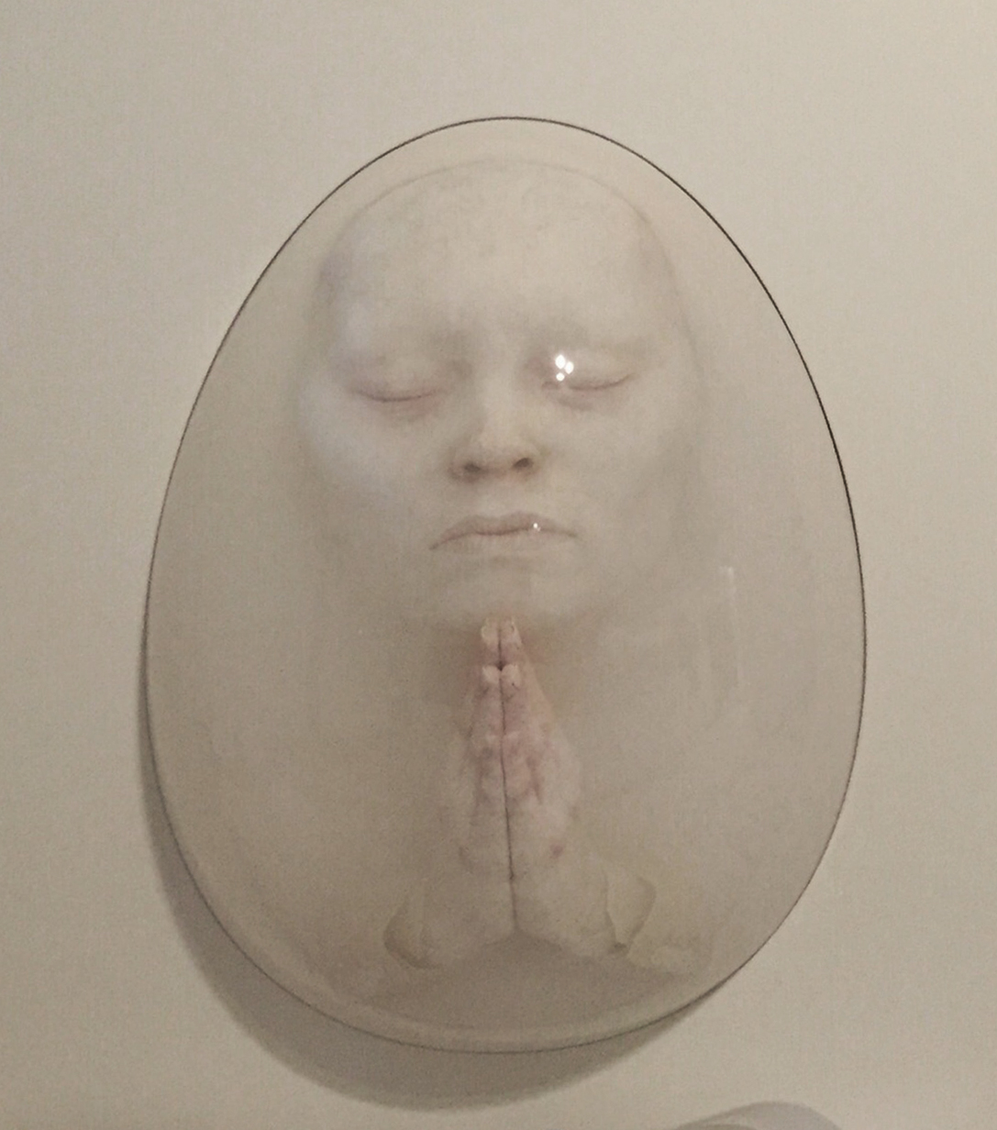

Fatality Series, “Untitled IV”, Silicone, epoxy, acrylic resin, plexiglas, wood,
height: 110, width: 106, depth: 24 cm, 2015

In his new exhibition, Bahadır Baruter’s sculptures portray business people, who have almost turned into living dead because of the pressure of being trapped by the income, success, carrier and security cycle of business life, as lifeless and desperate bodies which are not born yet or have already lost their vitality. The artist aims at taking us to a mental and emotional journey by reflecting the fears such as despair and captivity of these business people who are in white suits referring to burial robes and who pray and beg to an almost divine force.

The transparent material in the bell jars, which contain the sculptures mainly made out of epoxy, is a kind of double components silicone. The process of moulding is performed with specific techniques under special temperature and hygiene conditions with the help of again specially produced syringes and tubes. The exhibition meets the audience at the end of an authentic and exhausting period lasting months long with a professional production team of 12 people. “Fatality” can be seen at x-ist until January 23, 2016.

For more information please consult Gözde Ulusoy from x-ist.

gozde@artxist.com
M. 545 357 60 70
T. 212 291 77 84

BAHADIR BARUTER | Ankara, 1963

The artist who studied at the Painting Department of the Fine Arts Faculty of Mimar Sinan University started to work as professional illustrator at the age of 27 and worked at various humour magazines as illustrator. Baruter met the art lovers at x-ist with its solo exhibitions entitled “Existence Anxiety” in 2007 and “Your Family Is A Lie, Dear” in 2012. Baruter also participated in the Contemporary Istanbul 12&13, ArtInternational Istanbul 13 and Art London 14 fairs. The artist is an illustrator of the weekly humour magazine Penguen since 2002 as one of its founders.

