 | Kemankeş Karamustafa Paşa Mah.,  Mumhane Cad., No:50, K:2,  34425, Beyoğlu, İstanbul  www.artxist.com, info@artxist.com | PRESS RELEASE

ALİ BİLGE AKKAYA
THREE OR THE PROFOUND ADVENTURES OF DESOLATE ROADS
Ali Bilge Akkaya’s third solo exhibition entitled “Three or Profound Adventures of Desolate Roads” can be visited between February 28 – March 30 at x-ist’s new address Karaköy Juma.
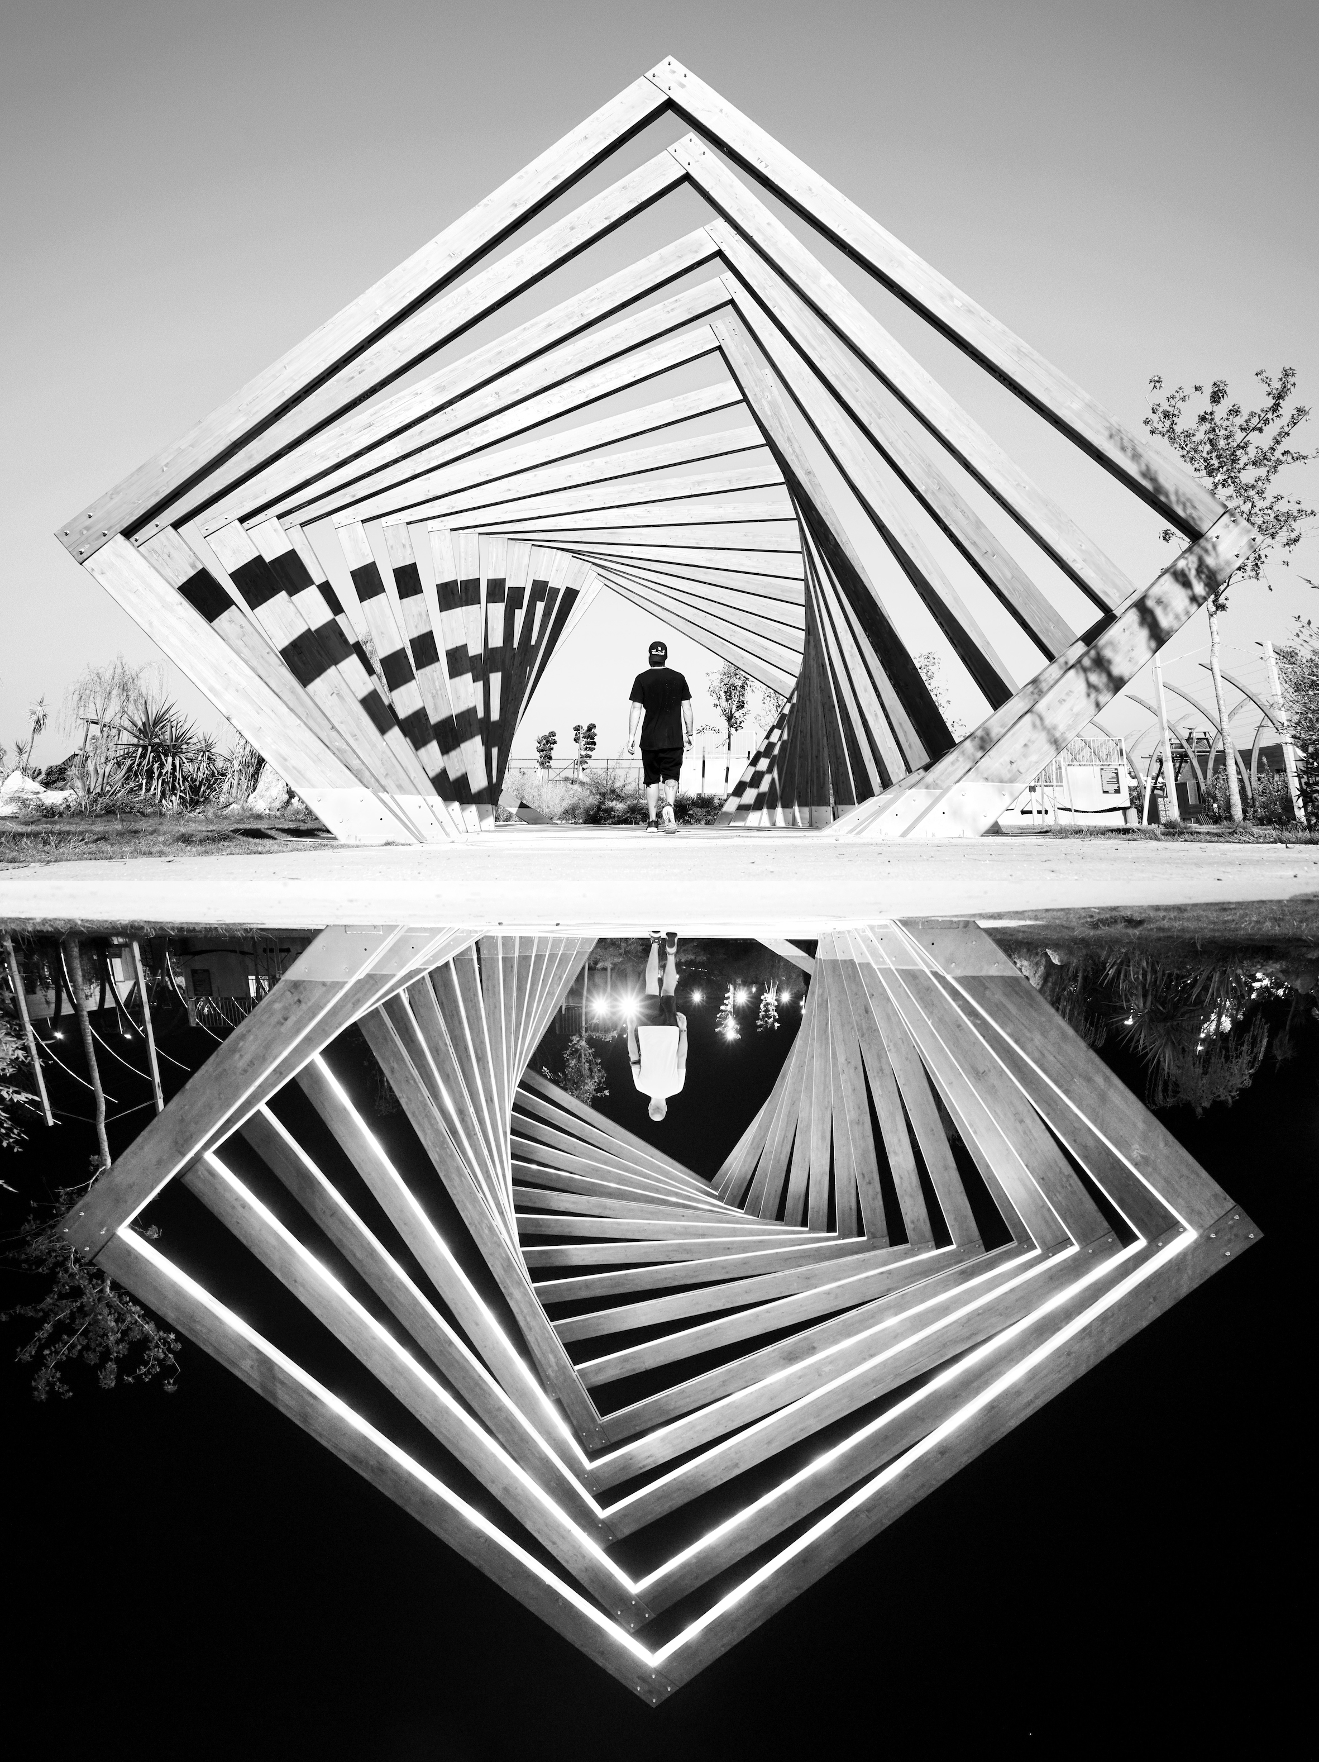
A Park in Fethiye – Night and Day, Fethiye, ed 5+1 ap,Fine Art Paper, archival pigment print,
100 x 75 cm, 2018

In his third solo exhibition, Ali Bilge Akkaya, who adds his strong aesthetic vision and perfectionist attitude to his frame as a result of the coincidences brought by the moment, stays related with his previous series, while he carries this one step further and presents the audience a series where they can lose themselves in his story and which also contains personal details regarding himself.

In his frames where the dramatic effect of contrasts are obviously seen, the artist goes one step further than the illusions that he creates through symmetry, the figures in motion which succeed in drawing attention at an unexpected point and the scenes giving an impression of being frozen in the moment. He defeats the boundaries of photography with the frame form and experiences his language created through specific geometric arrangements by means of a new form and sizing. “Check-in, Antalya”, in which he has directly captured the effect of language, meets the audience as his first and the only video work in this exhibition.

The third solo exhibition entitled “Three or Profound Adventures of Desolate Roads” by Ali Bilge Akkaya, who freezes the relationship between space and human being in perfect scenes, can be visited between February 28 – March 30 at x-ist’s new address Karaköy Juma.

For more detailed information, please consult Gözde Ulusoy from x-ist.

gozde@artxist.com
M. 545 357 60 70
T. 212 291 77 84

