 | Abdi İpekçi Caddesi Kaşıkçıoğlu Apt. No:42 D:2 34365 Nişantaşı İstanbul www.artxist.com  info@artxist.com  T. +90 212 291 77 84 F. +90 212 343 69 35 | PRESS RELEASE

x-ist hosts young artist, Murat Palta's very first solo show in Turkey between January 29, 2014 and February 28, 2015.

MURAT PALTA | Depictions of White Screen

Bringing together young talents worth discovering, x-ist is proud to host "Depictions of White Screen", the first solo exhibition of the young talent, Murat Palta in Turkey .

After literally becoming a media phenomenon on the net around the world Palta’s series
consisting of the works where he turned the legendary scenes from Hollywood movies to Ottoman miniatures from 16th century, was initially shown in the Civic Museum of Bagnacavallo, Italy in 2014.
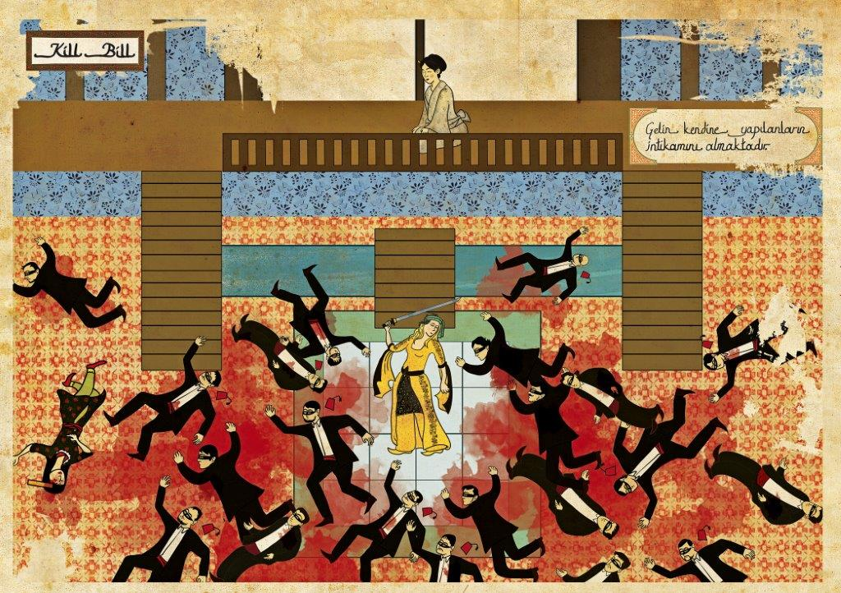

Murat Palta, “Kill Bill”, 60 x 85 cm, Monoprint on fine art paper, 2012

The works in Murat Palta’s this solo exhibition gathered under the title of "Murat Palta: Cult Hollywood Movies As Ottoman Miniatures". Some of the works from this exhibition which was acclaimed highly in Italy, has also simultaneously meet with the Turkish audience in x-ists’ booth during the Contemporary Istanbul.

His willingness to "combine the local and the global, East and West, traditional and contemporary", resulted in a fascinating series of works which reinterprets through the aspect of a miniaturist from the Sultan's Palace brought together the scenes from the most famous movies etched upon our collective imagination.

Murat Palta’s new series “Depictions of White Screen” which was meticulously conducted by the artist portrays the contemporary movie scenes from the aspect of 16th century with the visual language of Ottoman miniature tradition. The very first solo show of Murat Palta in Turkey can be seen till 28th of February, 2015 at x-ist.

For further information please contact to Ece Göymen from x-ist.
ece@artxist.com
M. 537 349 13 27
T. 212 291 77 84

MURAT PALTA | HATAY, 1990

Murat Palta was born in Hatay, in 1990. After graduating from Graphic and Design department of Dumlupınar University in 2012, he started to work in various advertisement agency in Istanbul. In 2013, he attended Miniature and Illumination Art workshop in Tlemcen (Algeria), and participated in different international art festivals such as Nour Festival of Arts in London and Cinephiliac: Art Transcending Technology & Motion, in Philedelphia. Palta had his first solo exhibition in City Museum of Bagnacavallo (Rome, Italy) in 2014. His works have also been published in many different publications such as Radikal, Bant.

