 | Kemankeş Karamustafa Paşa Mah.,  Mumhane Cad., No:50, K:2,  34425, Beyoğlu, İstanbul  www.artxist.com, info@artxist.com | PRESS RELEASE

ERKUT TERLİKSİZ
BEYOND SEEN
x-ist hosts Erkut Terliksiz’s seventh solo exhibition “Beyond Seen” between April 9 and May 22, 2020.

Erkut Terliksiz tells the story of an inward journey at “Beyond Seen” his seventh solo exhibition at x-ist. Offering a contemporary mind map, Terliksiz reveals humane feelings in an expressionist way.

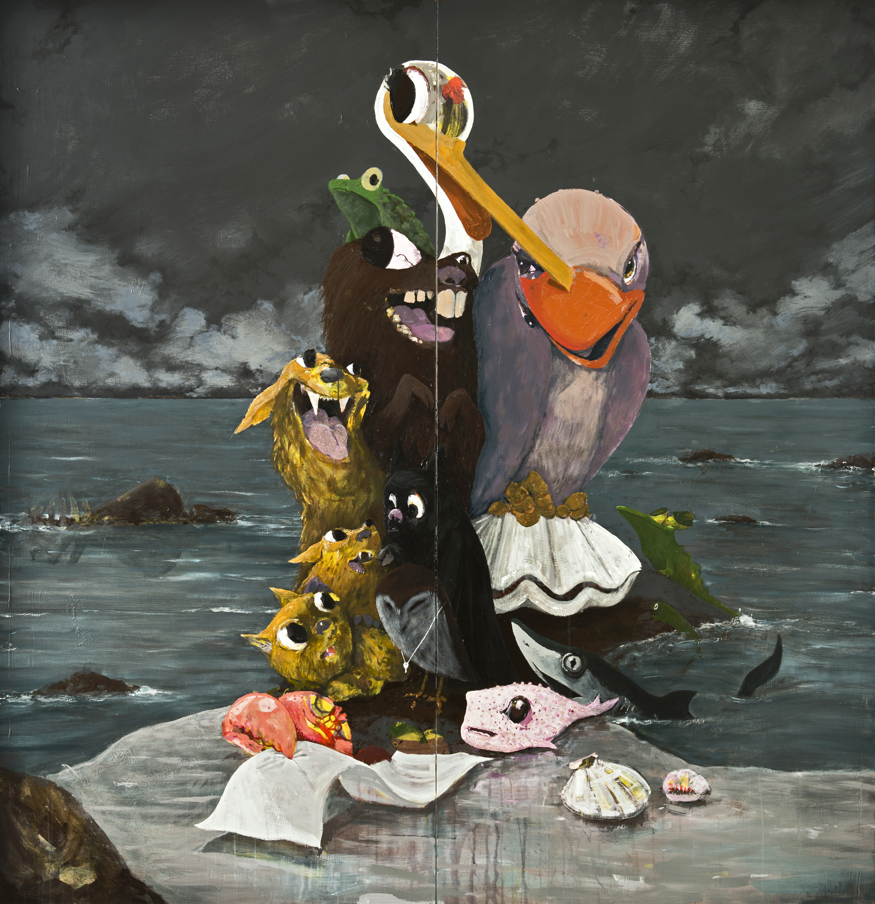
“The Last Song”, Mixed technique on canvas, diptych, 193 x 186 cm, 2020

Comparing the art of painting to a great world of delights, Erkut Terliksiz regards painting as a way to achieve the truth and magical. In this sense, his works refer to the act of painting itself and tell us how the artist connects with the supernatural and the fantastic.
Starting his works without any sketches, the artist uses the materials on hand in an autonomous and intuitive way. He offers a coincidental and surreal visual realm with the forms and figures by deconstructing and rebuilding. Carving out an abstract playground for the audience in this realm, Terliksiz leaves them to set stories out of his paintings.
Comprising large canvases and a series of portraits on a smaller scale, the exhibition features once again the amorphous human and animal figures that are closely associated with the artist.
“It was a way to achieve the supreme, the beautiful, and the truth;
A ‘tariq’ in his own complex language.
Always talked about the impossibility of achieving the truth without eliminating reason,
And mostly walked around half-stoned.”
The Time Regulation Institute / Ahmet Hamdi Tanpınar
Erkut Terliksiz’s seventh solo exhibition at x-ist “Beyond Seen” is open between April 9 and May 22.
For more information, please contact Melis Golar at x-ist.
melis@artxist.com
M. 535 555 35 36
T. 212 291 77 84

