 | Kemankeş Karamustafa Paşa Mah.,  Mumhane Cad., No:50, K:2,  34425, Beyoğlu, İstanbul  www.artxist.com, info@artxist.com | PRESS RELEASE
From the exhibition text written by İdil Deniz Türkmen:

In Aylin Zaptçıoğlu’s paintings, the ‘living ones’ posing in the form of sculptures and the sculptures looking like as if they will begin moving soon determine the starting and endpoint of the world that the artist has created. The figures each creating a composition on their own sometimes pose for the audience and sometimes play games of which rules they determine. The flowers and ivies around become part of the beings standing there for a long time. Cutting at one point the cycle that she deals with in her paintings, Zaptçıoğlu interferes in that moment and documents it secretly.

AYLİN ZAPTÇIOĞLU
INTERRUPTED CYCLE
Aylin Zaptçıoğlu’s first solo exhibition entitled “Interrupted Cycle” at x-ist can be visited at the gallery’s Karaköy Juma address between January 24 – February 23.

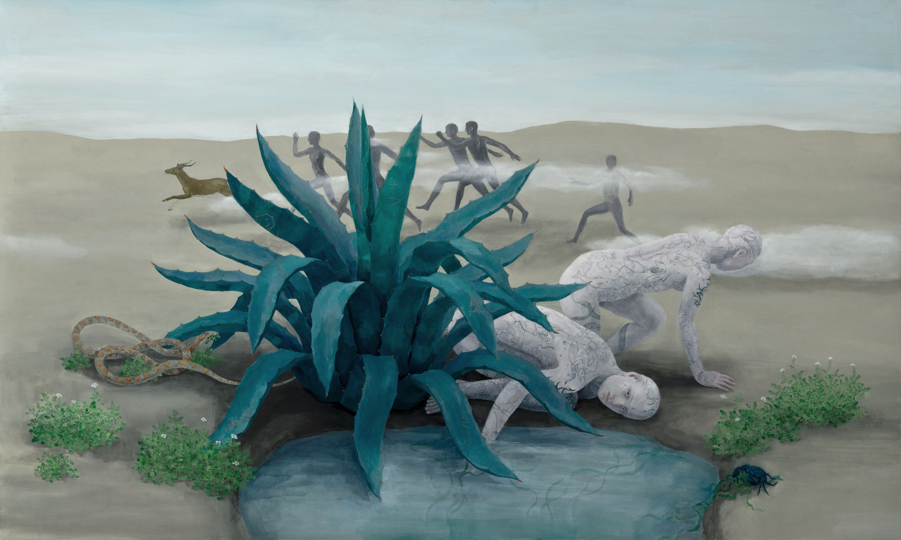
‘Nice and Beautiful’, Oil painting on canvas,123 x 205 cm, 2018

Aylin Zaptçıoğlu has joined the gallery at the beginning of the season and “Interrupted Cycle” is her sixth exhibition in total and her first solo exhibition at x-ist, where she addresses the interventions in the functioning of humanity, all living beings and nature by means of fictional scenes. In her works where a feeling of timelessness prevails, we see a surprising transformation of balance where half-animal and half-human creatures, plants and sculptures turn into each other. Using her colour palette in a way that it reflects the daylight and the night’s darkness, the artist is nourished by Eastern philosophy and its symbolism which provide a conceptual basis for the exhibition. Without focusing on positive or negative sides of intervention, Zaptçıoğlu evaluates it only as a case and enriches her sculptures and paintings, which look like having been frozen in the moment, with details that enables the audience to examine them closely.

Aylin Zaptçıoğlu’s exhibition entitled “Interrupted Cycle” can be visited at x-ist between January 24 – February 23, 2019.

Please consult Gözde Ulusoy from x-ist for more information.

gozde@artxist.com
M. 545 357 60 70
T. 212 291 77 84

