 | Abdi İpekçi Caddesi Kaşıkçıoğlu Apt. No:42 D:2 34365 Nişantaşı İstanbul www.artxist.com  info@artxist.com  T. +90 212 291 77 84 F. +90 212 343 69 35 | PRESS RELEASE

x-ist’s first foreign artist Decolife’s third solo exhibition “Horizontal” will be held between May 12 – June 11 at x-ist.

DECOLIFE
“HORIZONTAL”

The second solo exhibition of Andre' Ruiz de Freitas, the Brazilian street artist known with the nickname Decolife, at x-ist consists of his previously unseen paintings on which he has been working for three years. Having been continuously travelling and being nourished by meeting new artists during the three years since x-ist has hosted his first exhibition “Mind the Gap” after the gallery added street art to its mission of supporting young artists, Decolife appears before the art audience this time with his paintings.
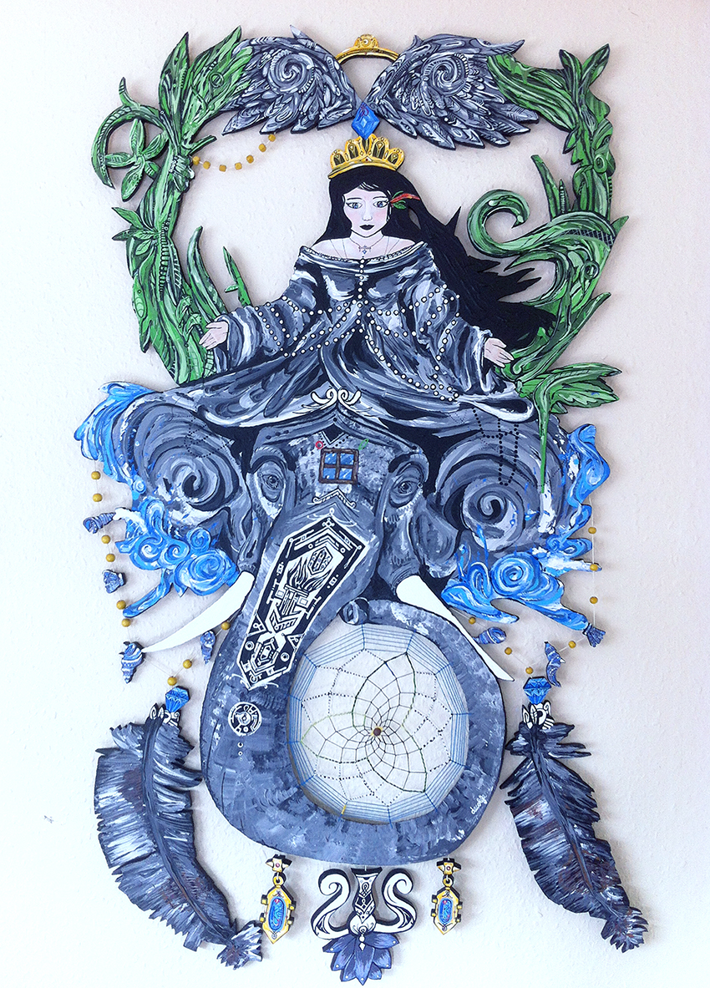
Decolife, “Yasmim and the Rebirth” acyrilic on wooden, 140x83 cm

This time giving weight to working with acrylic and brush in his recent works instead of graffiti and spray paint, Decolife states that painting is the best method for expressing himself since his childhood and he likes using different techniques. The artist, who has drawn attention with the performance that he carried out in the gallery in his previous exhibition, will paint one of the walls of x-ist with acrylic in his recent exhibition as well.

Using acrylic paint and brush in his recent works, which are influenced by the free spirit of a street artist or a homeless that he met while travelling and are each setting out from different stories, Decolife addresses his continuing relationship with painting since his childhood. Referring to this as revealing his inner world and emotional side, Decolife associates the title of his exhibition “Horizontal” with eternity. Being nourished from all cultures in which he lived and to which he travelled and reflecting in his works the events that have impressed him, Decolife states that one of the reasons why he gravitated towards painting in this period is that he finds people’s views on painting and different interpretations impressive and that he attaches importance to being influenced by some people or being part of the change by influencing them.

Decolife’s solo exhibition entitled “Horizontal” can be visited between May 12 – June 11 at x-ist.

You can consult Gözde Ulusoy from x-ist for more detailed information.
gozde@artxist.com
M. 545 357 60 70
T. 212 291 77 84

