 | Abdi İpekçi Caddesi Kaşıkçıoğlu Apt. No:42 D:2 34365 Nişantaşı İstanbul www.artxist.com  info@artxist.com  T. +90 212 291 77 84 F. +90 212 343 69 35 | PRESS RELEASE

Seda Hepsev’s 6th solo exhibition “Sirens and Mermaids” to be held at x-ist will meet the audience between May 25 – June 24, 2017.

SEDA HEPSEV
-
SIRENS AND MERMAIDS

Seda Hepsev’s exhibition entitled “Sirens and Mermaids”, named after a chapter of Christopher Dell’s book ‘Monsters: A Bestiary of the Bizarre’, addresses the existential problems of women from different perspectives but again from women’s eyes.
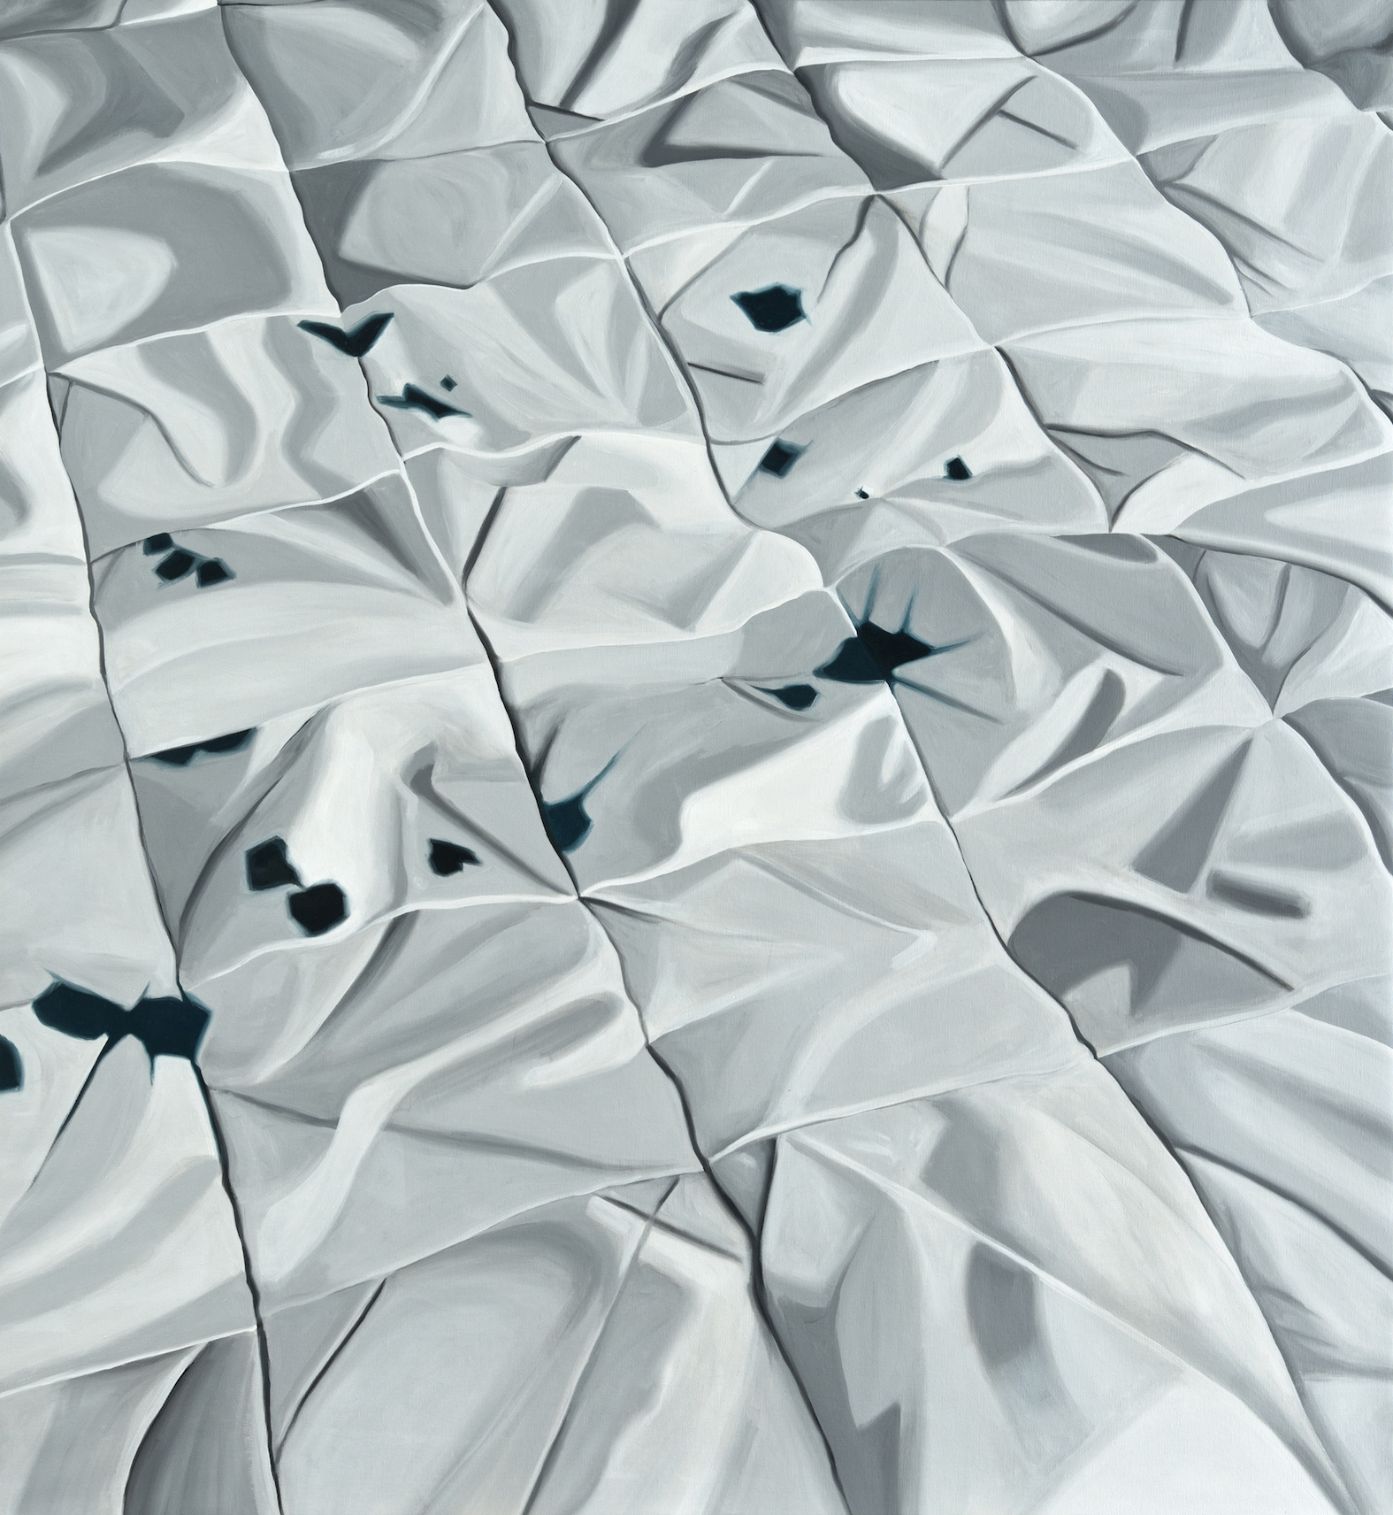

“Rose”, Acrylic on canvas, 110 x 120cm, 2016
“She started her talk as follows: ‘based on men’s observation rather than on women’s experience’ and finished with the orgasm of rats*.”

Males of some animal species (mouse, rat, bee, squirrel, scorpion, spider) create a mating plug during the sexual intercourse. This prevents the female to have a sexual intercourse with other males. The mating plug is a gelatinous component placed into the female’s womb after the intercourse. When it solidifies, the female cannot have intercourse with other males.

The artist focuses on the feminine existence and the construction process of the feminine identity, which creates space, time and language for itself by getting through different social experiences and constructs. She deals with womanhood on the basis of the similarity of the social roles provided for women, the ways of their representation and the dynamics bringing out these representations in even incompatible cultures and geographies.

In the exhibition, which includes paintings, drawings and embroideries, the paintings are displayed as 6 different installations. The 6 groups of paintings, differing from each other through short texts written by the artist and each of them featuring a female character, actually tell the whole story of the exhibition. “Eli belinde” (hands on hips) patterns lack one of the arms as they are intervened by the artist who features in her embroideries patterns of female bodies symbolizing femininity, fertility and abundance. Her drawings include pedestals which again consist of stylized forms of this pattern.

The title of the exhibition “Sirens and Mermaids”, in contrast to the romanticized understanding, continues to question the perception of identity with a subtle contradiction such as the facts that mermaids are one of the sea monsters and that people drown in the sea when they hear the hypnotizing songs of the sirens which actually do not live in the sea.

Seda Hepsev’s 6th solo exhibition “Sirens and Mermaids” meets the audience between May 25 – June 24, 2017 at x-ist.

For more information, you can consult Gözde Ulusoy from x-ist.

gozde@artxist.com
M. 545 357 60 70
T. 212 291 77 84

