 | Abdi İpekçi Caddesi Kaşıkçıoğlu Apt. No:42 D:2 34365 Nişantaşı İstanbul www.artxist.com  info@artxist.com  T. +90 212 291 77 84 F. +90 212 343 69 35 | PRESS RELEASE

x-ist is hosting “Variations on An Andalusian Dog” between July 9 and August 18, 2015.

“Variations on An Andalusian Dog”

The starting point for the exhibition is the fruit of Salvador Dali and Luis Bunuel’s friendship developed at Madrid University, the first example of surrealist cinema; “An Andalusian Dog”
The critically acclaimed short film introduced a new language standing on the thin line between dreams and reality by going beyond the literary narrative. Film’s irrational and bizarre imagery, creates a flamboyant experience with Bunuel and Dali’s satiric aesthetic.

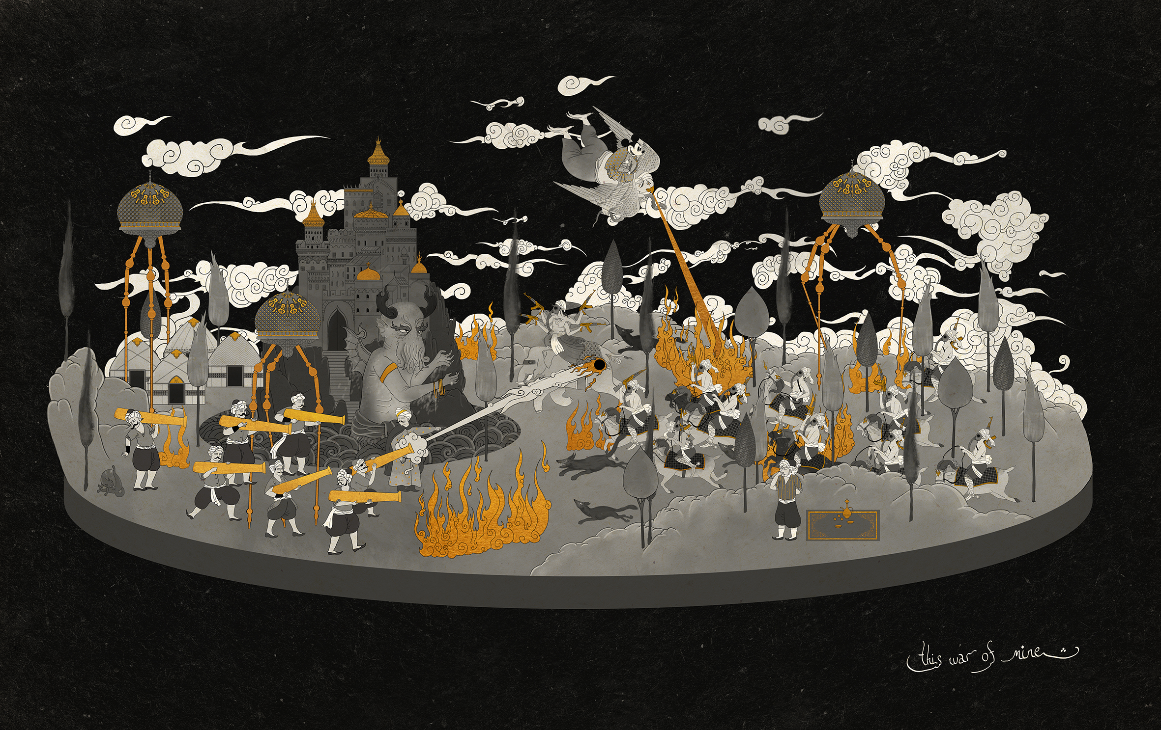Murat Palta "This war of mine", Mono print on fine art paper, 55 x 87 cm, 2015
Following x-ist artists are producing black and white works inspired by the finest example of collaboration of plastic arts and cinema; Ansen, Ali Elmaci, Ali Bilge Akkaya, Bahadır Baruter, Burçin Başar, Cem Dinlenmiş, Ceren Oykut, Ekin Saçlıoğlu, Erkut Terliksiz, Emin Mete Erdoğan, Engin Konuklu, Murat Palta, and Seda Hepsev.
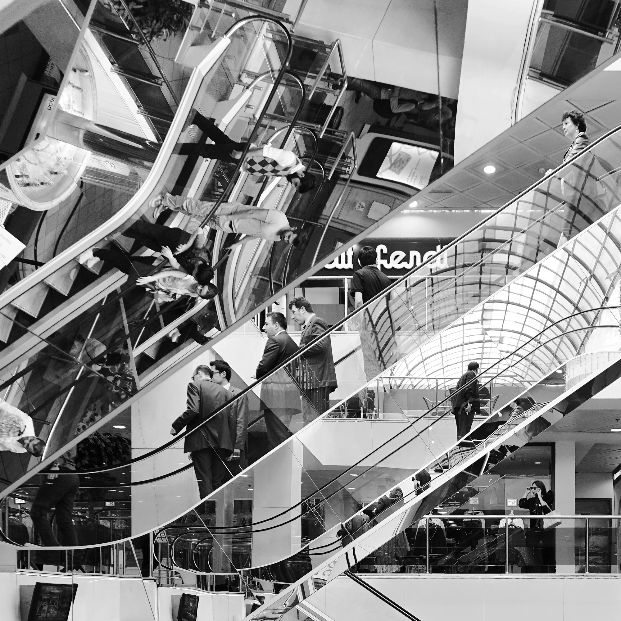
Ali Bilge Akkaya, '2A', Archival pigmet print, 45 x 45 cm, 2015

For further information please contact to Sırma Karasu from x-ist.
sirma@artxist.com
M. +90 543 540 29 85
T. +90 212 291 77 84

