 | Abdi İpekçi Caddesi Kaşıkçıoğlu Apt. No:42 D:2 34365 Nişantaşı İstanbul www.artxist.com  info@artxist.com  T. +90 212 291 77 84 F. +90 212 343 69 35 | Press Release

x-ist is hosting Ceren Oykut’s new solo exhibition between September 8 and October 10, 2015.

CEREN OYKUT | Swimmers in the Field

Ceren Oykut’s ninth solo show; “Swimmers in the Field” originates from her two earlier etchings.

First etching takes its inspiration from an early memory of Oykut, the demolishment of a vegetable garden as a part of an urban gentrification project. The namesake etching “Swimmers in the field” dates back to 2010 and was created by superposing to images using photogravure technique.

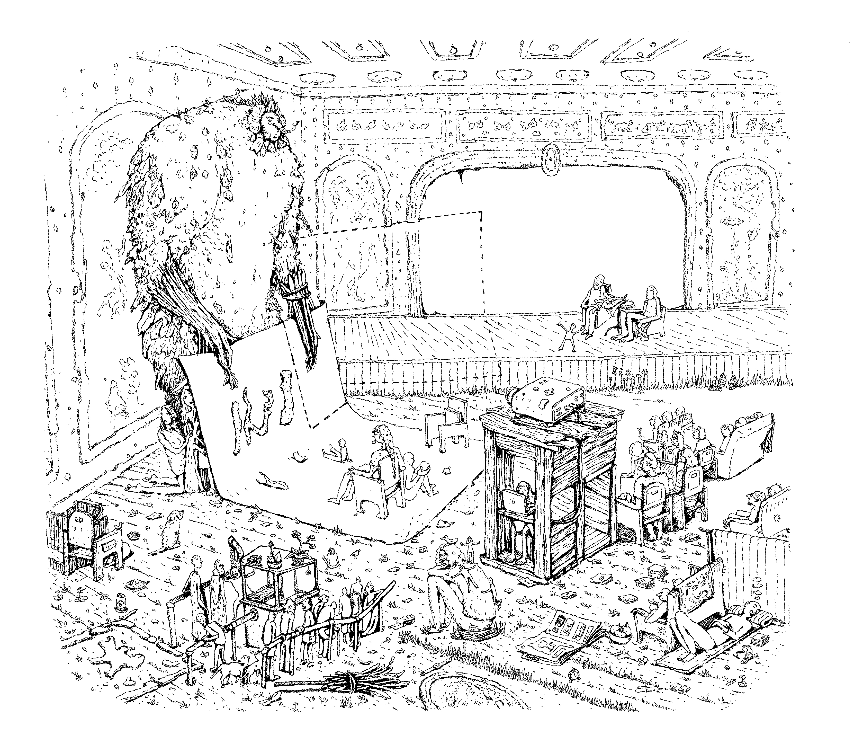
Ceren Oykut, ‘Projection’, Ink on paper, 45,5 x 61cm, 2015

The other work that forms basis to the exhibition is “Tsunami”. The etching is a detail from a collection of drawings that depicts habitants’ tormenting anticipation of the massive earthquake.

In her latest solo show, Ceren Oykut gathers fantasy stories by focusing on relationships, past and present attractions that take place both above and below on the unstable and hectic ground she saw, watched and walked on for years. Oykut’s book illustrations from 2013 are also included in “Swimmers in the Field” .

For more information please contact Sırma Karasu from x-ist
sirma@artxist.com
M. 545 357 60 70
T. 212 291 77 84

CEREN OYKUT | İSTANBUL, 1978
After graduating from Mimar Sinan University, Fine Arts Faculty, Painting Department in 2002, Ceren Oykut had her first solo show in 2003 “Drawing Exhibition” in Kultur Köln 30, Germany. Oykut’s other solo shows are: “Utopia” (Karaburun Festival, Izmir, 2005), “City Can” (Under Construction Contemporary Art Space, Maltepe, Istanbul, 2006), “City Can” (Under Construction Contemporary Art Space - Kuştepe, Istanbul, 2006), "Musical Drawings" (Karaburun Festival, Izmir, 2006), “Lost Passport” (Kibla, Maribor, Slovenia, 2008), "Original / No Subtitles" (artSümer, Istanbul, 2010), “With Bells On" (artSümer, Istanbul, 2011), “Indistinct” (x-ist, 2013) and Swimmers in the Fields (x-ist, 2015).
Among other the national and international exhibitions, biennials and art fairs she participated in are: “Postcards from Stockholm / Istanbul” (Botkyrka Konsthall, Stockholm, Sweden, 2006), “Hafriyat Group Exhibition” (Hafriyat Karaköy, 2007), “Save As.. Contemporary Art From Turkey” (Triennale Bovisa, Milano, Italy, 2008), “Tracing” (Kasa Gallery, 2009), “Istanbul Traverseé” (Palais Des Beaux Arts De Lille, France, 2009), “Reciprocal Visit” (DEPO, Istanbul, 2009), 10th Istanbul Biennial (“2+1”, santralistanbul, 2007), Lyon Biennial 2009 (“La Spectacle du Quotidien”, Musee d’Art Contemporain de Lyon, France) and “Journeys: Wanderings in contemporary Turkey” (Espace Culturel Louis Vuitton, Paris, 2012), “The Feeling of Happiness” (Homa Art Gallery, Tehran, 2014), “A Universe Supplementary to This One” ( x-ist, 2014), “(the) Nature of (the) Material #1” (Polistar, Istanbul, 2014). “I Dream But..”, “stay with me” (DEPO, Istanbul, 2015), “Line” (Art Rooms at the House, Kyrenia, 2015) and “Variations on An Andalusian Dog” (x-ist, 2015). Invited by Lille 3000 for “Istanbul Traverseé” exhibitions Oykut attended a residency program in France.
The artist also took place in Contemporary Istanbul 12, 13, 14 & 15, Scope Basel 12, Arco Madrid 2013, Art Basel Hong Kong 13, Art14London, Artissima 2013 (Italy), ArtInternational 2014 (Istanbul) fairs. Oykut contributes to several periodic publications such as Radikal Kitap, Bant Magazine. Ceren Oykut is featured in the book “Unleashed: Contemporary Art From Turkey” first published in 2010.

