 | Abdi İpekçi Caddesi Kaşıkçıoğlu Apt. No:42 D:2 34365 Nişantaşı İstanbul www.artxist.com  info@artxist.com  T. +90 212 291 77 84 F. +90 212 343 69 35 | PRESS RELEASE

x-ist is hosting the seventh solo exhibition by Ansen between April 9 and May 9, 2015.

ANSEN | “No(ir)land”

As a combination of today’s reality and of what is left in the artist’s mind from the encyclopedia pages he often used to scan in his childhood, No(ir)land is a place where the scriptwriter is a child, the players are the Victorian and Baroque characters of the encyclopaedia illustrations, and the space is a “no land”. The artist’s imagination actually builds an alternative reality combined with what he would like to currently avoid and run away from. In fact he is opening to question whether “No land” is an emptied world or a land to escape to from the existing one.

Paradoxes such as reality and fictional, past and future, eastern references embedded in the encyclopaedic illustrations of the western literature all combine to form a dystopia in Ansen's work. Each piece resembles illustrations in a futuristic children’s book, demanding the accompanying text from an imaginary, futuristic encyclopaedia. As mechanized, wrinkly, angular forms meet the artist’s prismatic perception of space, they transform into a game, a new quest for form.

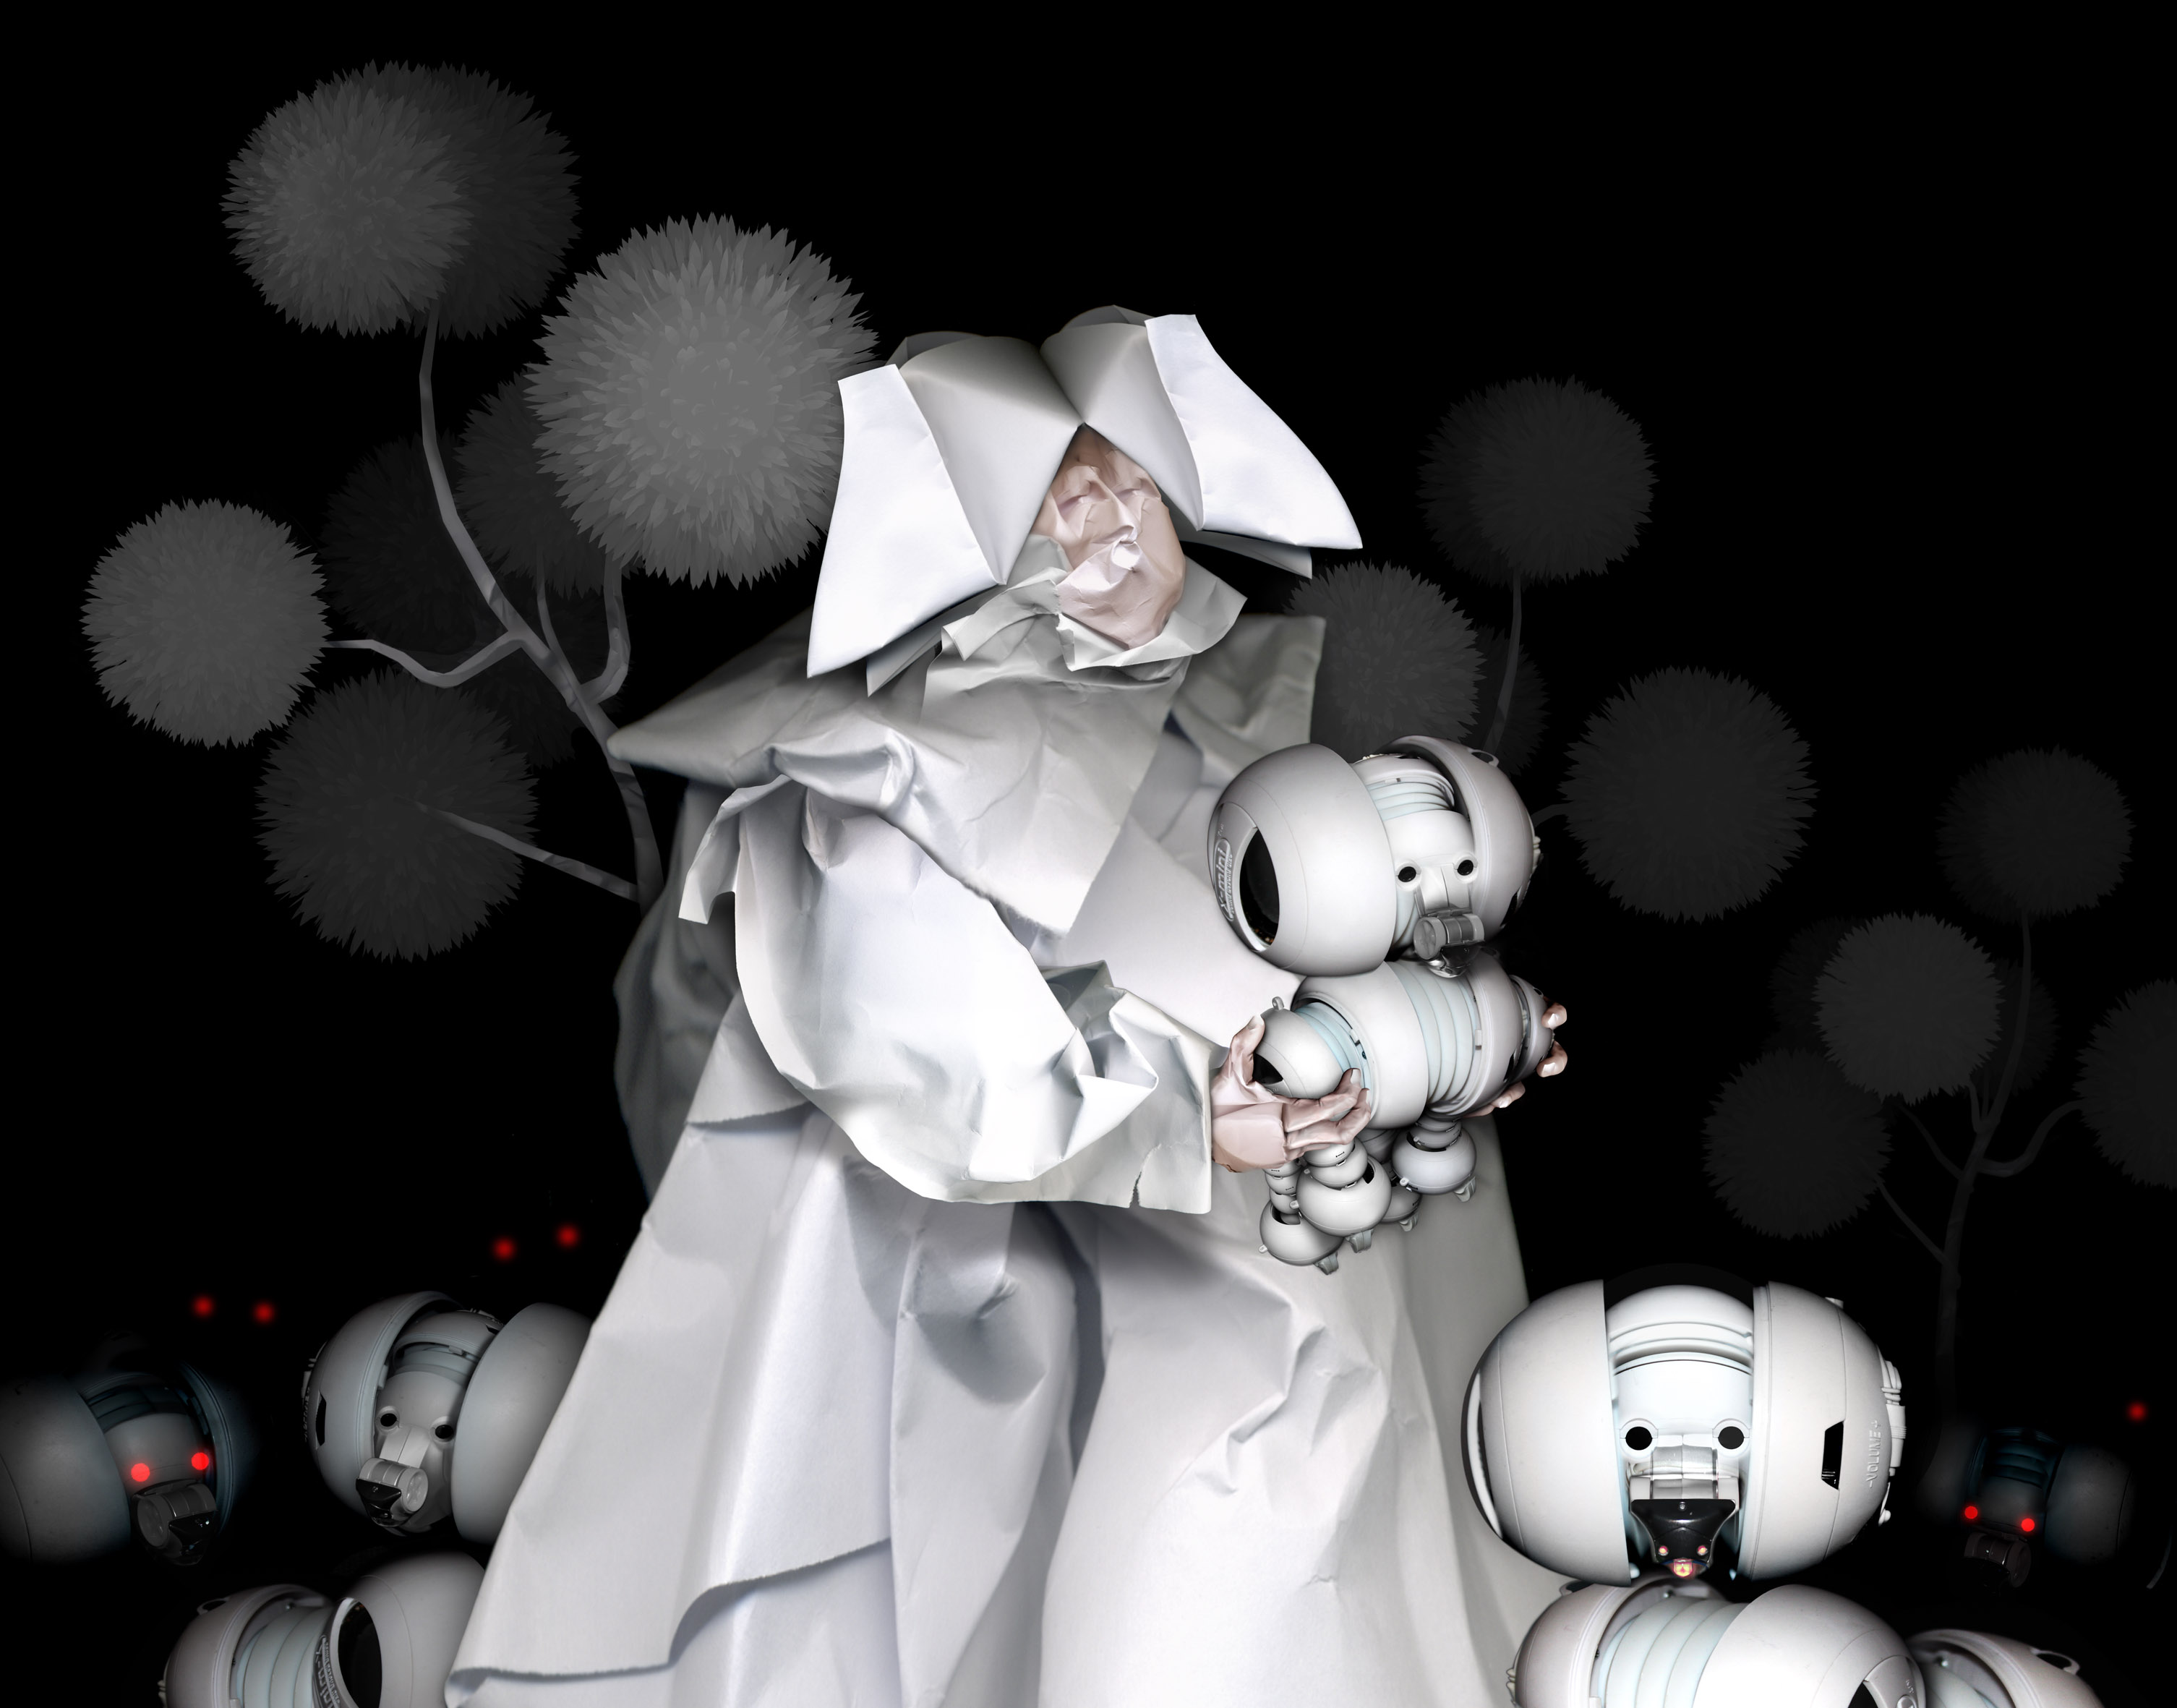
Ansen, The Master’s Calling, 102x130, C-Print, Face mount to plexiglass mounted on dibond, 2015
In this modern world dominated by politics and technology, Ansen's new works in fact offer an opportunity to return to essence, to escape and to fantasize.
On the other hand, Ansen’s lightboxes can be interpreted as the contemporary versions of stained glass. This time the backlit religious portraits are replaced by mechanic and robotic characters animated by an artificial “sacred” light, highlighting the synthetic idea of "modern" values.
In the exhibition’s catalogue text, Ali Şimşek explaines No(ir)land as:
“NO(ir)LAND, black continent, black country or “no country”… The story told is about dreams, myths on the forehead invading the Silicon Valley, and about the continents we are imprisoned in.
Ansen combines the 17th century Baroque curve sneaking into comics, children’s illustrations and machine parts with the “new economy” and media of 2000s. He paints the lace’s grey shadow cast upon cold, minimalist surfaces and robot dogs….
He illustrates the monolith baroque power; the slim hope floating in resistance…”

For further information please contact to Sırma Karasu from x-ist.
sirma@artxist.com
M. +90 545 357 60 70
T. +90 212 291 77 84

ANSEN | Kayseri, 1978

Ansen graduated from Mimar Sinan Fine Arts Faculty, Painting Department. He had six solo exhibitions at x-ist: “x-ist-ence” (2004), “Resistance” (2006), “Menace” (2008), “The Trace” (2009), “Malevolence” (2011) and “Alliance” (2013). Ansen's works were selected for the Sotheby’s London 2009, 2010, 2011 & 2012 and Christie’s Dubai 2011 & 2012 Contemporary Turkish Art Auctions. Among the group shows Ansen participated are “Young Expansions” (Pera Museum, Istanbul, 2005), “Tradition of the New: New Aspects in Contemporary Asian Art” (Sakshi Gallery, Taiwan, 2009), “A Subjective Panorama on Turkish Contemporary Photography” (Maison des Métallos, Paris, 2009), “Confessions of Dangerous Minds” (Saatchi Gallery, London, 2011), “Samawi Collection II Exhibition” (Ayyam Gallery, Dubai, 2012), “Formless”(Santral İstanbul,2014), “Young Collectors Exhibition” (Elgiz Çağdaş Sanat Merkezi, İstanbul,2014). Ansen’s work took place in such fairs as Contemporary Istanbul’06, 07, 08, 09, 10, 11, 12, 13 & 14, Art Fair Cologne’06 (Germany, 2006), CIGE’08 – China International Gallery Exposition (Beijing, China), ShContemporary’09 (Shanghai Asia Pacific Contemporary Art Fair), SCOPE New York 2010, ArtRT HK’10 (Hong Kong International Art Fair), SCOPE Basel 2010, Art Beat 2011 (Istanbul), Art Dubai 2011 & 2012, fairs ArtInternational 2013 & 2014 (Istanbul). Ansen is featured in the book “Unleashed: Contemporary Art from Turkey” first published in 2010.
.

