 | Abdi İpekçi Caddesi Kaşıkçıoğlu Apt. No:42 D:2 34365 Nişantaşı İstanbul www.artxist.com  info@artxist.com  T. +90 212 291 77 84 F. +90 212 343 69 35 | PRESS RELEASE

x-ist is hosting the fifth solo exhibition by Seda Hepsev between March 5 and April 4, 2015.

SEDA HEPSEV | "a mountain in the finger, a mountain in the anus, a mountain riding an elephant"*

Hepsev’s exhibition entitled "a mountain in the finger, a mountain in the anus, a mountain riding an elephant" takes its name from the expression "a sun in the finger, a sun in the anus, a sun riding an elephant" in Etel Adnan’s book “The Arab Apocalypse”.

Up to now Seda Hepsev has been reinterpreting social institutions like family, school and military, and gender roles through power relations, often from an ironic point of view. These questionings were also an expression of how the artist’s individual observations and experiences were reflected in her mind. In this exhibition, on the other hand, Hepsev transforms social relationship motifs invading life in its entirety (individual relations, institutional relations, relations with nature) into works in which she uses a variety of materials, putting them through her individual filter and without pointing at one single concept.

Seda Hepsev’s migration from Istanbul to Zurich also had an impact on her transition from generic works often focusing on a local concept into minor quotes about life as a whole.

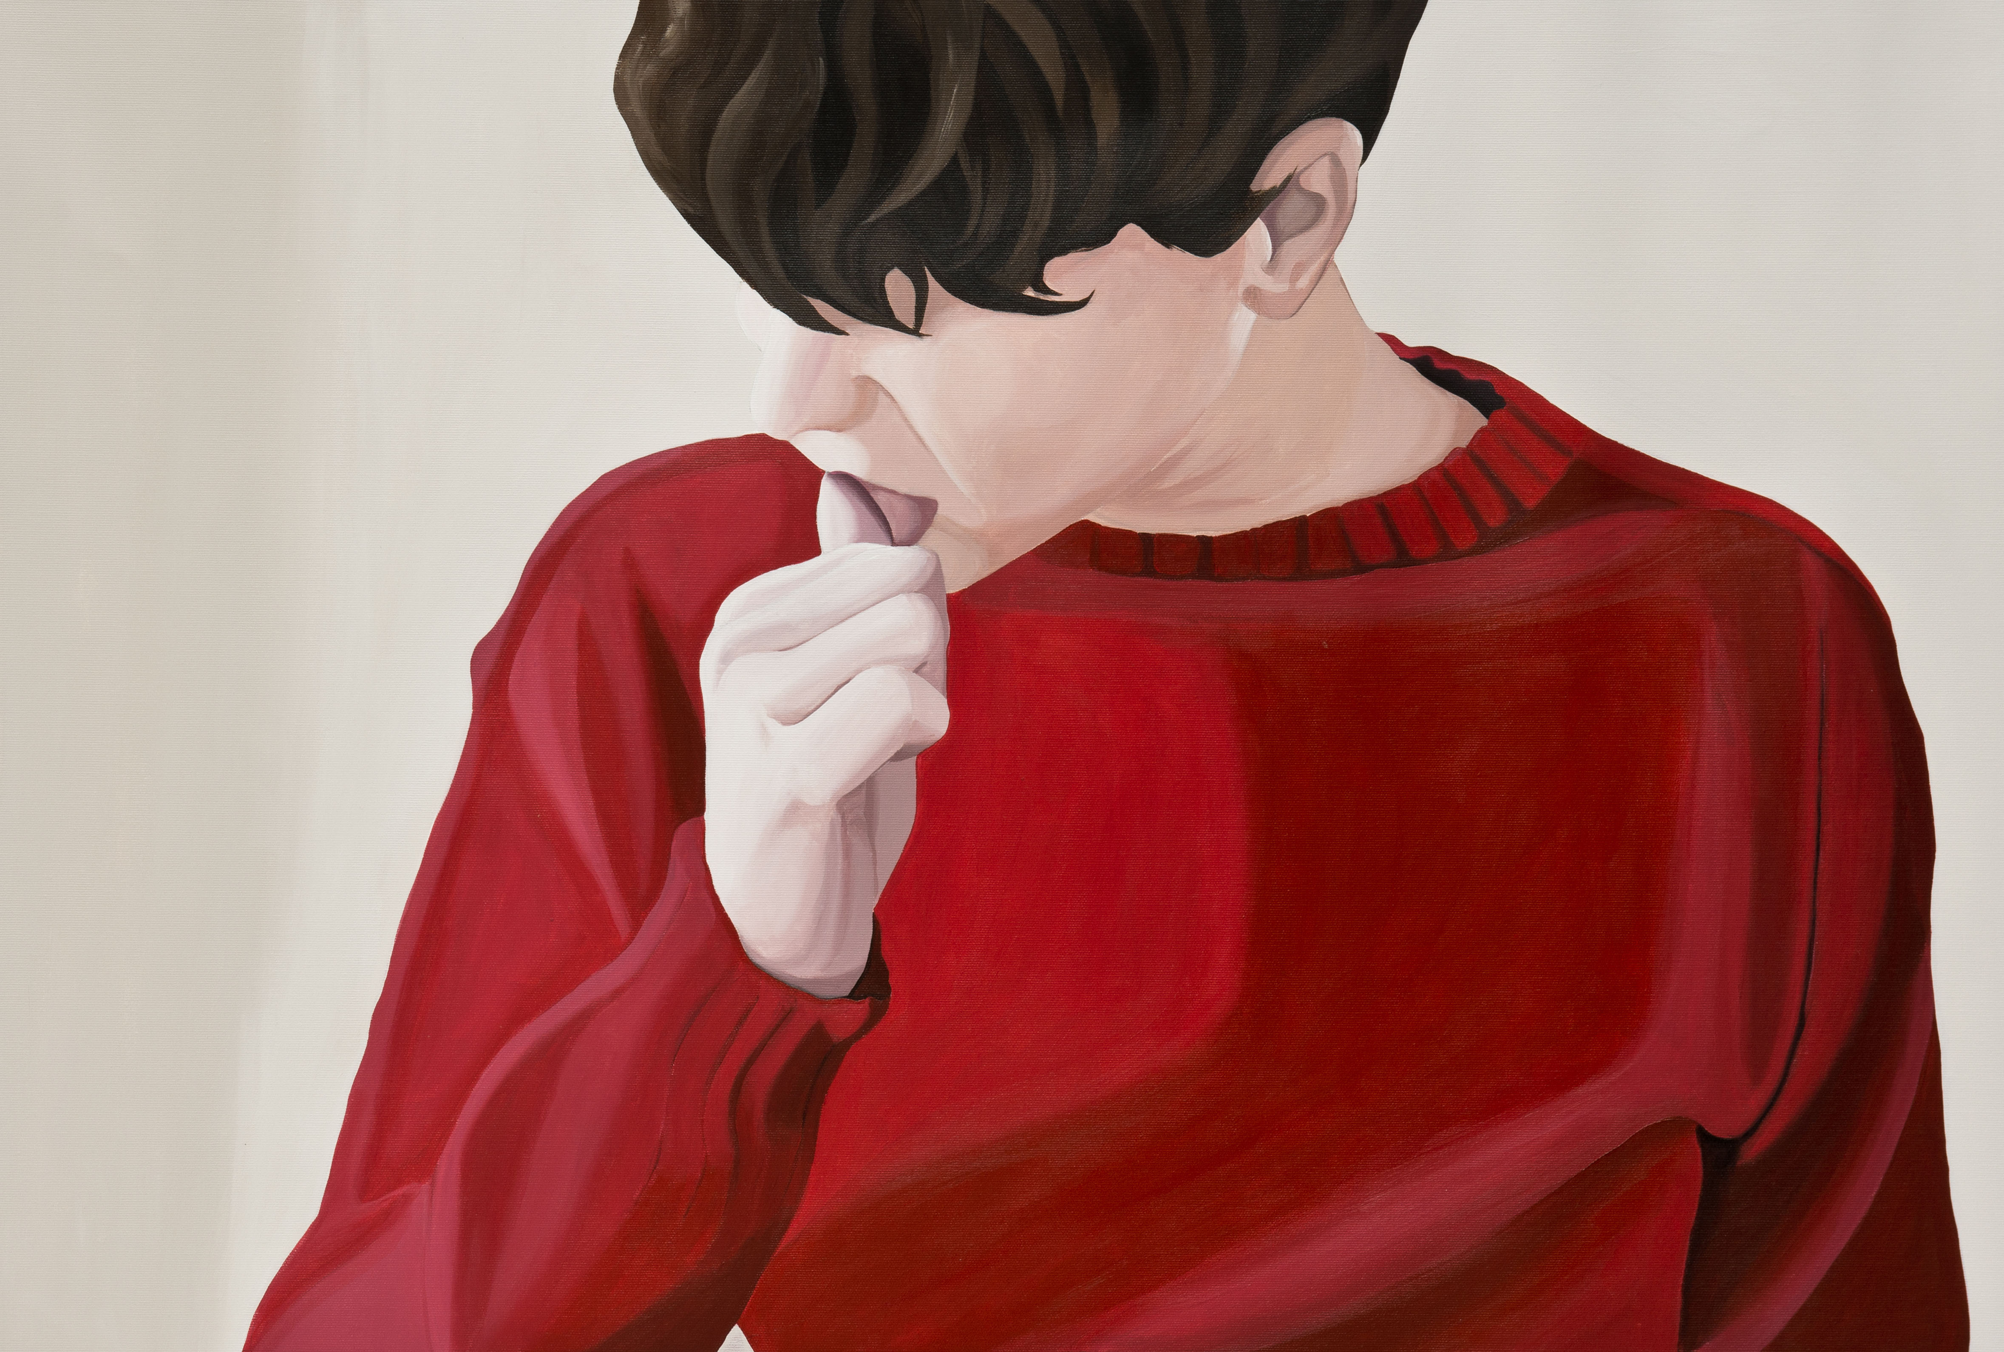

Seda Hepsev, “Outsiders, Insiders”, acrylic on canvas, 60 x 90 cm, 2014
“The impact of geographic conditions on life styles of people is a familiar issue. As I moved from a city with water passing through to a city with mountains passing through, I also began to realize the consequences of this new geographic interaction. Always coming face to face with a mountain’s silhouette, with a mountain part regardless of the point of view, the feeling of confinement despite being outdoors, is defined by some as a pleasant view but often creates a feeling of clostrophobia in me. In this society well knoen with its formalism, anything anomalous can hit one of these mountains and rebound. At this very point the mountain itself became the speaker, the ruler, the male, the dominant, the phallic. Seda Hepsev”

In the exhibition we see two separate series of canvas paintings realized in different techniques and composed of mountain images. The works, all representing moments passed indoors with a variety of individuals, spread photographic moments into the time of the painting process, to settle the accounts. In the “Passive Challenge” series, on the other hand, we encounter motifs and patterns of mountains embroided on fabric. This time the challenge is not only against time, but also an obsessive one against the very image of the mountain.

The poster to be distributed to the viewers is also part of the exhibition. As we look to the patterns, embroideries and these posters as a whole, we perceive more clearly the artist’s venture to consume the image of mountain indispensable for her life, or to define a new indoor space composed of outdoor views within the gallery.

For further information please contact to x-ist.
info@artxist.com
M. +90 545 357 60 70
T. +90 212 291 77 84

SEDA HEPSEV | Istanbul, 1978

Graduated from the sufficiency in arts program in 2013 , Hepsev had the following exhibitions at x-ist: "Intersection I" (2005), "The Null Element" (2007), "Some Wrongs Do Make a Right" (2008), "Everyone is a Kid at a Kids' Birthday Party" (2011) and "Disguise" (2013). Her drawing exhibition "A Lot of Tango" took place in IMC 5533 (Istanbul) in 2012. Hepsev participated in many international exhibitions and art fairs such as "A new hook. Rethinking Needlework" (Switzerland, 2011), "Istanbul Now" (Vienna, 2007), "Art Dulcinium" (Serbia, 2005), 11thBiennial of Young Artists of Europe and the Mediterranean (Athens, 2003), "İstanbul's Doors" (Amiens, 1999), "young expansions" (Pera Museum, 2005), Contemporary Istanbul'07, 08, 09, 10, 11, 12 & 13, Start-2009 (14th European Contemporary Art Fair, Strasbourg, France), Vienna Art Fair 2011, Art Beat 2011 (Istanbul), VIP Art Fair 2012, SCOPE Basel 2010 & 2012, ArtInternational Istanbul2014. Hepsev took place in the artist residency program at Cité Internationale des Arts (Paris) in 2011 and also exhibited her work in the group show "Dream & Reality" at The Istanbul Museum of Modern Art (2011 - 2012). Hepsev was invited as a visiting artist by OG9 Zurich Kunsthaus Aussersihl where she exhibited her project titled "Clocks". Seda Hepsev is featured in the book "Unleashed: Contemporary Art From Turkey" first published in 2010.
.

