 | Abdi İpekçi Caddesi Kaşıkçıoğlu Apt. No:42 D:2 34365 Nişantaşı İstanbul www.artxist.com  info@artxist.com  T. +90 212 291 77 84 F. +90 212 343 69 35 | PRESS RELEASE

x-ist will host Ahmet Polat’s fourth photography exhibition entitled “A Bridge Too Far” between March 3 – April 2, 2016.

AHMET POLAT I A BRIDGE TOO FAR

Continuing his work in Turkey and mainly in the Netherlands, Ahmet Polat carries on with his career by adding recent international successes while his new exhibition “A Bridge Too Far” meets its audience in Turkey.
Having made a name for himself by being the first Turkish photographer who won the “Young Photographer” award at the 22nd Infinity Awards organized by the ICP (International Center of Photography) – the most prominent photography institution in the world – and having been selected as the “Photography Ambassador of the Year” in 2015 in the Netherlands, the artist will participate in the Photo London fair with x-ist between May 19-24 after his solo exhibition at x-ist between March 3 – April 2.
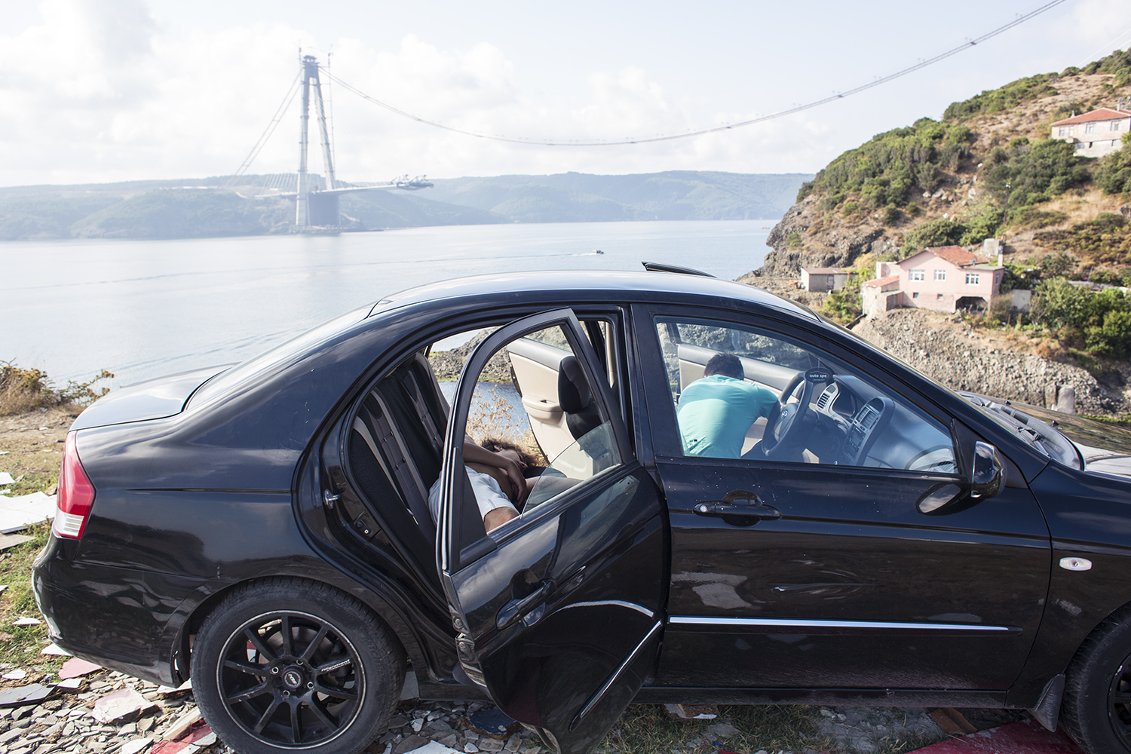
“Third Bridge, Garipce”, Istanbul, 2015.

Experiencing his multicultural identity in his works both as part of that culture and as an outsider, Ahmet Polat presents in his new exhibition his series ‘Imagine Istanbul’ which was exhibited at BOZAR Brussels within the scope of the Europalia Art Festival curated by R. Paul McMillen.

The series, which will meet the art audience in Turkey for the first time, consists of photographs analyzing this time by only focusing on Istanbul via the social dynamics of the artist, the identities and the people. Portraits, which are always at the forefront in the works of the artist who has the opportunity to analyze the representative power of photography in different cultures, have this time also the characteristics of being a record of Istanbul’s present.

AHMET POLAT I Hollanda, 1978
Ahmet Polat is a Turkish-Dutch photographer living in Istanbul & Holland. After graduating from St. Joost Academy in Breda, 2000 he started exhibiting his work in Turkey and the Netherlands. Among his solo exhibitions are, “Silence in Kayapinar” (Dorts Museum, Netherlands, 2001), “Home Is Where I Left My Dreams” (Karşı Sanat Gallery, Istanbul, 2003; Resim Heykel Museum, Ankara, Turkey), “Old Country, New Country” (Photo Museum The Hague, Netherlands, 2004), “Neither Here nor There” (Breda Photo Biennial, 2008), “Kemal's Dream” (FOAM, Amsterdam, 2010, DEPO, Istanbul, 2012).
At x-ist he had three solo shows titled “Submitted to Change” (2005), “Invitation Only” (2006), “The Other Kemal” (2014) in addition to a public space installation “Where Are You?” in 2007. Polat has received the “Young Photographer” award in the 22nd Infinity Awards given by one of the most important photography institutions of the world, ICP (International Center of Photography in New York). The artist also participated in several international group shows like “Old Country, New Country” (Stroom, The Netherlands, 2005), “Genç Açılım” (Pera Museum, Istanbul, 2005), “Fluorescent Adolescent” (7th International Biennial of Photography, Netherlands, 2010), “In what language shall I tell you my story?” (Stedelijk Schiedam, Netherlands, 2012), “Modern Turkey” (Rijksmuseum, Amsterdam, 2012), “Istanbul Modern – Bahrain” (Bahrain National Museum, Bahrain, 2013), “On the Move” (Stedelijk Amsterdam, 2014) and x-Tension (Office 4200, Bursa, 2015).
Polat also takes commercial and fashion photographs for several international magazines such as French and Turkish Vogue, Harper’s Bazaar, New York Times, Paris Match, Marie Claire, Quest and Vice. Among the art fairs Polat participated are Art-Rotterdam, Contemporary Istanbul 07, 12, 13, 14 & 15, UNSEEN Amsterdam 2012 and ArtInternational 2013 & 2014.
The book of his latest work “Kemal’s Dream” has been launched in the Unseen Photography Fair, Amsterdam in 2012. In 2013, Polat was nominated for the long list of Dutch Doc Award, the largest Dutch photography prize, with his two different projects, “Kemal’s Dream” and “Dark Moon”. In 2015, Polat has received "Ambassador of Dutch Photography" title by FOTOWEEK Festival. The photo series Polat took for the festival is presented during FOTOWEEK (FOTODOK, Netherlands, 2015). He had an exhibition entitled "Imagine Istanbul", in Palais des Baux Art in Brussels curated by R. Paul McMillen.

For detailed information please consult Gözde Ulusoy from x-ist.

gozde@artxist.com
M. 545 357 60 70
T. 212 291 77 84

