 | Abdi İpekçi Caddesi Kaşıkçıoğlu Apt. No:42 D:2 34365 Nişantaşı İstanbul www.artxist.com  info@artxist.com  T. +90 212 291 77 84 F. +90 212 343 69 35 | PRESS RELEASE

x-ist, will be at Halic Congress Center on 5-6 September 2015 at ArtInternational...

x-ist @ ArtInternational 15

Stand No: B7

x-ist will be at stand B7 with following artists that will debut at this year’s ArtInternational; Ali Elmacı, Burçin Başar and Burcu Perçin along with Ansen and Serkan Adın who attended previous years.
Burcu Perçin, who joined x-ist recently, will be at a seperate stand with her solo project.

Ansen depicts the historical facts with his unique surrealistic approach in his new works. In his work “Hang’em High”, he refers to his previous colour harmony with a Western story and deals with the status of women throughout history with a feminist perspective.
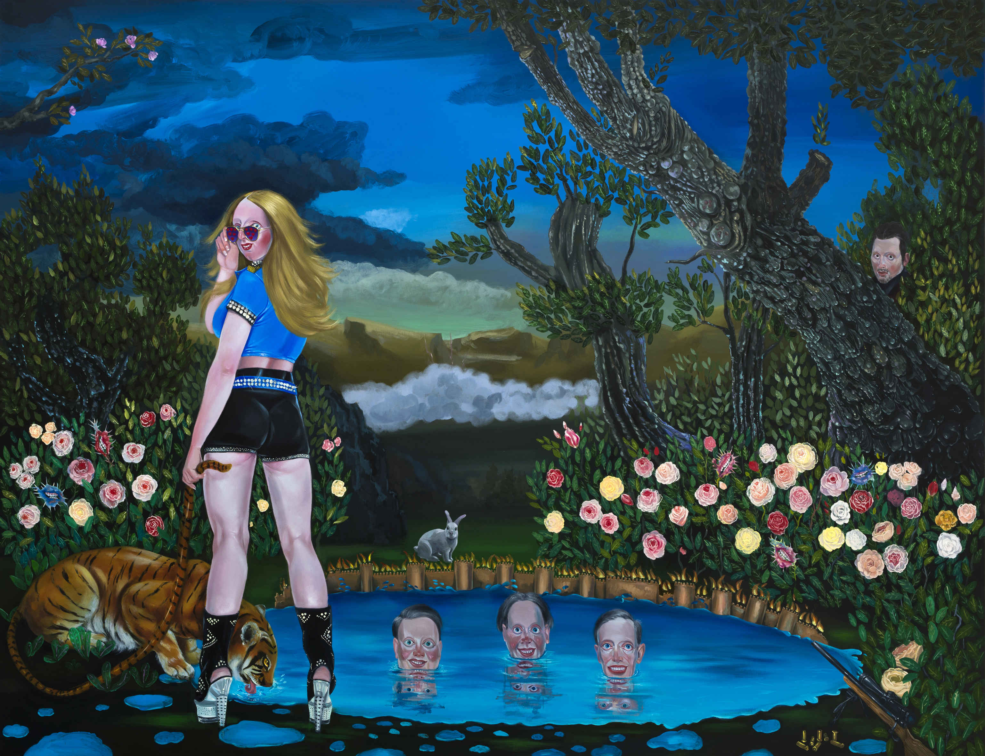
In his other work “The Master and the Conqueror; Stand a Little Out of My Sunshine”, Ansen depicts the famous dialogue between Alexander the Great and Diogenes which ends up with the infamous quote“Stand a little out of my sunshine” .
Ali Elmacı, “Shadows Rise When the Weapons are Drawn II”, 175 x 230 cm, 2015

Ali Elmacı, “Shadows Rise When the Weapons are Drawn II”, 175 x 230 cm, 2015
Ali Elmacı portrays the illusionary nature of normative public morality and bourgeois values with his unique humorous violence approach in his “Shadows Rise When the Weapons are Drawn” series that he made for ArtInternational’15. The series which consists of two canvas paintings and “My Home is the Safest Place” artwork portray authority’s war and scorn against the enemy that it created itself against itself with existential anxieties.

Burçin Başar will be at ArtInternational’15 with her “painting-sculpture” form glass works. In the series that the artist describe as “studies on the invisibility, transparency and fourth dimension of glass” , the material interferes the artwork itself and prevents the painting’s desire to breath. Also, two canvas paintings of the artist will be exhibited: “Doorstep” and “Lost Journey”.

Burcu Perçin takes place at ArtInternational with her indoor and outdoor space painting works that she reconstructed by adding human figures and plant images. While we were seeing the dilemma of human between artificial world and the natural world in her works, this time she includes the human dilemma between culture and technology. By aestheticizing social inequality and exploitation, she focuses on environment that is affected by these. She explains her production process as:

“Observing the bleakness of marble quarries in the middle of nature has provoked my curiosity to see the organic forms and encouraged me to incorporate human and plant figures into these landscapes. The contradiction between the inner spaces of mountains that was created by human-made sharp and distinct lines lightened by artificial lights parallel to the sunlight and the existence of natural plants constitutes the expressive emotion of my creation process. I am, for the first time, exhibiting these three-dimensional collage-like works that I created by cutting natural stones and marbles inspiring from my own pictorial style.”

Serkan Adın, depicts concepts like perception of opposite sex, sexual incitement and challenge. The artworks of Serkan Adın, “Slippery When Wet”, “Drink Cold” and “Black Widow”, are in the form of wall sculptures on flat surface. This time, we see Serkan Adın’s typical women figures, this time are not only torsos but as glance and face, more closely in their placeless and private moments.

For further information please contact Sırma Karasu from x-ist.
sirma@artxist.com
M. 545 357 60 70
T. 212 291 77 84

