 | Abdi İpekçi Caddesi Kaşıkçıoğlu Apt. No:42 D:2 34365 Nişantaşı İstanbul www.artxist.com  info@artxist.com  T. +90 212 291 77 84 F. +90 212 343 69 35 | PRESS RELEASE

CerModern is hosting fifth solo show by Erkut Terliksiz, “Monster Tamer” between September 11 and October 11, 2015.

ERKUT TERLİKSİZ | MONSTER TAMER

Terliksiz tells the story of uncanny and bizarre through childish and naive characters borrowed from the tales. In his cartoon-like paintings, Terliksiz takes the well-known stories of fantastic and mythological creatures and transforms them into the manifestation of the subconscious. Terliksiz, with his unique style, adjust the themes of fear and unwariness in parables and tales to modern-day human.
The name of the exhibition is named after premiering series, “Monster Tamer”, in CerModern. The works in the series depict the actual events transpired after the artist’s last solo exhibition “Hunger” with unique metaphors.
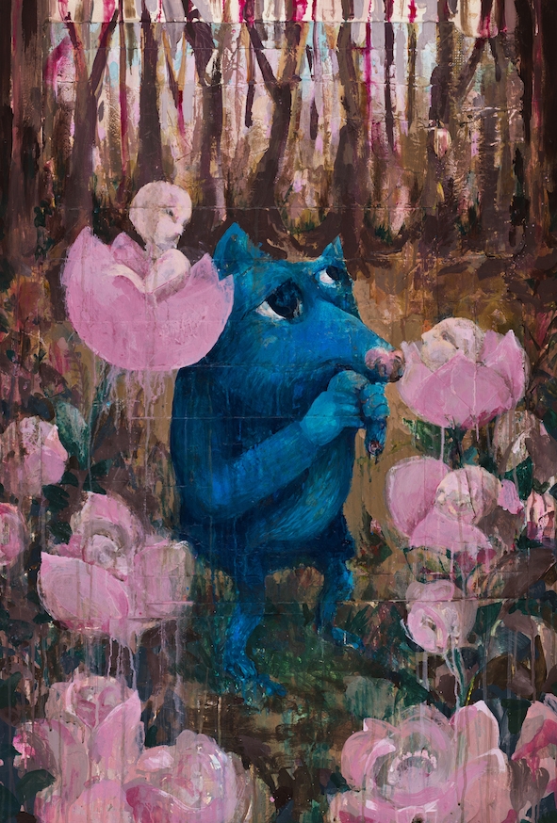
The series consists of three artworks, which depict animals whose private spaces are invaded in various ways by humans. One of the works depicts a donkey in flames whose disappointment in his putative beautiful eyes is emphasized with humanlike mimics. The fox who holds his ruptured tail in his paw is searching for its perpetrator among the powder pink flowers. The third picture of the series depicts an in flagrento delicto scene in which an anxiously awaiting panther and a human entering its terrain...

Terliksiz explains the mathematics of his metaphors referring to Neil McWilliams’s book “Art and Utopia”:
“...Metaphor is considered as a tool which both the paves the way for and precludes opportunities. It allows the imagination to multiply meaning by deciphering the codes of imagery but at the same time protects the meaning against those who are unable to comprehend the figurative language of the artist. Metaphor provokes the free leaps of imagination that is liberated from the limits of prudent rationalism but at the same time acts as a guardian by protecting the wisdom in imagination from those who can’t do such leaps.”
Erkut Terliksiz, Monster Tamer I, Mixed media on paper and wood, 120 x 80 cm, 2015

For more information please contact x-ist
Sırma Karasu
sirma@artxist.com
M. 545 357 60 70
T. 212 291 77 84

Erkut Terliksiz | Adana, 1978

Erkut Terliksiz is a Turkish designer and an artist based in Istanbul. He graduated from Mimar Sinan University, Fine Arts Faculty, Department of Graphic Design in 2002. The artist, who took place in several group exhibitions in Australia, England, Spain and Germany, exhibited his work in x-ist for the first time in the group show “Intersection I” (2005). “Debut” (2007), “Till We Meet Again” (2010), “Nothing Personal” (2012) and “Hunger” (2014) were his following solo shows at x-ist. In 2015, he also had a solo exhibition in Cermodern titled “Monster Tamer” (Ankara).
Terliksiz’s works were displayed in the group shows “Thanks for Sharing” (Leipzig, Germany, 2010), “Confessions of Dangerous Minds” (Saatchi Gallery, London, 2011), “Happy Medium” (Nancy Victor Gallery, London, 2012), “The Feeling of Happiness” (Homa Art Gallery, Tehran, 2014), “x-tension” (Office 4200, Bursa, 2015), “#GaiaOnPaper” (Gaia Gallery, Istanbul, 2015) and “Variations on An Andalusian Dog” (x-ist, 2015).
Among the international art fairs Terliksiz participated are Art Fair Cologne’06 (Germany, 2006), Contemporary Istanbul 06, 07, 09, 10, 11, 12, 13, 14 & 15, CIGE 2008- China International Gallery Exposition (Beijing, China), St-art 2009 (14th European Contemporary Art Fair, Strasbourg, France), Vienna Art Fair 2011, VIP Art Fair (2012), Art Dubai 2012, Scope Basel 2011 & 2012, and Art14 London, ArtInternational 2014 (Istanbul).
Terliksiz’s works are published in a range of magazines and books such as “in Slanted Magazine’s contemporary illustration almanac “Fresh 3” and Pictoplasma Berlin”.

