 | Abdi İpekçi Caddesi Kaşıkçıoğlu Apt. No:42 D:2 34365 Nişantaşı İstanbul www.artxist.com  info@artxist.com  T. +90 212 291 77 84 F. +90 212 343 69 35 | PRESS RELEASE

x-ist participates with Emin Mete Erdoğan and Murat Palta for the fourth time in Art Dubai, one of the most important contemporary art fairs of Middle East, North Africa and South Asia, held between March 16-19.

ART DUBAI’16
EMİN METE ERDOĞAN I MURAT PALTA

x-ist participates in Art Dubai, one of the important fairs in which it takes part as part of its mission to represent young artists in the international art environment, with Emin Mete Erdoğan and Murat Palta this year.

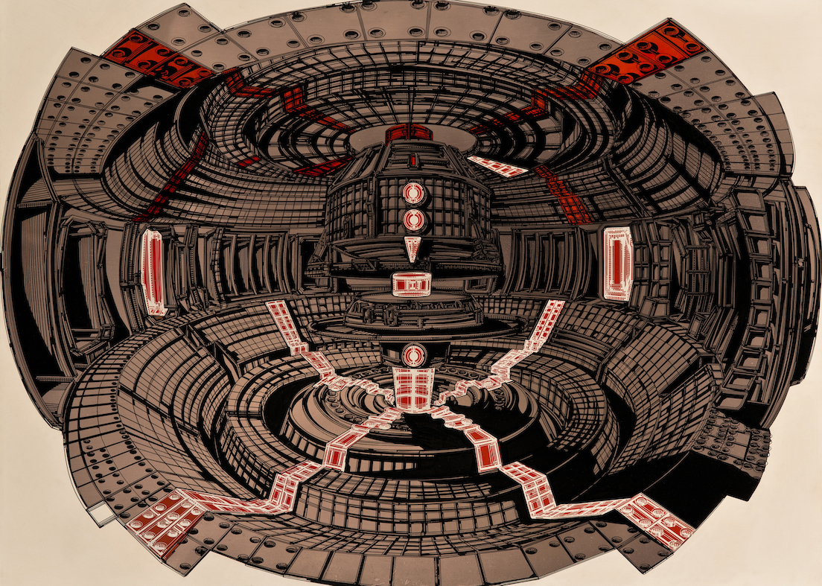
Emin Mete Erdoğan, ‘Entroforming under the Dome 7’, ink and acrylic pen on copper plate,
70 x 100 cm, 2015.

While in 2015, 92 galleries from 40 countries participated in Art Dubai – the most important contemporary art fair of Middle East, North Africa and South Asia – more than 500 artists are represented with the participation of 94 galleries from 40 countries this year. Among these are also x-ist, participating for the fourth time, and its young artists Emin Mete Erdoğan and Murat Palta from Turkey. The artists, whose works are going to be exhibited in Dubai for the first time, will meet the art audience with the works that they specially created for the fair.
Emin Mete Erdoğan, who by combining classic and technical painting creates a dystopian vision of future where organic and inorganic forms meet, and Murat Palta, who brings together tradition and the present day by reviving scenes from cult movies and literary works through miniatures, surprise the art audience first with their techniques. Murat Palta, who besides his digital works will take part in the fair with his carpet works to be exhibited for the first time, presents to the audience the traditional and the modern in a new form. Evoking admiration with their elaborateness in which they share a common ground, these two young artists differ from each other completely with contrasts such as past-future, illustration-classic painting.

You can visit x-ist and its artists at the booth C5 in Art Dubai fair to be held between March 16-19.

EMİN METE ERDOĞAN I İstanbul, 1982
The artist graduated from Marmara University, Faculty of Fine Arts, Painting Department. In 2013, he opened his first solo show titled “Entangled Cern Plans” in Sanatorium (Istanbul). In 2015 his second solo show, “Entroforming”, opened at x-ist. Erdoğan’s works took part in several group exhibitions including “No 3” (Nesrin Esirtgen Collection, Istanbul, 2014), “The Break” (Kare Sanat, Istanbul, 2014) and “Variations on An Andalusian Dog” (x-ist, 2015). The artist participated in Miami Pulse 2013, Art Stage Singapore 2016, Contemporary Istanbul 13, 14 & 15 and ArtInternational İstanbul 2014 (Istanbul).

MURAT PALTA I Hatay, 1990

After graduating from Graphic and Design department of Dumlupınar University in 2012, he started to work in various advertisement agency in Istanbul. In 2013, he attended Miniature and Illumination Art workshop in Tlemcen (Algeria), and participated in different international art festivals such as Nour Festival of Arts in London and Cinephiliac: Art Transcending Technology & Motion, in Philedelphia. Palta had his first solo exhibition titled “Murat Palta: Cult Hollywood movies as Ottoman miniatures” in City Museum of Bagnacavallo (Bagnacavallo, Italy) in 2014. His second show, “Depictions of White Screen” (2015) opened at x-ist. In 2015, Palta's works took place in a group show titled "Kitsch ou pas kitsch" in ICI (Institut des Cultures d'Islam, Paris, France) and in a solo show in Savina Gallery (St. Petersburg, Russia).
He also participated in the group shows titled “x-tension” (Office 4200, Bursa, 2015) and “Variations on An Andalusian Dog” (x-ist, 2015).
He illustrates for magazines and newspapers such as JR. by Campaign.

For more detailed information you can consult Gözde Ulusoy from x-ist.

gozde@artxist.com
M. 545 357 60 70
T. 212 291 77 84

