 | Kemankeş Karamustafa Paşa Mah.,  Mumhane Cad., No:50, K:2,  34425, Beyoğlu, İstanbul  www.artxist.com, info@artxist.com  T. +90 212 291 77 84 F. +90 212 343 69 35 | PRESS RELEASE

x-ist participates in the Contemporary Istanbul Fair, which is going to be held between September 20-23 for the 13th time, with Ali Bilge Akkaya, Ansen, Burçin Başar, Cem Dinlenmiş, Erkut Terliksiz, Hüseyin Arıcı, Murat Palta, Tayfun Gülnar, as well as with Emin Mete Erdoğan in the special project space, with Aylin Zaptçıoğlu who joined the gallery this year, and with Serkan Yüksel who will be represented by the gallery.

x-ist @ CI’18
Booth I Stand No: A1-122
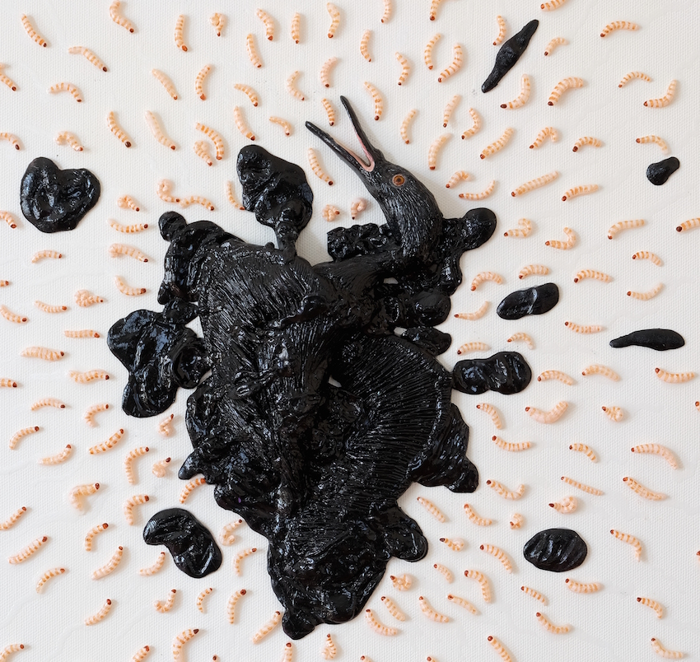

Hüseyin Arıcı, “You Are A Killer Of The Most Beautiful Emotions, Too” (Detail), Oil painting on modelling clay, 60x70 cm, 2018

x-ist participates in Contemporary Istanbul to be held between September 20- 23 at Lütfi Kırdar Convention and Exhibition Center this year with its 11 artists. x-ist meets the audience every year on the same spot at the Booth No. A1-122 with a special selection including artworks prepared to be exhibited at the fair and this year Emin Mete Erdoğan’s works will be featured in the solo project space to be included in the gallery’s main booth.
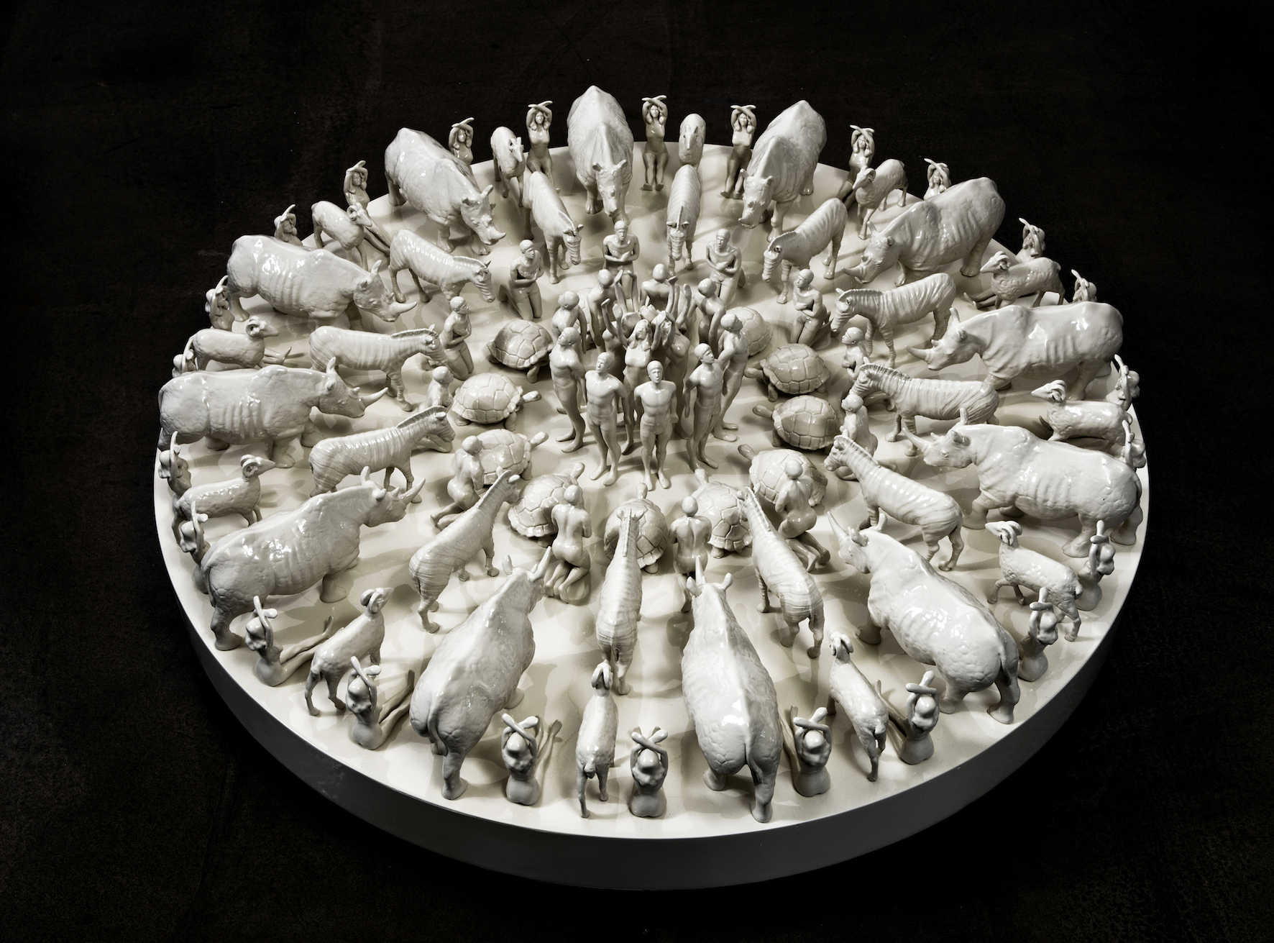
Emin Mete Erdoğan, 'Beautiful Sadness II', Acrylic on polyester, Ø90, h30 cm, 2018

As a continuation of his third solo exhibition “The Flood”, Emin Mete Erdoğan presents his works with alternative answers that he prepared for the question “What kind of a landscape would we encounter if the Great Flood happened today?”, and exhibits a comprehensive selection consisting of works on canvas, acrylic works on paper and works of ink as well as of polyester cast sculptures and reliefs. Constructing alternative landscapes concerning man’s fallacy of being in the center of the universe and ruling over all the living beings, Emin Mete Erdoğan creates a record of today’s world with his reliefs referring to Sumerian tablets and featuring forms, which represent reason, and animal figures, which are impossible to come side by side.

Consisting of works by Ali Bilge Akkaya, who traces perfection in his photographs; by Ansen, who presents his scenes on contemporary matters this time from a different frame; by Burçin Başar, who conveys the created chaos on metal and canvas surfaces while searching for a new order; by Cem Dinlenmiş, who studies the aesthetic codes of his own childhood by means of public places; by Hüseyin Arıcı, who distorts the perception of reality; by Murat Palta, who blends in his illustrations the form of classical miniature with cult literature and cinema; by Seda Hepsev, whose drawings will be exhibited for the first time; by Tayfun Gülnar, who creates depictions of a new chaotic world; and by Aylin Zaptçıoğlu and Serkan Yüksel, who will be represented by x-ist in the new season, the special selection can be visited at x-ist’s Booth No. A1-122 at Contemporary Istanbul.

Please consult Gözde Ulusoy from x-ist for more detailed information.

gozde@artxist.com
M. 545 357 60 70
T. 212 291 77 84

