 | Abdi İpekçi Caddesi Kaşıkçıoğlu Apt. No:42 D:2 34365 Nişantaşı İstanbul www.artxist.com  info@artxist.com  T. +90 212 291 77 84 F. +90 212 343 69 35 | Press Release

x-ist hosts Emin Mete Erdoğan’s solo exhibition titled “Entroforming” between
October 15 – November 14

Emin Mete Erdoğan | Entroforming

Emin Mete Erdoğan whose contemporary works combine classical painting and technical drawing has been focusing on the void, the space and their relationship. He produced works on paper, canvas or aluminum composed of intertwined nets departing from the sketches of ambiguous spaces and both building and machine-like hybrid structures. On the other hand in “Entroforming”, his first solo exhibition at x-ist, he addresses the creation story of a new world by combining the organic and the inorganic.

In the series titled “Entroforming” that he translates as “giving form to order”, the artist creates indoor and outdoor spaces in which machine and plant forms intertwine in fine detail and cover the entirety of surfaces. In scenes detached from their contexts but reminiscent of this world, both the plants and the machinery lose their identity as if evolving, with the impact of an outside force or a superior form of intelligence, into a world which today’s human being cannot belong to.

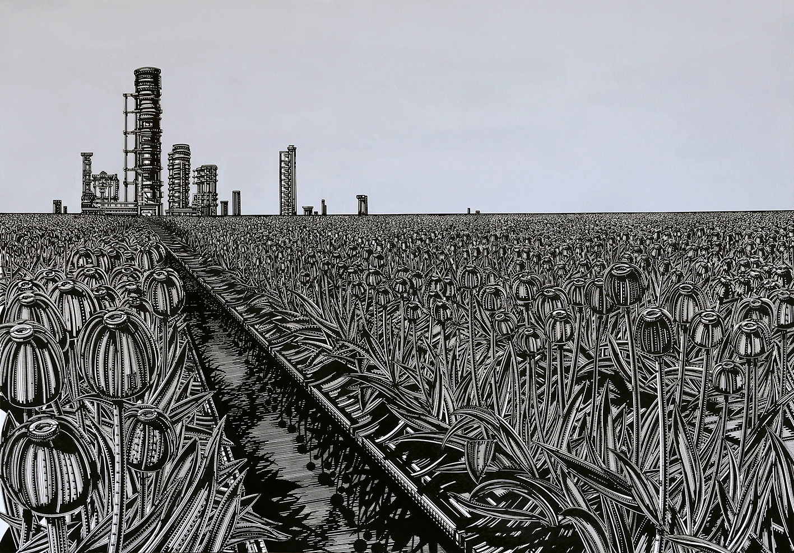

Emin Mete Erdoğan, “Entroforming upon a Globe 2”, acrylic ink and acrylic pen on paper, 70 x 100 cm, 2015
Emin Mete Erdoğan who closely monitors scientific and technological developments and consequently positions his fictional world in a place not too far from the real one, describes the scenes in “Entroforming” as:
“At this point plants are transformed into plant-like and the machinery into machine-like, and they appear intertwined as the components of order in a pool of information. They become information encoded pixel by pixel in the details of this imagery. In this newly established world I expose the relationships that enable pure information flow and transformation. As if they all united for a secret and great purpose…”
“Entroforming” will be on until November 14.

For more information please contact x-ist
info@artxist.com
M. 545 357 60 70
T. 212 291 77 84

EMIN METE ERDOGAN | ISTANBUL, 1982

The artist graduated from Marmara University, Faculty of Fine Arts, Painting Department. In 2013, he opened his first solo show titled “Entangled Cern Plans” in Sanatorium (Istanbul). In 2015 his second solo show, “Entroforming”, opened at x-ist. Erdoğan’s works took part in several group exhibitions including “No 3” (Nesrin Esirtgen Collection, Istanbul, 2014), “The Break” (Kare Sanat, Istanbul, 2014) and “Variations on An Andalusian Dog” (x-ist, 2015). The artist participated in Miami Pulse 2013, Contemporary Istanbul 13, 14 & 15 and ArtInternational İstanbul 2014 (Istanbul).

