 | Kemankeş Karamustafa Paşa Mah.,  Mumhane Cad., No:50, K:2,  34425, Beyoğlu, İstanbul  www.artxist.com, info@artxist.com | PRESS RELEASE

x-ist will host Hüseyin Arıcı’s second solo exhibition entitled “Beauties of Civilization Fought for Beauty” between December 20, 2018 – January 19, 2019 at its new address at Karaköy Juma.

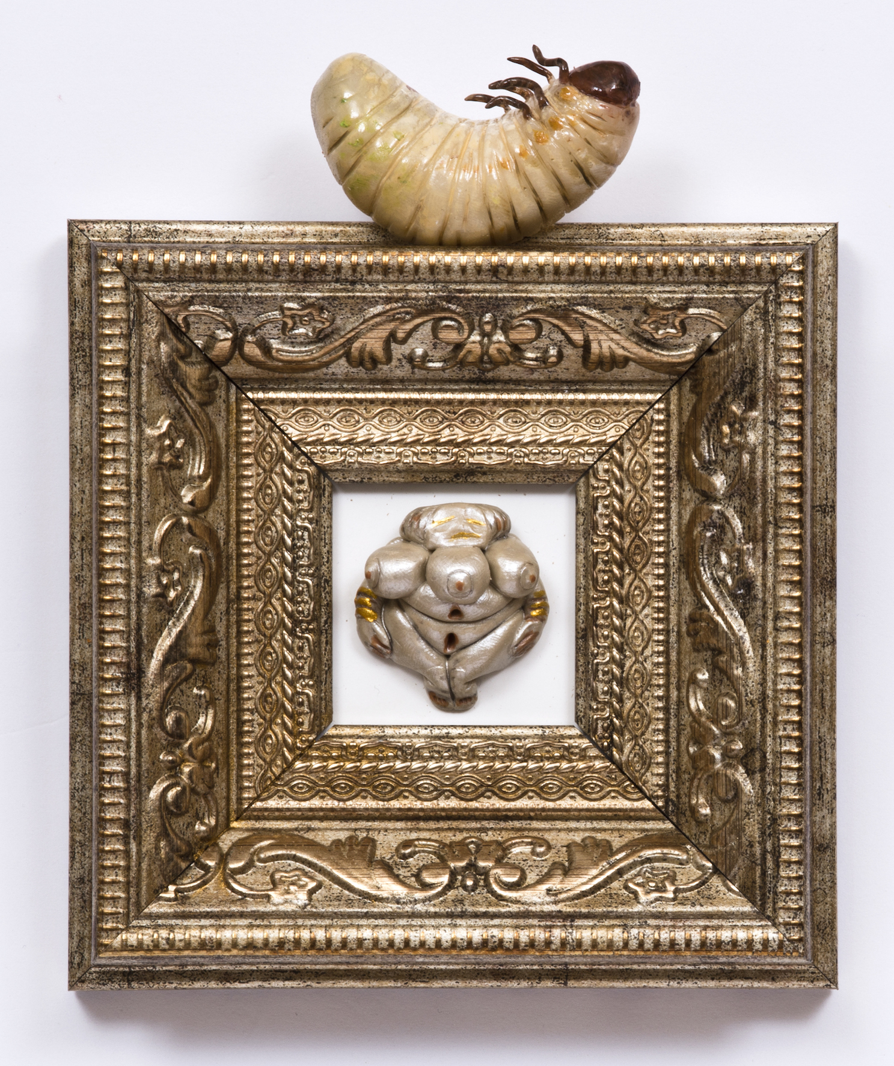
‘Women Figurines IV’, Oil painting on modelling clay, acrylic, frame, 16 x 12 cm, 2018

Hüseyin Arıcı is an artist who obscures the boundaries between reality and illusion and leads the audience to questioning their beliefs within a framework stretching from personal tendencies to social instructions. He will meet the audience with his second solo exhibition entitled “Beauties of Civilization Fought for Beauty” to be held at x-ist.
Having set up his first solo exhibition ‘Don’t Be Deceived!’ in three different series, the artist has prepared paintings, sculptures and installations for this exhibition by only focusing on his series ‘Spineless’. He starts to tell about the starting point of the exhibition with these words: “The pieces in the series ‘Spineless’ are each little monuments of our shames. These monuments are fed by human fragments of immense societies. The spineless creatures that make us cripple are the characteristics of our disturbing sides. And these characteristics are fed by tyranny, exploitation, class distinction, arrogance and greed. In short, these little monuments are not after honouring our honesty but the darkness of our heart.”

The young artist will also present to the audience his eponymous poem as part of the exhibition entitled “Beauties of Civilization Fought for Beauty” which can be visited between December 20, 2018 – January 19, 2019 at x-ist.
For more detailed information, please consult Gözde Ulusoy from x-ist.

gozde@artxist.com
M. 545 357 60 70
T. 212 291 77 84

