 | Kemankeş Karamustafa Paşa Mah.,  Mumhane Cad., No:50, K:2,  34425, Beyoğlu, İstanbul  www.artxist.com, info@artxist.com | PRESS RELEASE

Aydın Berk Bilgin’s first solo exhibition at x-ist, “Day’s Imprint”, meets the audience between January 23 - February 22, 2020.

AYDIN BERK BİLGİN
DAY’S IMPRINT

“Day’s Imprint,” the first solo exhibition at x-ist by photography artist Aydın Berk Bilgin, who focuses on the concept of time in his works. The exhibition presents the audience with the results of the artist’s art project of seven years. Placing the pin hole cameras he made from ordinary tin cans in public places and setting their exposure to days, months, and years, Bilgin utilizes these images to visualize the concept of time which drags him along.

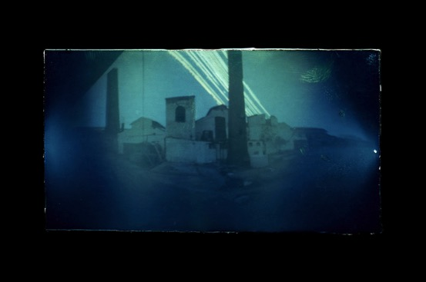
“Day’s Imprint 2”, Photography, fine art print, 3 ed. + 1 AP, 20x30 cm, 2012

Since photographs essentially freeze time, they are regarded as documents. Experimental photography breaks this strictness. It enables interference with the composition and the process of creating the image. It makes a structural and content-wise contribution to the expression beyond a mere stance. In Aydın Berk Bilgin’s works, photographic image overcomes the limits of being a surface touched by light, includes the traces of the tangible world and goes beyond the surface record. An extremely simple principle suddenly opens up a surreal world for the audience.

“The concept of time has always been problematic for me. While I can analyze and overcome many situations/events in daily life, I cannot seem to be adequate for time. Most of my works are based on time and daily events,” the artist says as he chases the physical traces of time in his first solo exhibition.

Named after the final result of the artist’s technique and how the sun leaves its traces by the number of days passed, “Day’s Imprint” can be visited at x-ist between January 23 - February 22, 2020.

Please consult Gamze Kantarcıoğlu from x-ist for more detailed information.
gamze@artxist.com
M. 0 536 255 95 12
T. 0 212 291 77 84

