 | Abdi İpekçi Caddesi Kaşıkçıoğlu Apt. No:42 D:2 34365 Nişantaşı İstanbul www.artxist.com  info@artxist.com  T. +90 212 291 77 84 F. +90 212 343 69 35 | PRESS RELEASE

Erkut Terliksiz’s fifth solo exhibition "The Transience of Life” is to be held at x-ist between September 22 – October 22, 2016.

ERKUT TERLİKSİZ I THE TRANSIENCE OF LIFE
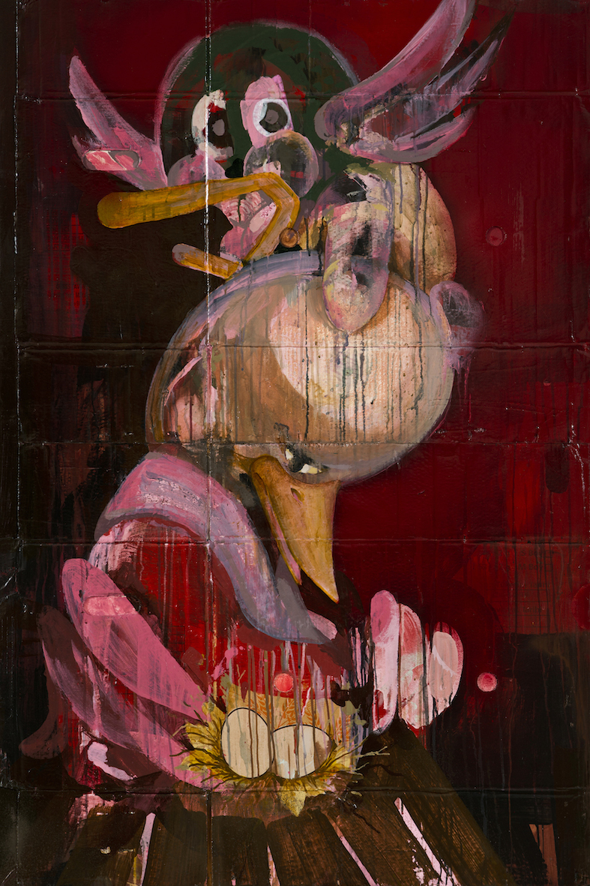
Erkut Terliksiz’s fifth solo exhibition "The Transience of Life" to be held at x-ist encourages the audience to search for the surreal both through his use of material and its beneficial defects as well as intertwined forms through his instinctive pictorialness.
“Eggs (Because We Need the Eggs)”, mixed technique on canvas and paper, 138,5 X 92,5 cm, 2016

The amorphous human and animal forms in Erkut Terliksiz’s paintings which at first make you think that you are face to face with a sympathetic expression open the door of a wilder and more frightening world which evokes different feelings and drives when examined. Through found materials and the working process allowing their accidental results on alternative surfaces, the artist actually makes the audience part of the story that he started out in order to see different things and partly go beyond reason. In his paintings in which a simplification is noticed compared to his past works, one feels the contrast between the background and the figures at first glance.
“There are confusing and even some destructive issues regarding my painting. The point in question is that a weird story much more beyond than what you think you saw confronts you. It is quite important how the figures look like at first glance, how they evolve in time and what they turn into by fragmentizing and merging again, and that in the end this process leaves an impression that arouses interest, makes the audience question what they saw and even touches the stories remained hidden in their mind… The change that this impression creates in the audience’s feelings in the same way evolves according to what they see at first, what they find and what they lose.” – Erkut Terliksiz

Erkut Terliksiz’s solo exhibition "The Transience of Life” can be visited at x-ist between September 22 – October 22, 2016.

