 | Kemankeş Karamustafa Paşa Mah.,  Mumhane Cad., No:50, K:2,  34425, Beyoğlu, İstanbul  www.artxist.com, info@artxist.com | PRESS RELEASE

BURÇİN BAŞAR
CORPUS

Burçin Başar’s third solo exhibition entitled “Corpus” will meet the audience between April 4 – May 4 at x-ist’s new address Karaköy Juma.

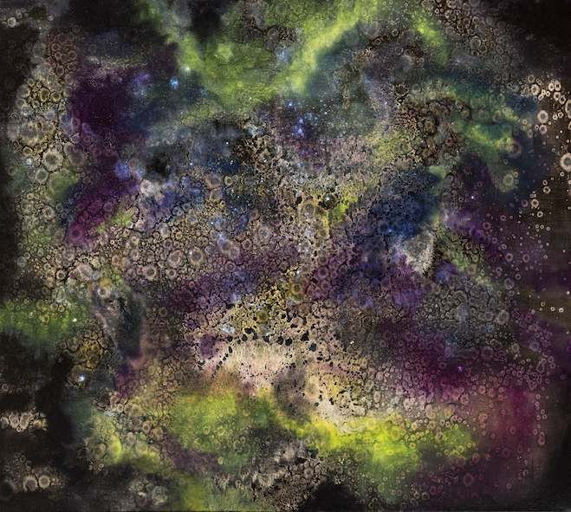
Untitled II, Oil painting on canvas, 90 x 80 cm, 2019

“While we are trying to work out the emotional violence that we go through, we are making the effort to constantly repair, clear, renew and fix our brain. While doing this we reach the whole, we shrink again and within these tides we question a world that is purified from the things that might be acknowledged as our personal or singular control. We shrink and we enlarge; we look with the eye of a microscope and then from the top of the heap… We live in a cell and then we become the cosmos. In this sense, “Corpus” should be considered as a somewhat ironic title.”

-Burçin Başar

In her third solo exhibition, Burçin Başar presents to the audience different forms of expression by means of sculptures and videos besides paintings as a part of the whole. While being defined in different ways, the word Corpus refers to the integrity of setting up the exhibition by considering it as a single work. When Corpus is used in the sense of body, organ, the entirety of the structure and the complete works, the young artist actually addresses the state of becoming a whole in the background of all works from the most fundamental perspective. The way of thinking questioned in all works is removed from a human or animal existence, broken up to pieces and then encoded again. Reducing this to being more of a human being, an animal or a point of the universe, Başar objectifies the thought while abstracting the body.

With its questioning extending to the most fundamental particles constituting the whole, Burçin Başar’s third solo exhibition “Corpus” can be seen between April 4 – May 4, 2019 at x-ist’s new address Karaköy Juma.

For more detailed information, you can consult Gözde Ulusoy from x-ist.

gozde@artxist.com
M. 545 357 60 70
T. 212 291 77 84

