 | Abdi İpekçi Caddesi Kaşıkçıoğlu Apt. No:42 D:2 34365 Nişantaşı İstanbul www.artxist.com  info@artxist.com  T. +90 212 291 77 84 F. +90 212 343 69 35 | PRESS RELEASE

Engin Konuklu’s second solo exhibition entitled “Home” is to be held between October 27 – November 26, 2016 at x-ist.

ENGİN KONUKLU I HOME
Engin Konuklu, whose first solo exhibition “Éternité” was held in 2014 at x-ist, will hold his second solo exhibition between October 27 – November 26, 2016 and this time focus on past memories and on “Home”, the concept which brings to mind these memories most intensely.
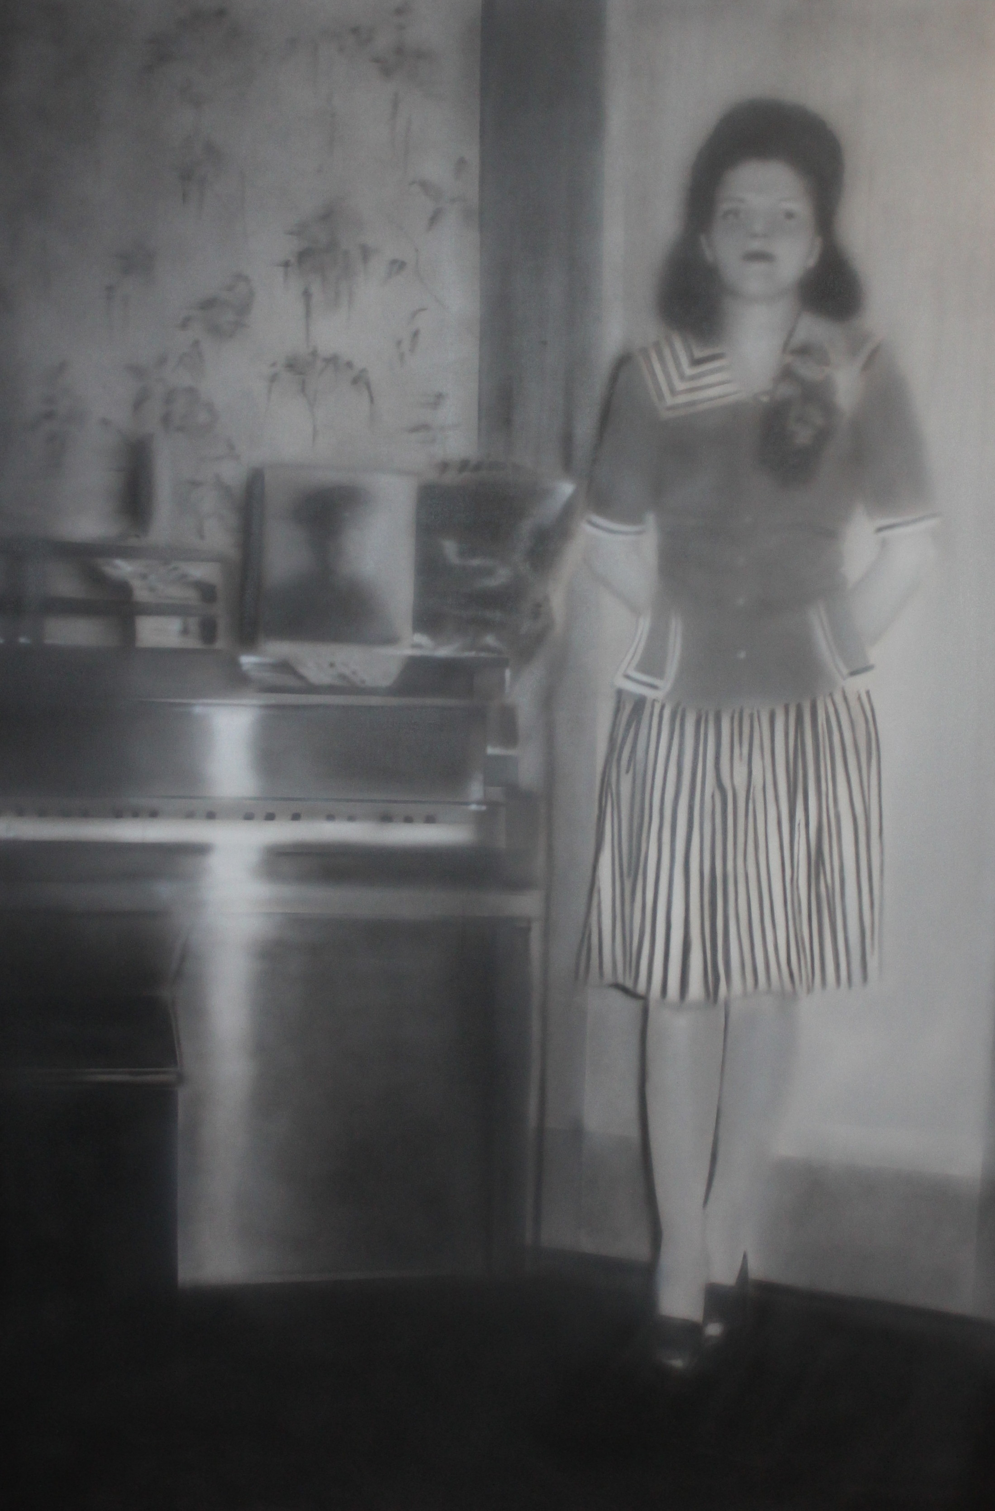
Erkut Terliksiz, “Room”, acrylic on canvas, 200 x 135 cm, 2016 .

Questioning the subjective search for nostalgia pursuing the beauties caught only in photography shots by people who, by saying that nothing is like before, actually long for a time in which they are not living, the artist emphasizes that reality, and even nostalgia, might never be like in that photographs indeed.
Nostalgia, which was considered as a disease in the 17th century, defines the state when in all those years of wars, genocides and epidemics, people’s yearning for home reached an intolerable extent and a fatal melancholy engulfed them.
The young artist, who transposes frames from photography shots to canvas by using airbrush, displays his talent in technique in his recent works as well.
Engin Konuklu’s solo exhibition entitled “Home” can be seen between October 27 – November 26, 2016 at x-ist.
ENGİN KONUKLU I ADANA, 1990

After graduating from Dokuz Eylül University Fine Arts Faculty Painting Department in 2011, Konuklu continues his masters degree in the same department. The artist opened his first solo show “Undefined” at the American Hospital Art Gallery “Operation Room” in 2011. Konuklu’s first solo show at x-ist, “Éternité”, opened in 2014.

Among the other exhibitions Konuklu attended are “30th Contemporary Artists Istanbul Exhibition” (Akbank Art Gallery, Istanbul, 2011), “Situations Possibilities” (Izmir, 2011), “Look Inside II” (Izmir, 2011), “Painting and Sculpture Museums Association, 30th Anniversary Exhibition” (Istanbul, 2011), “x-tension” (Office 4200, Bursa, 2015), “Variations on An Andalusian Dog” (x-ist, 2015) and Contemporary Istanbul’13, 14 & 15.

For more detailed information you can consult Gözde Ulusoy from x-ist.

gozde@artxist.com
M. 545 357 60 70
T. 212 291 77 84

