 | Abdi İpekçi Caddesi Kaşıkçıoğlu Apt. No:42 D:2 34365 Nişantaşı İstanbul www.artxist.com  info@artxist.com  T. +90 212 291 77 84 F. +90 212 343 69 35 | PRESS RELEASE

Ansen’s 8th solo exhibition at x-ist entitled “Tyrant’s Reign and Titan’s Slain” can be visited between March 22 – April 15, 2017.

ANSEN
TYRANT’S REIGN AND TITAN’S SLAIN

With his last solo exhibition “Tyrant’s Reign and Titan’s Slain”,
Ansen adds a new episode to his past series.

In the context of a period passing from these ‘demigods’ - who have been identified with different concepts and existed with phenomena such as justice, order, memory, reminiscence, and even war and peace, but whose short-lived reigns have been pulverized by Gods - to “Tyrants”, new demigods of our age’s world order, we witness Ansen once again looking at human and power relations that he has examined before.

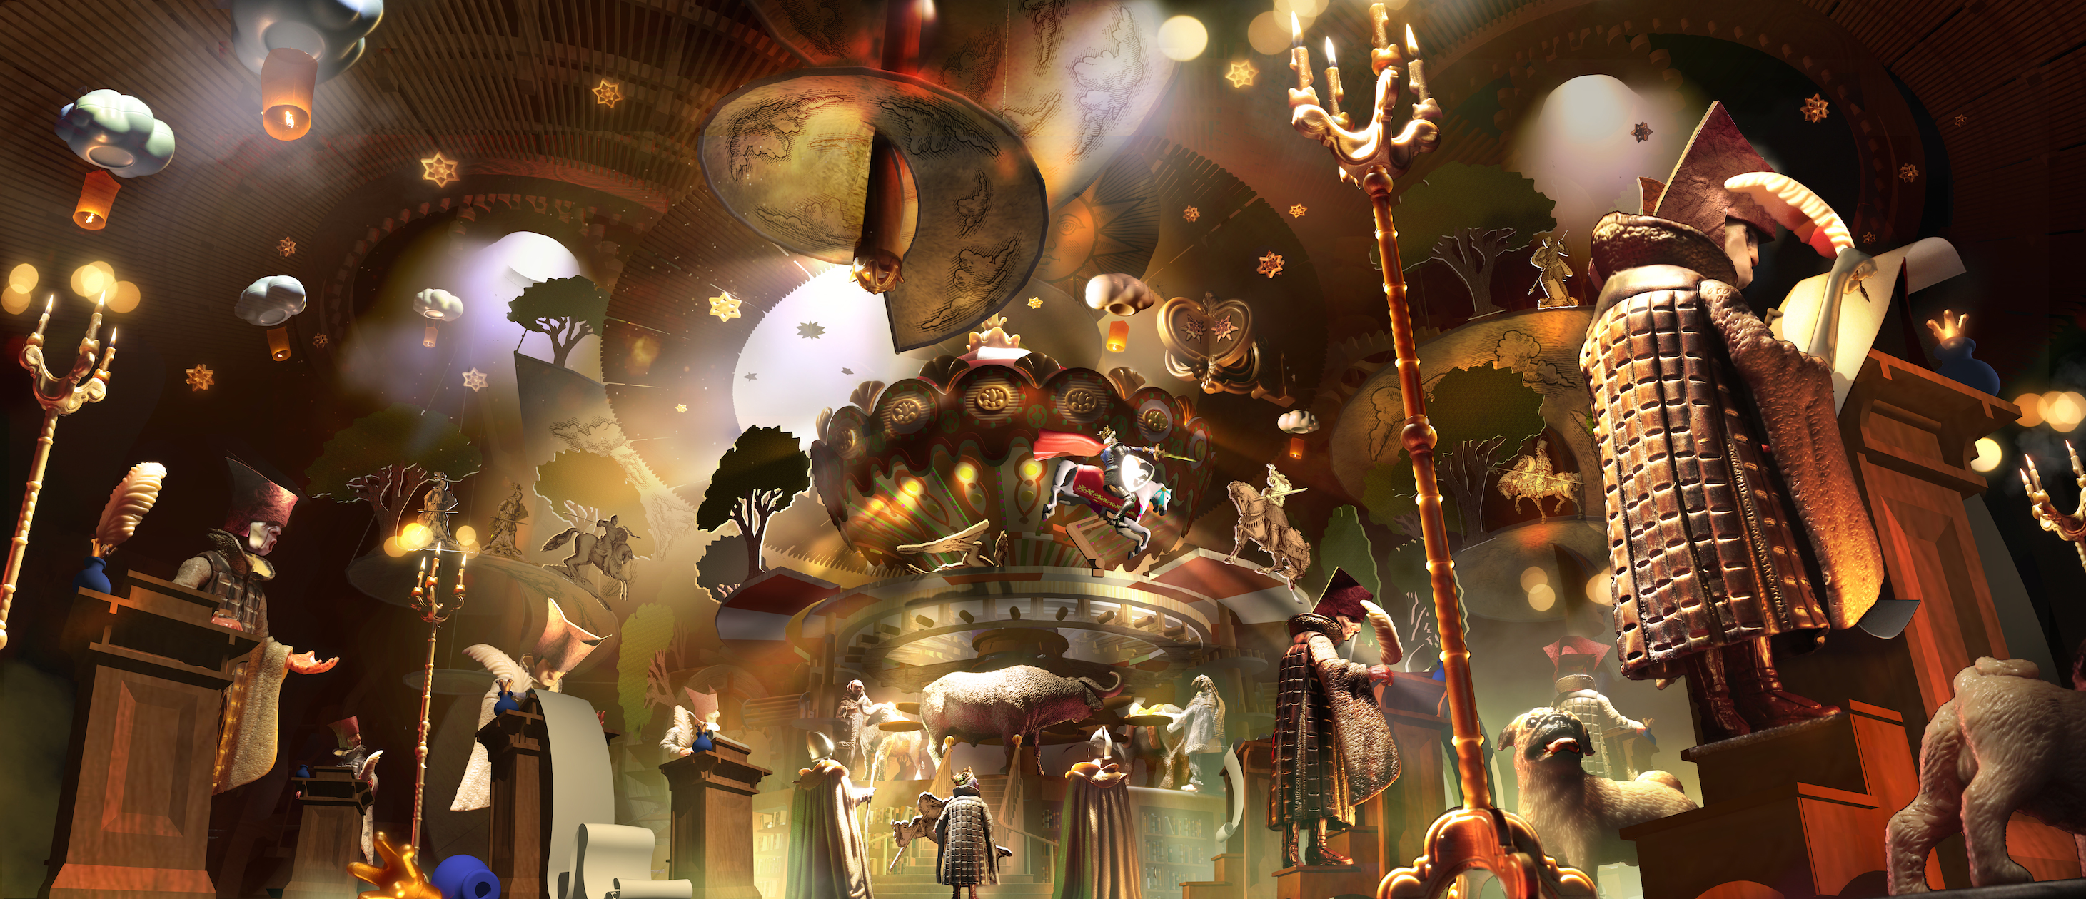
Ansen, “The False Kingdom” (Modified History), 95cmx 220cm, 2017

In this way, as a result of a partly mythical and mostly contemporary interpretation of an era, shortly, of a new world order, in which Titans, who - unlike the arbitrary rulings of Gods, approach human beings with the reality of mortality, take sides with them and revolt - are also brought to their knees by their allies, human beings, the series “Tyrant’s Reign and Titan’s Slain” emerges.

Today, mortals who now themselves play God sit on the throne of the new order. In comparison to the black and white universe of Noirland, Ansen’s previous series - which pertains to the satirical but dark world of a vague future having, however, a predictable end, in which societies are ruled arbitrarily and by mere worship of power - a more colourful palette is presented to the audience.

In our time when our age’s new global actors and balances of power constantly change and the past’s deep and tainted traces are followed almost as a route, Ansen brings together in this exhibition the ancient era of Tyrants and the wrath that Titans fell victim to through mankind’s betrayal by converting them into a story based on new alliances in the calm before the storm, metaphoric mechanisms symbolizing the system, kings, presidents, and unstable balances, and by processing them in an interwoven way.

You can visit the exhibition entitled “Tyrant’s Reign and Titan’s Slain” between March 16 – April 15, 2017 at x-ist.

For more detailed information you can consult Gözde Ulusoy from x-ist.

gozde@artxist.com
M. 545 357 60 70
T. 212 291 77 84

