 | Abdi İpekçi Caddesi Kaşıkçıoğlu Apt. No:46 D:2 34365 Nişantaşı İstanbul  www.artxist.com  info@artxist.com  T. +90 212 291 77 84 F. +90 212 343 69 35 | PRESS RELEASE

3rd solo exhibition of Ekin Saçlıoğlu at x-ist
CAT NAP
Between 19th of March and 11th of April, Ekin Saçlıoğlu will be opening her 3rd exhibit at x-ist, following her exhibitions From a Little Closer (2005) and Narrative Memory (2007).

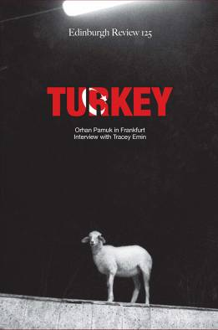

We become partners in crime with Ekin Saçlıoğlu, in this, her open-ended journey; consisting of a series of paintings which contain free-associative symbols that emerges naturally and are worked up with less narration, unlike her previous exhibition.

This journey that enables diverse interpretations on the viewers behalf, transforms into a different character with flexible transitions between dual notions like dream-reality, fiction-reality and playful double meaning triggered by symbols.

Similar function of symbols that Saçlıoğlu uses for the visualization of her personal experiences, is that they render possible various readings which sprouts from viewers very own experiences. In this respect, a voluntary partnership between the artist and the viewer is established.

Saçlıoğlu keeps maintaining her endeavor of revealing the things beyond the visible in “Cat Nap” with her phosphorous painting, just like she did in her previous exhibition “Narrative Memory” and she leaves the viewer with the question: “Where does the visible ends and where does it starts?”

Ekin Saçlıoğlu:
Ekin Saçlıoğlu was born in İzmir, 1979. She graduated from İstanbul Anadolu Fine Arts Lycee in 1997 and Mimar Sinan University Fine Arts Faculty Painting Department in 2002. She worked in Salzburg Summer Academy in 2001. In 2005, she completed her graduate study in Mimar Sinan University Social Sciences Institute and continues to work in İstanbul. Saçlıoğlu’s works were exhibited in Turkey, America, Australia, Greece, Germany, Switzerland and Holland.

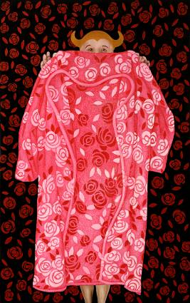

Opening: March 19, 2009, 18:00
Exhibition Dates: March 19 - April 11, 2009

