Press Release
Ansen
"The Tradition of the New: New Aspects in Contemporary Asian Art"
Sakshi Gallery, Taipei, Tayvan
July 18 - August 9 2009
The latest exhibition “The Tradition of the New: New Aspects in Contemporary Asian Art” of Gallery
x-ist’s artist Ansen, opened on July 18th in Sakshi Gallery, Taipei, Taiwan. In addition to Ansen, the works of Noriko Yamaguchi (Japan), Wu Chi-Tsung (Taiwan), Wang Wan-Yu (Taiwan), Sheu Jer-Yu (Taiwan), Tao Ai-Min (China) and Jompet Kuswidananto (Indonesia) took place in the international exhibition curated by Andre Lee. Ansen, who participated in this group exhibition with the works Bull's Eye (2009) and Untraceable (2009), attracted much critical attention and great enthusiasm from art-reviewers, art-lovers and the general public. Ansen’s works deal with repressed social issues within the community and how they reflect in the modern world.

Ansen, one of the young rising stars of the Turkish contemporary art scene, has also managed to ignite the interest of the Asian market. Ansen’s debut in Asia occured with CIGE 08 (China International Gallery Exhibition) and now Sakshi Gallery in Taiwan is hosting the artist for the second time with the show The Tradition of the New.

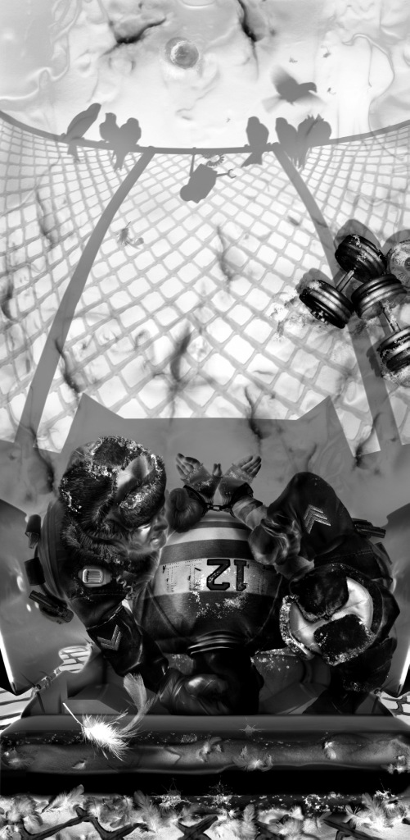
The display of his most current works in ShContemporary 09 (Shanghai Asia Pacific Contemporary Art Fair), will reinforce his dominant presence in Asia. This young artist who has managed to capture the interest and attention of such a diverse and new group of audience in a short time period, indicates that he is very impressed to see the wide scope of the contemporary Asian art.

In regards to the exhibit, Ansen says, “I know that x-ist is one of the only Turkish art galleries that has established a market in Asia and therefore this continuity is praiseworthy. The socio-political standing of the East enables the establishment of convenient art production areas. For us, who are in the middle of the East and the West and can turn our heads either way, Central Asia has a more important place. It is inevitable for the Turkish and the Chinese, two nations that have influenced each other throughout history, to be in a cultural interchange. The works exhibited in Sakshi Gallery are forerunners of a new synthesis, a new creation…”

Ansen:
Born in Kayseri in 1978. Graduated from Mimar Sinan University Fine Arts Faculty, Painting Division in 2003. Participated in group exhibitions in Berlin Municipality Palace, Siemens Art, Contemporary İstanbul, China Internatonal Gallery Exposition, artfair. Opened solo exhibitions in Gallery x-ist titled "x-ist-ence" (2004), "Resistance" (2005), "The Menace" (2008) and “Trace” (2009).

