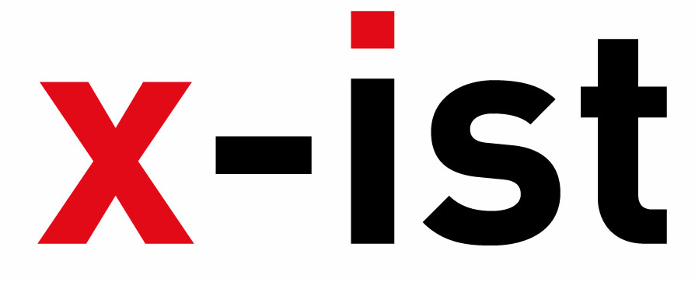 | Abdi İpekçi Cad. Kaşıkçıoğlu Apt.  No:46 /2 34365 Nişantaşı - İstanbul / Türkiye  www.artxist.com  info@artxist.com  T. +90 212 291 77 84 F. +90 212 343 69 35 | PRESS RELEASE

ShContemporary’09
(Shanghai Asia Pacific Contemporary Art Fair)
In it's third year Shanghai Asia Pacific Contemporary Art Fair ’09 is hosting more than 140 galleries and 15,000 artists, curators and art-lovers from 30 different countries between September 9-13. x-ist will be taking part in ShContemporary’09, with a selection of artists who represent the very best of Turkish contemporary art today. x-ist reaffirms its name in the Asian market with this fair where the works of the well known artist Mehmet Guleryüz and the young talents Ansen and Serkan Adin will be exhibited.
Mehmet Güleryüz, regarded as one of the most influential and important living painters in Turkey today is the headliner of the x-ist artists in Shanghay. Guleryuz's works, “Bilerek” (Knowingly) and “Bilmeden” (Unawares), focuses on the central theme of the universal superficiality of how we deal with information, knowledge and our general need to be informed.

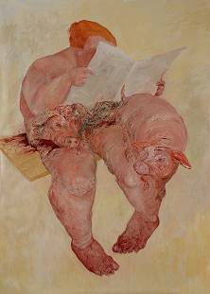

Mehmet Güleryüz,
“Knowingly”, oil on canvas,
250 x 175cm, 2009
Ansen, who will be participating in the exhibition with his works “Drop Zone”, “H1N1” and “The Cleaner” is a familiar name in the emerging young market, after a very successful debut in CIGE08 (Pekin, China) and the exhibition in Sakshi Gallery (Taipei, Taiwan) in the summer of 2009.
Serkan Adin following his series, E-doll, questioned the way women are perceived through his hyper-realistic approach to painting, Adın this time has a tongue-in-cheek look at what exactly we define as "Asian", in the ironically titled "E-mitation" series, for ShContemporary’09.
ShContemporary’09 aims to provide new opportunities for artists, collectors and galleries through its four divisions: Collection-er Development Program, Platform, Discoveries and The Best Galleries. The Discoveries program consists of public talks, discussions on the question: what is contemporary art and an exhibition of artists whose works have stood out in the last few decades.

