 | Abdi İpekçi Caddesi Kaşıkçıoğlu Apt. No:42 D:2 34365 Nişantaşı İstanbul  www.artxist.com  info@artxist.com  T. +90 212 291 77 84 F. +90 212 343 69 35 | PRESS RELEASE

DİLEK
Emre Tandırlı’s new exhibit “Dilek” portrays familiar views and objects for the residents of Istanbul, as if the city were an extension of our body and have become a part of us, these works can be seen in x-ist between October 22- November 14, 2009.

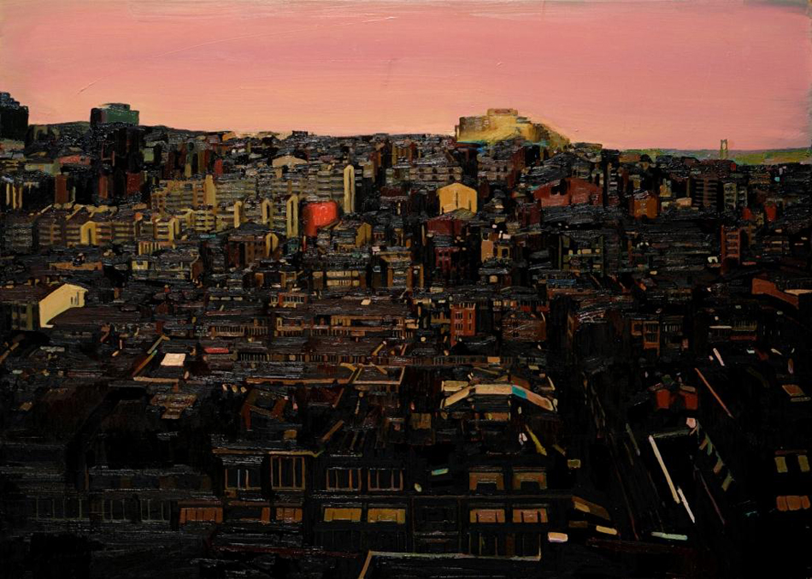
In day-to-day city life, every individual has a view that s/he is familiar with, perhaps even that they personally identify with. Most people who live in big cities, tend to have a set route to their homes passing through certain landmarks and locations, repeating the same cycle every day. During the experience of this scenery as a part of the individual’s daily routine, the perception or the way it resonates depends on his/her inner world and in-turn remains a mystery.

Opening: 22 October 2009
Time: 18:00
Exhibition Dates: 22 October – 14 November
2009

Emre Tandırlı Istanbul, 1977

Tandırlı finished his studies at Mimar Sinan University and his masters and doctorate in Pantheon – Sorbonne University in 2008. His three solo shows in x-ist were Virtual Paradise (2007), Simulation (2006) and Par’ist (2005). Tandırlı who has also participated in several exhibitions in Canada and France, was in the “Young Expansions” group show (Pera Museum, 2005) and The Contemporary Istanbul 07. Dr. Emre Tandırlı is currenly working as a teacher in Bahcesehir University, Faculty of Communications, Visual Arts and Visual Communications Department.

