 | Abdi İpekçi Caddesi Kaşıkçıoğlu Apt. No:42 D:2 34365 Nişantaşı İstanbul  www.artxist.com  info@artxist.com  T. +90 212 291 77 84 F. +90 212 343 69 35 | PRESS RELEASE

NOTHING SURPRISING

x-ist hosts Ali Taptık’s second solo exhibit in Turkey “Nothing Surprising” between 24 December 2009 – 16 January 2010.

Ali Taptık is facinated with small, ordinary things of everyday life and the individual’s place in the “here and now”. This strong underlying issue was the core of his previous series “Accident and Fate”, stories which he continues telling in his latest series “Nothing Surprising”.
Taptık approaches buildings, structures and things similar to the way he interacts with people. He connects with them on a personal level. Every “thing” that stands out as an emotional element is a surrogate for a word. The words build up a narrative and give the series its real name. Through content that concerns everyone, regardless of its personal origin, the artist creates an environment that is similar to literature.
“Nothing Surprising” started with the trend word “crisis” affixed to all things/ events that are societal, political or economic in nature. Even though this much repeated word creates expectations of a drastic change, the “reality of crisis” depicted in Taptık’s photographs explains that nothing is actually changing. Photography critic Lauerence Cornet talks about this unchangeablity as: “Wooden, clotted, fixed, rooted, frozen… People or buildings, his subjects are as unchanging as the world. Hidden behind a curtain, a shutter, a scaffolding, a t-shirt or thick black hair, characters and architecture bear the weight of this metaphoric cover.”
Taptık will continue adding new stories and portraits of “now” based in Istanbul to his series “Nothing Surprising”.
.

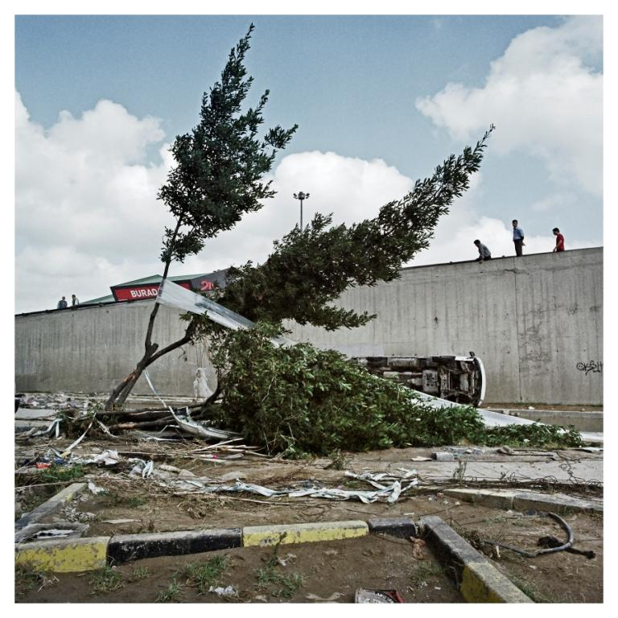
“Nothing Surprising”,
60 x 60 cm, lambda print, 2009

ALİ TAPTIK, 1983
Taptık graduated from ITU, Faculty of Architecture. In 2004 he completed his studies in documentary photography in Stockholm, Switzerland. In 2002, his short film “Uyan(ma)ma” received the “Best Experimental Movie Award” in the Istanbul Short Film Festival. In 2005, his exhibition “Remembering Me” was shown in Belgium, Holland and Poland. His second series, Accident and Fate which was first exhibited in x-ist, was later shown in Holland and France. After taking place in the Contemporary Istanbul Artfair 07, Familiar Strangers was Taptık’s second solo exhibition at x-ist in 2008. The same year, Taptık also participated in CIGE 08 ( China International Gallery Exposition) and in the Cities on the Edge group show part of the Liverpool Capital of culture exhibition series. In 2009, he took place in Start-2009 (14th European Contemporary Art Fair, Strasbourg, France) and the exhibit curated by Kerimcan Güleryüz, “A Subjective Panorama on Turkish Contemporary Photography” in Maison des Métallos, Paris.

