 | Abdi İpekçi Caddesi Kaşıkçıoğlu Apt. No:42 D:2 34365 Nişantaşı İstanbul  www.artxist.com  info@artxist.com  T. +90 212 291 77 84 F. +90 212 343 69 35 | BASIN BÜLTENİ

EVEN A CAT HAS A MUSTACHE
Canan Şenol, whom we know from her works on bio-political concepts creates a link between the past and today in her new show “Even A Cat Has a Mustache” which will be exhibited in x-ist between 21 January – 13 February 2010.

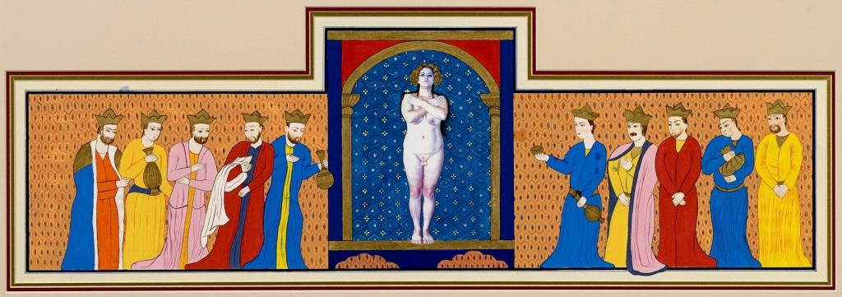
Hünsa, ink, gold, photography on special paper, 40x100cm, 2009
The traditional Eastern tale always start with “the heralds of news, the conveyors of ideas, the story-tellers of the day tell us that…” Therefore, the story-tellers used to be called “râvi.” Canan Şenol who has developed a reputation for her bio-political works assumes the role of a “ravi” in her new work the “Vakvak Tree” that links the past and today, exhibited in her first ever solo show “Even a Cat Has a Mustache”. “Vakvak Tree” is a video-animation consisting images from recent Turkish history in the vein of her first video-legend “Exemplary” that was shown in the 11th International Istanbul Biennial.
The artist states that, “Although we immediate think of an unrealistic world when we think of a fable, I think that fables point to a kind of memory transfer and verbal history. There is a grain of truth in every fable.”
Taking its name from the legendary tree that grows in hell and has human heads as fruits, according to Islamic mythology, the “Vakvak Tree” has also given its name to an important historical event. In 1656, in an attempt to quel a internal uprising many Janissary soldiers were garroted from a mighty maple tree in Sultanahmet, this tree has been called the “vakvak tree” and the incident in which people have been hung from this tree has been named “vaka-i vakvakiye” (the incident of vakvak). The narrative that Şenol constructs in her video begins with the story of this tree and the Janissary incident in the Ottoman times leading to the military strikes in up to recent Turkish history beyond this narrative story the video could be said to embrace a documentary style.
The works in the exhibit “Even A Cat Has A Mustache” are constructed not only to link but also to compare and contrast the past and today. In the making of her other work, “Hünsa” (the Woman with Testicles), the artist was inspired by the story of Sultan Halife becoming the sheikh. Through this story that exemplifies that women could only attain a higher position by becoming masculine, the work examines the “normalization, legitimization” process governed by the power structures.
Canan Şenol’s “Perfect Beauty” series of seven, shown previously in ScopeBasel 2009, and miniatures of the captions from the video “Exemplary” can also be seen in the exhibit.

CANAN ŞENOL Istanbul, 1970

Şenol studied painting in Marmara University, Fine Arts Faculty. She participated in residency programs in Germany and the USA. Among her exhibitions are Hicap (Performans, Platform Art Center, Istanbul, 2007), Bahname (Masa Project, Istanbul, 2007), Perde Arkası (Festival De Rode, Amsterdam, 2006), Nihayet İçimdesin (Istanbul, 2000). Şenol participated in Contemporary Istanbul 08, Contemporary Istanbul 09, IFCA 13th International Festival of Computer Arts (Maribor), 9th International Istanbul Biennial Hospitality Zone, ScopeBasel ArtShow 2009, 11th International Istanbul Biennial as well as the Sotheby’s 2009, Contemporary Turkish Art Auction.

