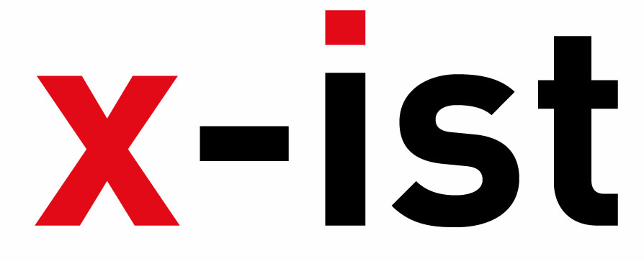 | Abdi İpekçi Caddesi Kaşıkçıoğlu Apt. No:42 D:2 34365 Nişantaşı İstanbul  www.artxist.com  info@artxist.com  T. +90 212 291 77 84 F. +90 212 343 69 35 | PRESS RELEASE

PLAN
Nuri Kuzucan’s latest show “Plan” which starts on April 21st 2010 at x-ist, is an opportunity for us to question our relationship with the city, our destiny and the loneliness that comes with modernity.

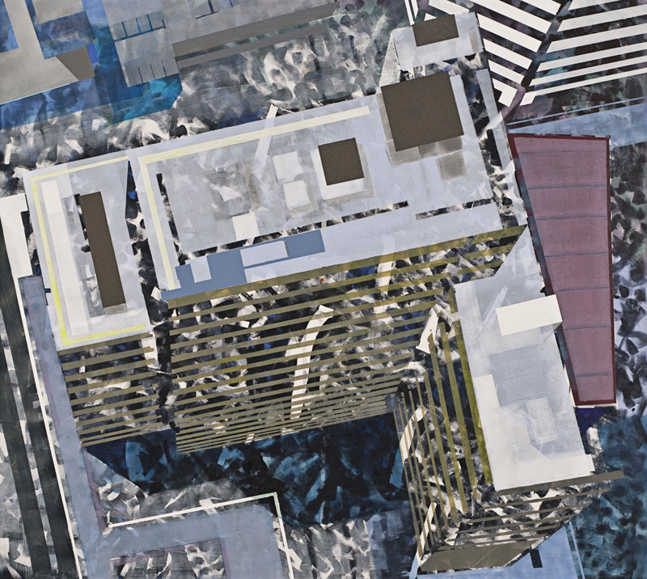
Askeri Bölge, tuval üzerine karışık teknik, 165 x 185 cm, 2010

In his previous exhibits, “Open Place” (2004), “Traffic” (2006) and “Are You Happy?” (2008), Kuzucan, produced works with a perspective that broke the boundaries of man-made urban landscapes. Through his own images of the city, he reshaped our vision of the era he witnessed, the city and conceptual modernism to make it all more bearable for us.

The questing layers and the reflections that stand out in his paintings which examine the city, urbanization and modernism were results of his desire to investigate the hidden story behind landscapes and the power the city contains. The stories sometimes play-out the scene of the crime, congestion and demolition and at times act as a justification for urban culture.
Since his first show, Kuzucan’s perspective shifted from a micro lens to a macro view of the city and in his last exhibit “Plan”, he takes us to the highest vantage point, where our urban landscape is laid out for us in an almost abstracted bird’s eye-view.

We witness the deeper inner connection which Kuzucan creates between the viewer and the landscapes as he pauses and simplifies the chaotic world we live in. These works which open the door for introspection also allows us to question the relationship that we form with the city, our fates and the sense of lonesomeness that is a byproduct of modernism.

NURİ KUZUCAN Zara, 1971

Kuzucan studied at the Mimar Sinan Social Sciences Institute after he graduated from Mimar Sinan Fine Arts School. He has had three solo shows at x-ist Open Place (2004), Traffic (2006) and Are You Happy? (2008). His works have also been exhibited at Scope Basel 2010, Contemporary Istanbul 07, 08, 09 and artFair06 Cologne art fairs.

