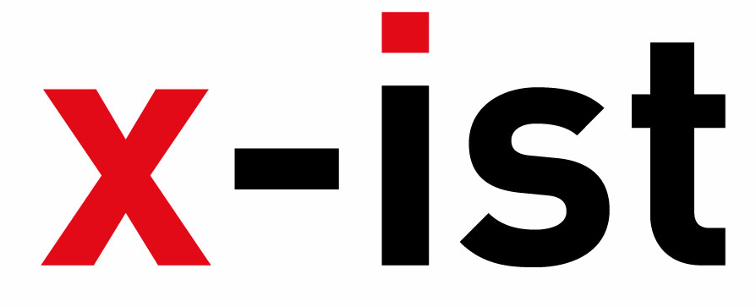 | Abdi İpekçi Caddesi Kaşıkçıoğlu Apt. No:42 D:2 34365 Nişantaşı İstanbul  www.artxist.com  info@artxist.com  T. +90 212 291 77 84 F. +90 212 343 69 35 | PRESS RELEASE

3angle
The work of SENA, could be said to translate the visible and the invisible that surrounds us, decoding the symbols of our body – the body as our real home- in her second solo show “3angle” in x-ist between May 27 – June 19, 2010.

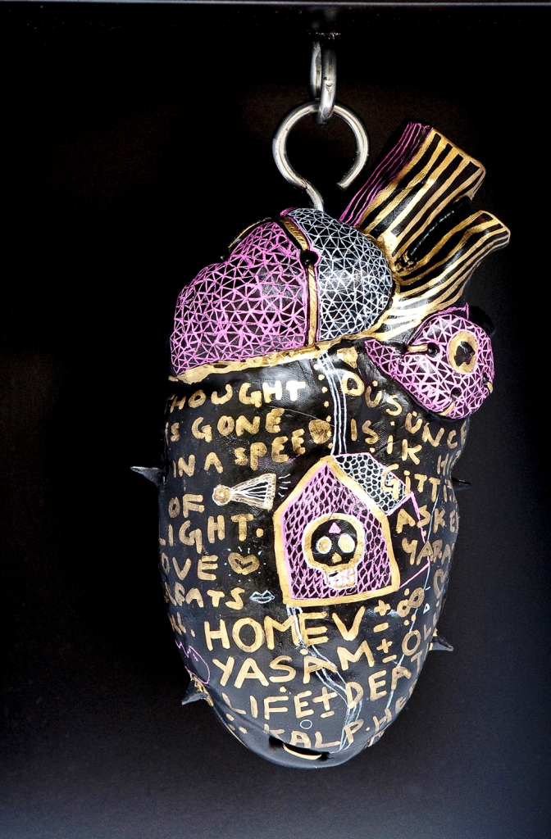
Body, lacquer on MDF and brass accesories, 2010, detail
The artist sets off from the idea that one human gene is in essence equal to the whole universe, she examines this through her own body, viewing it as a building looking for the rooms, the nooks and crannies, the hidden spaces, the doors and picking the locks she finds there. Symbolic depictions of thoughts, the spine, the cerebellum, the phallus and other body parts are presented to the viewer as a result of this search. Another important concept in SENA’s mental and spiritual world is “power animals”. In the history of beliefs, “Power animals” are spiritual entities and follow us throughout our entire life.

In 3angle, SENA, who belives that painting is a transfer of information, tells us about the states of the female and the male body, their dreams, secrets and treasures.

SENA Istanbul, 1982

Sena graduated from London Central Saint Martins Arts College, Graphic Arts and Design Department in 2006. She worked on socially responsible art projects and exhibited her work in certain areas of England and Istanbul. She is one of the two creators of ‘Tershane’ project started in 2006. In 2008, she opened her solo show 2 in x-ist. Sena participated in Contemporary Istanbul art fairs in 2006, 2007, 2008 and 2009.

