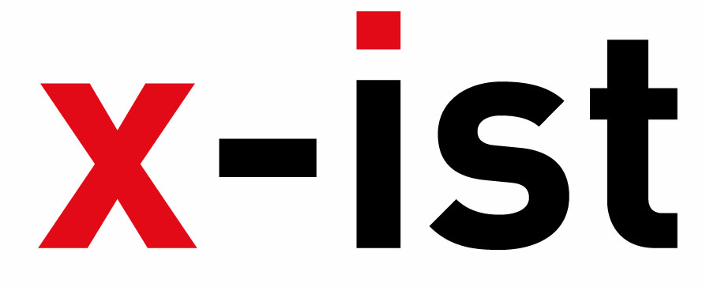 | Abdi İpekçi Caddesi Kaşıkçıoğlu Apt. No:42 D:2 34365 Nişantaşı İstanbul  www.artxist.com  info@artxist.com  T. +90 212 291 77 84 F. +90 212 343 69 35 | PRESS RELEASE

“Neither here nor there: Reflections on Cultural Hybridity and the Third Space”

Working as a channel that encourages cultural diplomacy, JAMM (Art & Beyond) explores the concept of hybridity in relation to cultural identity in the exhibit titled “Neither here nor there: Reflections on Cultural Hybridity and the Third Space” during October 7-31 in London.

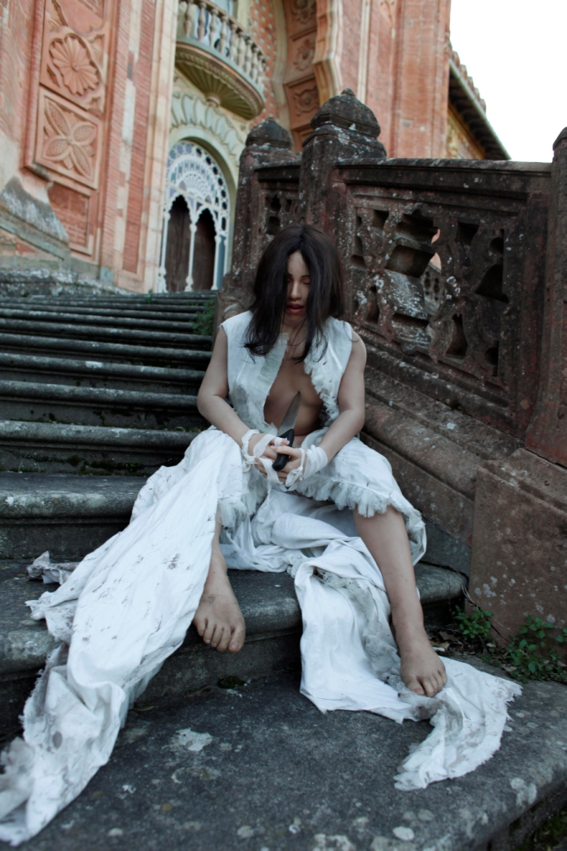
Lale Tara, ”I Might Be Wrong”

Lale Tara, an x-ist artist, is one of the twelve artists who will participate in the exhibit titled “Neither Here nor There : Reflections on Cultural Hybridity and the Third Space” in the art initiative in London, JAMM (Art & Beyond). Taking place in one of the most prestigious halls in London, The Belgravia House, between October 7-31, 2010, the exhibit has also been organized in respect to the eminent cultural theorist, Homi K. Bhabha.

Consisting of artists from several different cultural traditions, the exhibit explores the concept of hybridity in relation to cultural identity. Bhabha views hybridity as an in-between space between two cultures where translation and negotiation peaks, instead of the mixture of the two parent cultures. The theorist believes that this ‘in-between" space, where the two cultures open to each other, the “Third Space as he calls it, is where the specific characteristics of the hybrid substantiates.

After exhibits in France (Paris, Maison des Métallos, 2009), India (Bombai, Sakshi Gallery, 2010), and in Taiwan (Sakshi Gallery, Taipei, 2010), Tara meets the art-lovers in London with four brand new works. Tara’s photographs, constructed with inanimate surrogates and objects, invite the audience to a level beyond the five senses.

Working as a channel that encourages cultural diplomacy, JAMM (Art & Beyond) supports the Arab & Iranian artists in the West, and Western artists in the East, and thus inspire further collaboration between the two. The other artists that will participate in the show, which will coincide with Frieze Art Fair, are Mohamed Abdulla, Lara Baladi, Sonia Balassanian, Al Braithwaite, Shezad Dawood, Alia Farid, Aya Haidar, Sacha Jafri, Bright Ugochukwu Eke and Sharif Waked.
The show will also host a VIP program that will take place in the Royal Collage of Art on October 5th. This event will have Professor of American Language and Literature at Harvard University, Homi K. Bhabha, and the curator of Serpentine Gallery (London), Hans Ulrich Obrist as guests.

