 | Abdi İpekçi Caddesi Kaşıkçıoğlu Apt. No:42 D:2 34365 Nişantaşı İstanbul  www.artxist.com  info@artxist.com  T. +90 212 291 77 84 F. +90 212 343 69 35 | PRESS RELEASE

Going somewhere?

Alp Sime meets the art-lovers at his new show “Going somewhere?” after his last exhibit “Parallax” (2009).

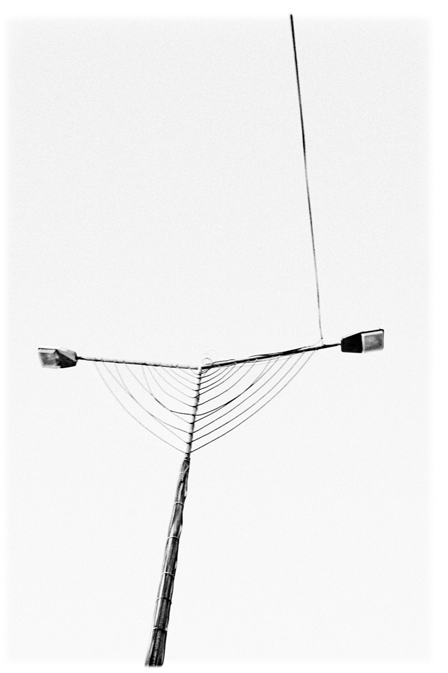
Alp Sime, who is renown for his powerful and refined language as one of the most important photographers of his time, meets the art-lovers at his new show “Going somewhere?” after his last exhibit “Parallax” (2009). The exhibit, taking place between December 16, 2010 – January 15, 2011 at x-ist, explicates the consolidation of his documentary and presentation processes in a unique experimental way.
The photographs indicate that the subjects start the visual dialogue. The photographs start another longer journey once they reach the audience setting off from the question “Going somewhere?”.
The works, which turn the most ordinary objects to alegorical elements of this adventure, invites the art-lovers to look closer and deeper.

ALP SİME İstanbul, 1970

Sime graduated from the Boston University, Fine Arts Faculty. After Ramora (Istanbul, 2002) and İstanbullu (Athens, 2006), his third solo show Parallax (2009) was shown at x-ist. Sime participated in the Contemporary Istanbul 08, 09 and 10, and also took part in the Sotheby’s 2009, Contemporary Turkish Art Auction in London, Start-2009 (14th European Contemporary Art Fair, Strasbourg, France) and the exhibit curated by Kerimcan Güleryüz, “A Subjective Panorama on Turkish Contemporary Photography” at the Maison des Métallos (Paris).

