 | Abdi İpekçi Caddesi Kaşıkçıoğlu Apt. No:42 D:2 34365 Nişantaşı İstanbul  www.artxist.com  info@artxist.com  T. +90 212 291 77 84 F. +90 212 343 69 35 | PRESS RELEASE

I’m Shocked But I’m Not Surprised”
The fourth show of Ekin Şaçlıoğlu “I’m Shocked But I’m Not Surprised”” can be seen between February 17 and March 19, 2011 at x-ist.

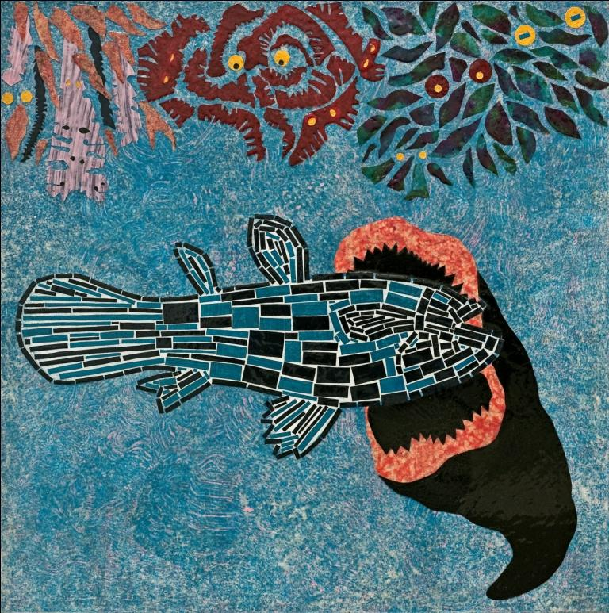

“I’m Shocked But I’m Not Surprised” is Ekin Saçlıoğlu’s fourth solo show at x-ist. Since her first exhibit in 2005 “From a Little Closer”, the artist has used “free associations”, a path which leads her to unpredictable and surprising ends every time. Regardless of its point of origin, Ekin always accepts the challenge of open-ended journeys, it is not unusual for her to start with dessert and wrap up with the entree.

In her previous shows, the artist questioned the relationship between reality and dreams, the reliability of the mind and memory. In this exhibition, although retaining her narrative quality, the works seem to diverge from the artist’s usual fictional world and focus on daily incidents and personal experiences, while editorializing on social issues at the same time.

For example, the piece “If You’re a Brunette, You’re Beautiful”, depicts a vignette based on Saclioglu’s boyfriend who faced harsh discrimination at an airport in Germany just for being of darker skin and possessing a beard, during an Islamic terror alert. Another work, “Warning, The Dog Could Bite” was inspired by a warning sign that the artist came across in a wealthy neighborhood in Istanbul.

This is perhaps one of the most distinguishing qualities of the artist….Instead of later naming the work; it is the very title that inspires her... She can escape from the mundane chaos of daily happenstance, by carefully select certain symbols from this flood of imagery. A line she hears in a movie, whose name she can’t recall, can be the source of inspiration for a new piece. One day Saçlıoğlu happened to sit next to a mother and son on a bus, during the journey the mother ceaselessly repeated “Barış, Don’t do it!’” to her son for no apparent reason, this puzzled and disturbed the artist. After being an unwilling observer to this Hitchcock’esque scene, where the son remained quiet despite all the harassment, Saçlıoğlu was prompted to create the piece ‘I Told You Not To Do It, Barış.’

Ekin’s fourth solo exhibition, ‘I’m in Shock But I’m Not Surprised’ consists of 3 different groups of works. The first group consists of latex on canvas pieces that are inspired by either daily incidents or the artist’s personal experiences. The second group is the series titled ‘Non-Story’, composed of 10 smaller sized works. We see similar shapes and forms in each piece; in fact they are like surrogates for words that build up the narrative in the works from the previous group. In the final series, ‘Animals & Icons from the Villa’ constructed with real human hair inserted into latex, the artist reinterprets the paintings that she came across in a historical villa in Munich.
Although the three series might appear disconnected and independent of each other, they share a common problematic. Ekin, in each work, takes in hand a different incident, influenced by current-events and associated tensions, while her unorthodox works seems to spring forth from a very personal perspective they relate to sum of us all.
Ekin Saçlıoğlu, 1979
Ekin Saçlıoğlu was born in İzmir, 1979. She graduated from İstanbul Anadolu Fine Arts Lycee in 1997 and Mimar Sinan University Fine Arts Faculty Painting Department in 2002. She worked in Salzburg Summer Academy in 2001. In 2005, she completed her graduate study in Mimar Sinan University Social Sciences Institute and continues to work in İstanbul. Saçlıoğlu’s works were exhibited in Turkey, America, Australia, Greece, Germany, Switzerland and Holland.

