 | Abdi İpekçi Caddesi Kaşıkçıoğlu Apt. No:42 D:2 34365 Nişantaşı İstanbul  www.artxist.com  info@artxist.com  T. +90 212 291 77 84 F. +90 212 343 69 35 | PRESS RELEASE

Please, Move Towards the Back

Nalan Yırtmaç’s first solo show at x-ist , ‘Please, Move Towards the Back’ can be seen between March 24 and April 16, 2011.

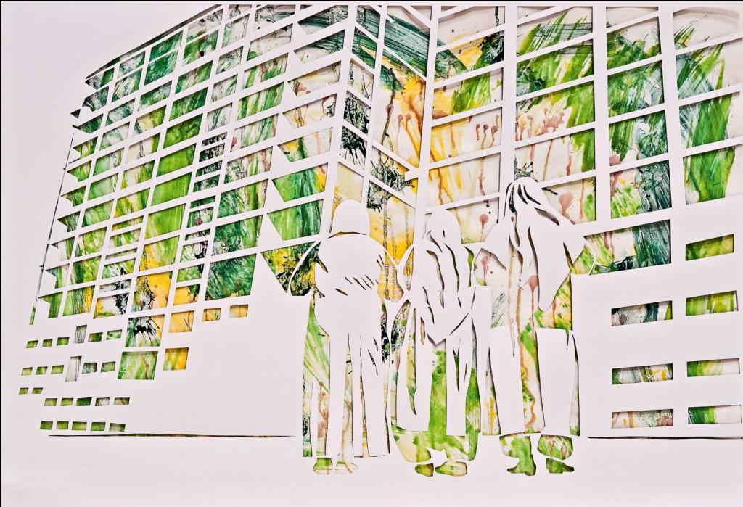
Gümüşsuyu Park Hotel 2, Stencil, 50 x 67 cm, 2011

“Please, Move Towards the Back” is Nalan Yırtmaç’s second solo show in her career and first solo show at x-ist.

As a result of recent demolition in Sulukule, the artist diverts her attention to urban transformation and the diminishment of neighborhood culture, expressing herself through a wide range of mediums stenciling over different kinds of materials, canvases and gallery walls.

An artist with a strong sense of social responsibility, Yırtmaç responds to societal concerns and daily experiences through her group & solo shows. The painter Yırtmaç creates her stencil pieces from photos she takes. She sometimes provides greater freedom of expression by using other techniques, including watercolor, lithography, paint and serigraphy. Yırtmaç focuses on the manipulation of social space in the urban environment and the relationship between object and place / individual and city. Her use of mundane materials straight out of daily life such as linoleum, table cloths and shower curtains, are compatible with the aesthetics of the subject of this exhibition.

It could be said that in this collection of her most recent works, it is possible to observe behavioral patterns of the illegitimate monster of modernism, the city. The artist brings the cacophony of messages, produced by the huddled sights of traveling people and buildings, to the bourgeois-fortress Nişantaşı. She, through the people and places acting as the subject of this exhibition, and with her subversive and voluntary view, weighs in on the clatter about photography as documentation and takes the townspeople—young and old— in this city of 13-million people on an inter-class ring tour for the duration of the exhibit. The artist deploys neighborhood intimacy like a cultural barricade against gentrification.

T This provocative exhibition, ‘Please, Move towards the Back’ can be seen between March 24 and April 16, 2011 at x-ist.

.

Nalan Yırtmaç, 1969

Yırtmaç opened her first exhibit “Hain Geceler” with the Hafriyat Group in 1999 after her graduation from Mimar Sinan University, Painting Department in 1994. Yırtmaç, who worked with Hafriyat and Karşı Sanat in many solo and group shows, also took place in several international exhibits in Germany, France and Austria, and the 9th and 10th Istanbul Biennials. Some of the shows the artist participated are: ““Istanbul Next Wave” (Akademie Der Kunst, Berlin, Germany, 2009), “Haksız Tahrik” (“Unjust Provocation”, Hafriyat, İstanbul, 2009), “Sobe!” (Bilsar, İstanbul, 2007) ve “Index” (Vienna, Avusturya, 2008)’dir.

