 | Abdi İpekçi Caddesi Kaşıkçıoğlu Apt. No:42 D:2 34365 Nişantaşı İstanbul  www.artxist.com  info@artxist.com  T. +90 212 291 77 84 F. +90 212 343 69 35 | PRESS RELEASE

MALEVOLENCE
Ansen, whose works have aroused much interest in the art-world with his previous shows, meets the art- lovers at his fifth solo show, titled ‘Malevolance’ on April 21st.

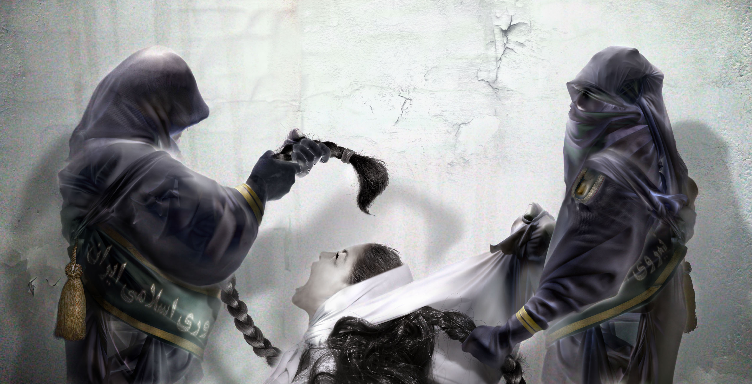
Heretic, 90 x 176 cm, 2011

In his unique hybrid works, born through an interaction of sculpture, photography and painting, Ansen transforms mundane daily objects that might otherwise escape our attention, composing new narratives with ironic commentary by active manipulation in a digital environment. His use of readymade combined with the height of current available technological means have led some critics to call him the 21st Centuries Man Ray.

Visual uniqueness alone doesn’t form the core of Ansen’s works. It is a path which aims to carry the audience into a deeper inner connection. The artist’s creativity extends beyond the boundaries of visibility. In his works, he either questions political & societal concerns or creates his own story and characters. Malevolance showcases two brand new works from the series entitled ‘From the Behind’ which the artist has been working on since 2005 and focusing on the people playing important roles in both international and national political arena. The works in Ansen’s new show are firmly grounded in literature, religion and history where he explores war, prohibition, justice and crime issues, which remain constant over time and place. The artist examines the stories enriched through the use of various symbols from an ironic standpoint. ‘Abel and Cain’, the first work from the series ‘Malevolence’, displayed at Art Dubai 2011 is a striking piece of Ansen a fresh take on the well-known story about the two sons of Adam and Eve, Cain commits the first murder through the killing of his brother Abel.

‘Malevolance’ the brand new series of Turkish wunderkind Ansen, whose works are part of numerous national and international collections, can be seen between April 21 and May 14, 2011 at x-ist.

Ansen
Kayseri, 1978

Ansen studied painting at the Mimar Sinan Faculty of Fine Arts. He has had four solo exhibitions at x-ist between 2004 and 2009, x-ist-ence, Resistance, Menace, and The Trace. He participated in The Contemporary Istanbul 06, 07, 08 and 10, artfair06 Cologne, CIGE 08 – China International Gallery Exposition (Beijing, China) and ShContemporary’09 (Shanghai Asia Pacific Contemporary Art Fair). Ansen’s work was in the Sotheby’s 2009 and 2011, Contemporary Turkish Art Auction and in the group shows “Tradition of the New: New Aspects in Contemporary Asian Art” in Sakshi Gallery, Taipei, Taiwan and ‘Confessions of Dangerous Minds’ at Saatchi Gallery, London.

