 | Abdi İpekçi Caddesi Kaşıkçıoğlu Apt. No:42 D:2 34365 Nişantaşı İstanbul  www.artxist.com  info@artxist.com  T. +90 212 291 77 84 F. +90 212 343 69 35 | PRESS RELEASE

INNOCENT SURROGATES

Lale Tara exhibits her lates series “Innocent Surrogates” at Istanbul Museum of Modern Art

Lale Tara is at Istanbul Museum of Modern Art with her latest cycle of photographs “Innocent Surrogates’

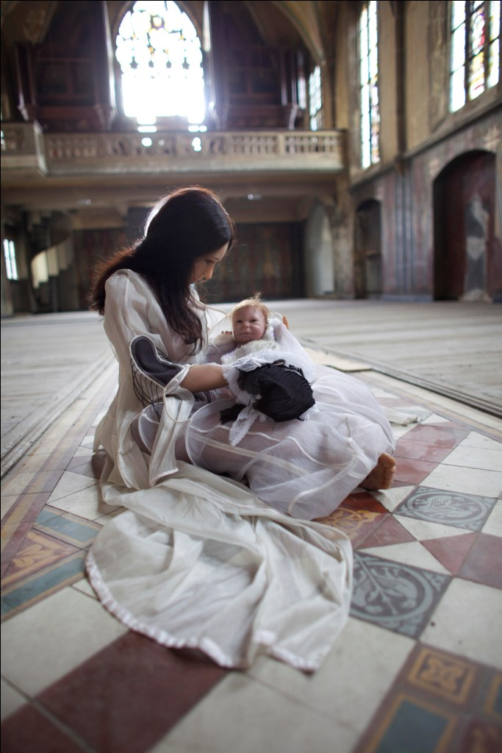

Lale Tara, Shining Madonna with child, Photograhpy, 150 x 220 cm, 2010

Lale Tara who has already become a well known name after her first solo show Doppelganger at x-ist (2009) and international exhibits in France (Paris, Maison des Métallos, 2009), Art HK’10 (Hong Kong, 2010), and in London (JAMM, UK, 2010), will present works from her latest series “Innocent Surrogates”, starting on June 1st at Istanbul Museum of Modern Art.
Since her first exhibition, Tara uses inanimate sexual surrogates and objects as definitive characters which embody the artist herself. The series is comprised of the initial problematic she discovered in her work, Madonna Con Bambino. This concept allows the artist/us to reexamine this iconic construct independent of a linear timeline and specific geopolitical placement which in its very nature changes and morphs through this embracement of the other, pulling in the audience into a world that transcends the rational mind. The artist strengthens the relationship between her experiences and imagination through her photographs constructed with mute objects and surrogates in a multitude of scenes and spaces which also play a role.
Innocent Surrogates, an exhibition bringing reality and the truth beyond reality together, can be seen between June 1 and September 4, 2011 at Istanbul Museum of Modern Art.

LALE TARA
After studying photography at The New School University (New York) and OCTET: School of Visual Arts (New York), Tara’s visual diary “sevenmonthssevendays” was published by the Robinson Crusoe Publishing House in 2005. Following her exhibits Live (Bilsar, 2006) and Hello Earth Goodbye (Bilsar, 2007), x-ist hosted her show doppelgänger (RUI) in 2009. The artist participated in Contemporary İstanbul ’09 and 10, Start-2009 (14th European Contemporary Art Fair, Strasbourg, France) and the exhibit curated by Kerimcan Güleryüz, “A Subjective Panorama on Turkish Contemporary Photography” in Maison des Métallos (Paris). In 2010, Tara took place in the multi-national exhibit titled “Tradition of the New” in Sakshi Gallery, Mumbai (India) and in the show “Between History and Tale: Contemporary Photography” in Sakshi Gallery, Taipei (Taiwan) in addition to ART HK 10 and 11 (Hong Kong International Art Fair).

