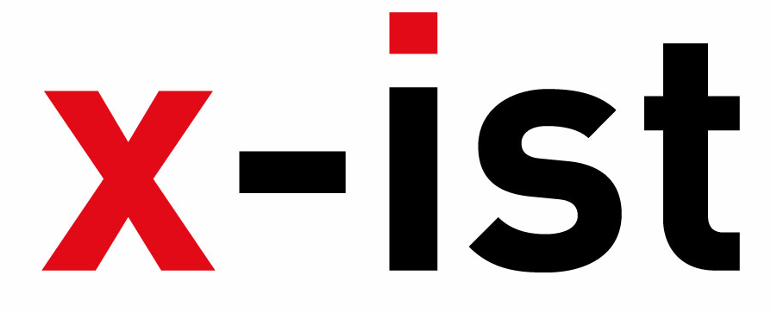 | Abdi İpekçi Caddesi Kaşıkçıoğlu Apt. No:42 D:2 34365 Nişantaşı İstanbul  www.artxist.com  info@artxist.com  T. +90 212 291 77 84 F. +90 212 343 69 35 | PRESS RELEASE

ART HK 2011
x-ist participates in Art HK 11, the most established contemporary art fair in Asia, taking place at the Hong Kong Convention and Exhibition Center between 26-29 May, 2011. Bringing together the Asian art world with the international art community and collectors, Art HK 11 also includes two feature gallery sections : Art Futures (for young galleries presenting emerging talents) and Asia One (Asian galleries showing solo shows of Asian
artists)

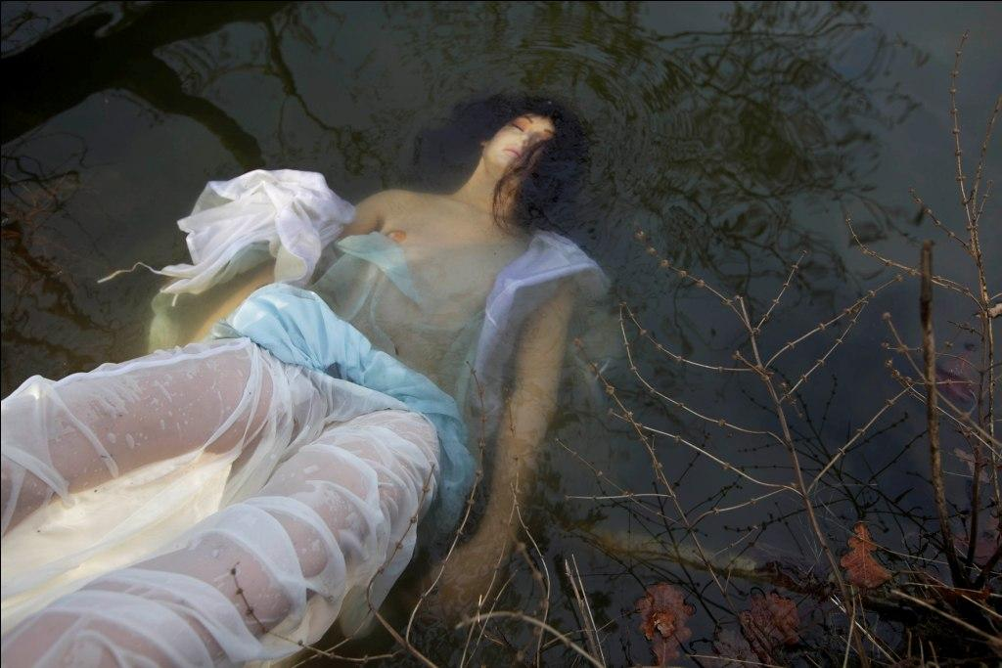

Lale Tara, Ophelia, Photohraphy,147 x 217 cm, 2011

x-ist participates in Art HK 11 with the works of Mehmet Güleryüz, Burhan Kum, Nuri Kuzucan, Lale Tara, Gözde Türkkan and Ali Taptık.
Lale Tara who has already become a well known name in Asia after her exhibitions and last year’s Art HK, will present works from her brand new series “The Opera Stills”. Her use of inanimate sexual surrogates as definitive characters in the creation of known and newly suggested operatic stills has raised the bar for this new exciting artist.
Burhan Kum will present his brand new “epigraphs” as strong critiques of today’s art world and politics. The works are a mix of readymade components making use of various materials such as blood vials, stuffed animals, kitsch touristic objects blended with the artist’s general medium of painting. The results could be interpreted as three dimensional statues-quos commenting both on the past and the present.
The talented young photographer Gözde Türkkan takes place in the fair with a selection from her series “Pudica”, an auto-erotic collection of self-portraits. Etymologically referring both to ‘female genitalia’ and ‘shame’, the “Pudica” series alludes to the paradoxes of self-objectification, reminding us of the Venus Pudica, where the act of concealing serves to draw more attention.
The young artist well-known both in Europe and the Middle East with his exhibits, Ali Taptık is another important name x-ist will present in HK. Taptık who approaches buildings, structures and things similar to the way he interacts with people and connects with them on a personal level, will be showing a special selection of photographs from his two series “Nothing Surprising” and “Accident and Fate”. Taptık is the first Turkish artist who has had a book published by Filigranes, the universally well-known French publishing house specialized in art books.

Mehmet
Nuri Kuzucan, whose muse is the megalopolis/organisms that we reside in, lays out city landscapes from almost abstracted bird’s eye-view using the canvas as a three dimensional platform. Kuzucan will take place in the fair with his brand new work “New Nature”, a follow-up to his last exhibit “Plan”.
Mehmet Güleryüz, regarded as one of the most influential and important living painters in Turkey today is the headliner of the x-ist artists in HK. Güleryüz will present works depicting scenes of human interaction with occasional animal familiars. In his paintings and drawings, expressionist line and color come together to form independent interpretations of the human form.
After the success of last year’s edition, where the fair welcomed 155 of the world’s leading galleries from 29 countries and an audience of over 46,000, Art HK 2011 is expected to consolidate its name as a leading international art fair.

