 | Abdi İpekçi Caddesi Kaşıkçıoğlu Apt. No:42 D:2 34365 Nişantaşı İstanbul  www.artxist.com  info@artxist.com  T. +90 212 291 77 84 F. +90 212 343 69 35 | PRESS RELEASE

KILLJOY

Following his previous shows, ‘Instant Message’, ‘Save As’ and ‘E-doll’, Serkan Adın stimulates his fans with his latest show, ‘Killjoy’ on June 23rd.

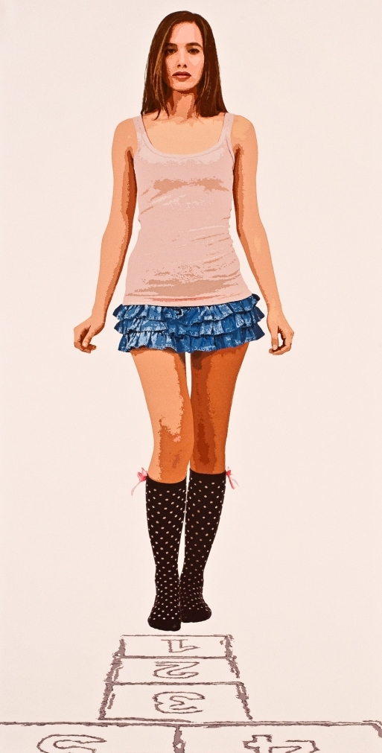

Serkan Adın, Hopscotch, Acrylic on canvas, 230 x 125 cm, 2011
The desire to find meaning and the illusions created between the rift of emotions and the mind traps individuals and society in general in a chaotic game. In this game, the arbiter is the ego which directs individuals about their own faiths and judgments. Ego begins to develop in games played as children, this could be considered the second milestone of personality development, after the child-parent relationship. Children’s games, reflections of the real life, are the platforms which prepare children for adult life and foster children’s social, intellectual and emotional stimulation. The result of this maturation period determines the role and attitudes of the individuals in daily life.
With his works from Killjoy, Adın portrays different characters from the scenes of different children’s games. In these scenes; the audience plays the role observer or in a sense the developmental therapist. As a witness to individual’s development of personality characteristics, the audience reveals hidden characteristics and aspects of the subject. This observation is proven successful when it is performed in a self-directed manner. The artist intention is to face the audience with her/his own ego. He embarks on his own internal journey which is open to the audience, it is up to the individual will determine whether to pursue this internal journey or not.
In his latest show, Adın presents his works inspired by a ‘killjoy’ attitude and develops a closer relationship between stable figures and the audience. He replaces the instantaneous confrontations of his previous shows with a deeper questioning through his brand new works. Killjoy can be seen between June 23rd and July 16th, 2011 at x-ist.

Serkan Adın, 1977
Adın graduated from Dokuz Eylul University Fine Arts Faculty, Painting Department. Following his first show Instant Message in x-ist, Adın had two more solo exhibitions Save As (2007) and E-Doll (2008) in x-ist. His works have been exhibited in many countries including Bulgaria, Romania, Switzerland, Macedonia, Japan and Korea. The artist also participated in the “young expansions” group show (Pera Museum, 2005), Contemporary Istanbul 07, 08, 10 and ShContemporary’09 (Shanghai Asia Pacific Contemporary Art Fair).

