 | Abdi İpekçi Caddesi Kaşıkçıoğlu Apt. No:42 D:2 34365 Nişantaşı İstanbul  www.artxist.com  info@artxist.com  T. +90 212 291 77 84 F. +90 212 343 69 35 | PRESS RELEASE

DEPLOYMENT

x-ist hosts Ali Taptık’s third solo exhibit “Deployment” between 22 September – 15 October 2011.

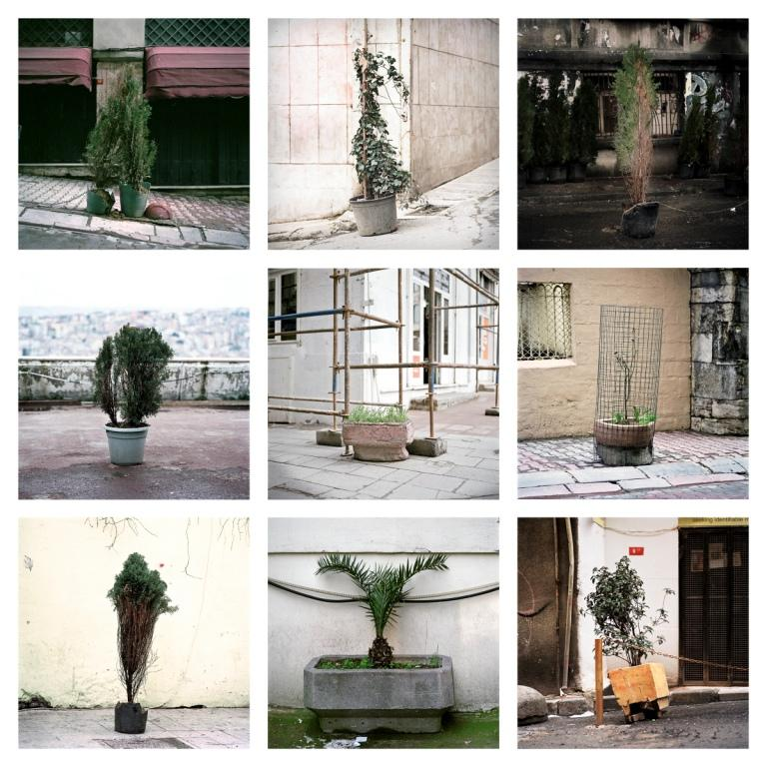

Ali Taptık, Towards A Flora / Border, photography (c-print), 120 x 120 cm, 2011

In his third solo show, Ali Taptık presents a selection of works taken between 2004 and 2011
by making use of different groupings and approaches, ranging from a classic series format to a more conceptual book structure and installation. In this exhibit, the artist, who generally prefers to work on different series at the same time, has taken an alternative route redefining his approach, where the exhibition takes on the format of a status report. Taptık sees the exhibit contrary to popular expectancy as where the work and production really begins, rather than the usual definitive closing argument that is the norm. Deployment, in which independent series become intertwined and open a multitude of possible relationships could be said to take the viewer in to the kitchen or the generally private studio of the artist; by this very act collapsing established rules and rigid expectations with an eye to promote discussion.

Taptık’s third solo exhibition, Deployment consists of four different series; ‘Tangent’, ‘Probe’, ‘Towards a Flora’ and ‘Meridians’. The first series titled ‘Tangent’ is the preliminary work for his upcoming book and consists of snapshot photographs which Taptık has been working for 5-6 years. Probe, the second series in the exhibit, is the result of an attempt by the artist to use different photographic languages at the same time, shifting from a detailed focused gaze, to a micro/macro perspective questing between the sum and its parts.
The third in the collection of series “Towards a Flora”, could be interpreted as a visual research or cataloging endeavor. Taptık plans to publish this series as a book including the contributions of biologists, botanists and landscape architects’ essays in coming years. The final series in the exhibit is titled ‘Meridians’ inspired by real events and source material behind the printing of Tropic of Capricorn in Turkey, the semi-autobiographical novel by Henry Miller, reminds us of a successful and collective stance against censorship.

Deployment, the title of Taptık’s third solo show, is translated into Turkish as "for a specific purpose in

Ansen, Kayseri, 1978

Ansen studied painting at the Mimar Sinan Faculty of Fine Arts. He has had four solo exhibitions at x-ist between 2004 and 2009, x-ist-ence, Resistance, Menace, and The Trace. He participated in The Contemporary Istanbul 06, 07, 08 and 10, artfair06 Cologne, CIGE 08 – China International Gallery

deploying, distributing, use", "emplacement" and "transferred’’. It can be said that the word, deployment meets the primary dictionary definition in this exhibit. Taptık’ photographs, brought together around different structures and narratives, beyond the images themselves are also influenced by their placement and presentation in the exhibit. Deployment can be seen between September 15th – October 22nd, 2011 at x-ist.

ALI TAPTIK İstanbul, 1983

Taptık graduated from ITU, Faculty of Architecture. In 2004 he completed his studies in documentary photography in Stockholm, Switzerland. In 2002, his short film “Uyan(ma)ma” received the “Best Experimental Movie Award” in the Istanbul Short Film Festival. His short film, ‘Your Face Won’t Be Visible” met with the cinema lovers in the category of special screenings within Istanbul Film Festival in 2011. His exhibition “Remembering Me” was shown in Belgium, Netherlands and Poland in 2005. His second series, Accident and Fate (2006) which was first exhibited in x-ist, was also shown in Holland and France. Taptık’s later shows were Familiar Strangers (2008) and Nothing Surprising (2009). Taptık also participated in CIGE 08 (China International Gallery Exposition) and the group show “Cities on the Edge” (Liverpool, 2008) curated by John Davies. In 2009, he took place in Start-2009 (14th European Contemporary Art Fair, Strasbourg, France) and the exhibit curated by Kerimcan Güleryüz, “A Subjective Panorama on Turkish Contemporary Photography” at the Maison des Métallos (Paris). The same year, his series “Accident and Fate” was published by the French publishing house Filigranes. Designed by Bülent Erkmen - BEK Design, Taptık’s book titled as “Photographing Istanbul” was published in 2009. The content of the book was formed in cooperation with Uğur Tanyeli. He participated in the group exhibit, titled ‘Right Here, Right Now’ at Cuadro Fine Art Gallery, Dubai in 2011. The artist has also participated in SCOPE New York 2010, SCOPE Basel 2010, Art Dubai 2011 and ART HK’11 (Hong Kong International Art Fair).

