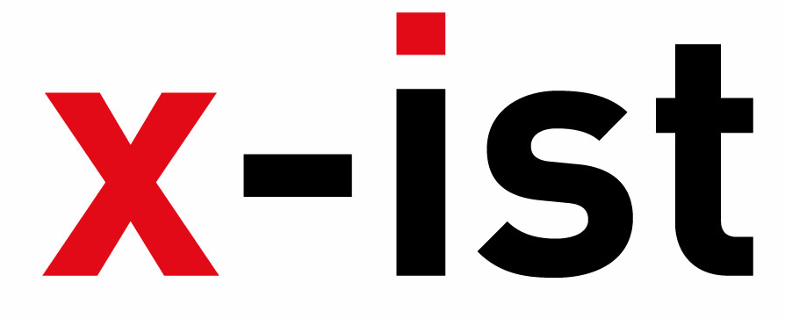 | Abdi İpekçi Caddesi Kaşıkçıoğlu Apt. No:42 D:2 34365 Nişantaşı İstanbul  www.artxist.com  info@artxist.com  T. +90 212 291 77 84 F. +90 212 343 69 35 | PRESS RELEASE

ART DUBAI 2012
x-ist participates in Art Dubai, the largest and most established contemporary art fair
in the Middle East taking place at the Madinat Jumeriah, Dubai between 21-24 March, 2012. Bringing together the art of the Middle East, North Africa and South Asia with the international
art world, Art Dubai hosted over 20,000 visitors in 2011. In its sixth year, Art Dubai features
72 art galleries from 32 different countries and 500 international artists.

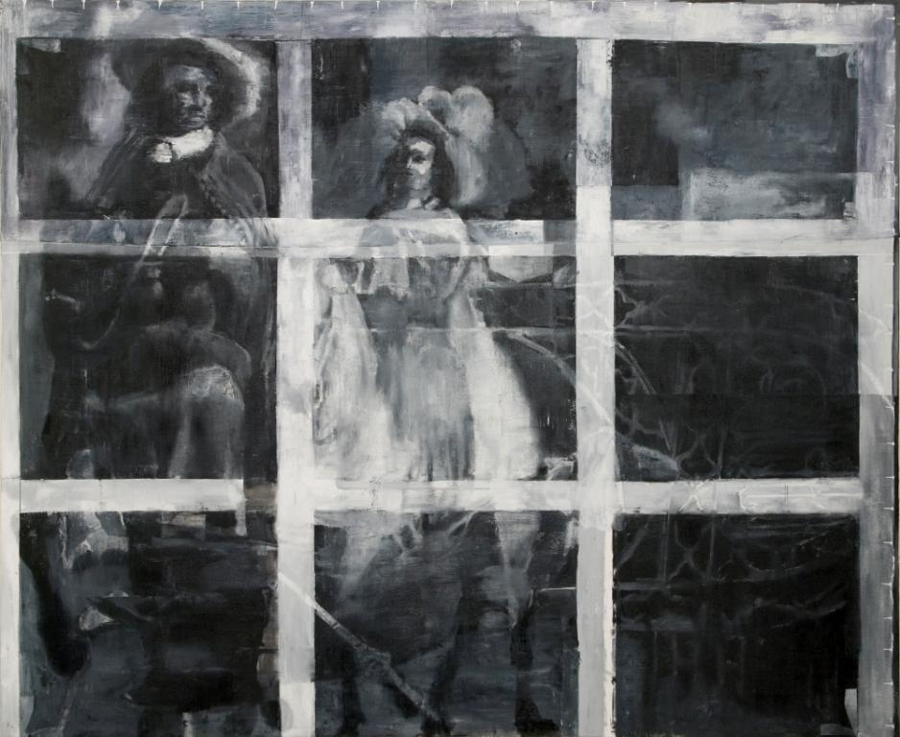

Burhan Kum, Underneath, oil on canvas, 180 x 220 cm, 2012
x-ist will be taking part in Art Dubai 2012 with works from Ansen, Ali Taptık, Ali Elmacı, Burhan Kum, Erkut Terliksiz, Ekin Saçlıoğlu, Sena, Nalan Yirtmac and Seckin Pirim.

Inspired from the ideas put forth in Darwin’s book “The Expression of the Emotions in Man and Animals”, Ansen’s new work “The Cold Meal” examines the power struggle and the survival instinct of the humans through an example from the wilds. “The Cold Meal”, the second piece of ‘The Feast Series’, hints to the shared codes among living creatures.

Ekin Saclioglu, who’s well-known for her narrative quality and experimental style, will present two brand new pieces, ‘Remains From An Unknown Fruit’ and ‘What Happens After Eating An Unknown Fruit?’ The works metaphorically depict two different scenes that result from the same situation in different environments.

Burhan Kum, who is also exhibiting his new series Digital Darkness at x-ist in March, presents his brand new work ‘Underneath’ for the first time in Art Dubai. Inspired by a technique known as scanning macro-X-ray fluorescence, which is used in academic research to reveal hidden

layers behind well-known paintings, Kum ‘peels off the skin’ of the painting in order to expose the unseen. White-and-black paintings that resemble the x-ray examinations analyse the polarizations such as the visible/hidden and the exposed/covered.

The young talented photographer Ali Taptık participates in the fair with his Meridians Series. “The Meridians” is inspired by real events and source material behind the printing of ‘Tropic of Capricorn’ in Turkey, the semi-autobiographical novel by Henry Miller and reminds us of a successful and collective stance against censorship.

Ali Elmacı, who responds to societal concerns and daily experiences through intimate portraits, will take place in the fair with brand new works from his latest series, ‘Save Me With Your Fire’. Elmacı takes in hand control mechanisms buried in the society that aim for supression more than protection, and criticises the results of taking refuge in a person or an institution assuming its superiority.

The young artist known for bringing together the real and the subjective worlds, Erkut Terliksiz is another important name x-ist will present in Art Dubai. In the brand new works, “The Immediate” and “The Remote”, Terliksiz combines his expressionist style with experimental material to produce 3 dimensional paintings.

Sena will display her paper work titled ‘Hidden Universe’ where she uses different materials such as ink and thread, and depicts a woman who’s covering her body and soul. “Hidden Universe” makes references to the stereotypical eastern woman by using visible and submerged symbolism.

Seçkin Pirim participates in Art Dubai with his three-dimensional work ‘Times of The Feigned’. The piece looks glowing and alluring from the outside; however, as the audience gets closer, s/he’s drawn to the decayed center part. Through this piece, Pirim criticizes the world today and questions the trustworthiness of the information presented to us.

Nalan Yırtmaç, who focuses on urban transformation, revives the silhouette of a demolished neighborhood as a result of gentrification, by using stencil and lightbox.

In addition to the works x-ist presents in Art Dubai (Stand A36), works of Ansen and Lale Tara will also be displayed in the exhibit, ‘The Samawi Collection II’ (March 12 – April 26, 2012) at Ayyam Gallery, Dubai.

