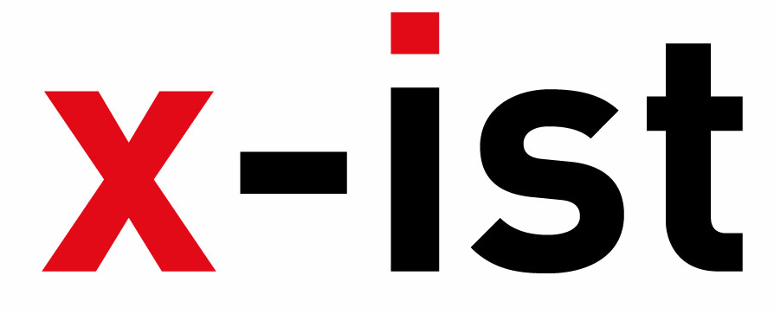 | Abdi İpekçi Caddesi Kaşıkçıoğlu Apt. No:42 D:2 34365 Nişantaşı İstanbul  www.artxist.com  info@artxist.com  T. +90 212 291 77 84 F. +90 212 343 69 35 | PRESS RELEASE

x-ist @ SCOPE Basel 2012

x-ist participates in Scope Basel between June 12-17, 2012 in Kaserne, Basel.
Scope Basel, coinciding with Art Basel, hosts cutting edge galleries from all around the world.
This year, x-ist shows works from Cem Dinlenmiş, Ali Elmacı, Seda Hepsev, Sena, Erkut Terliksiz, Gözde Türkkan,
Ceren Oykut, Nalan Yırtmaç, Lale Tara, Banu Birecikligil and Nuri Kuzucan.

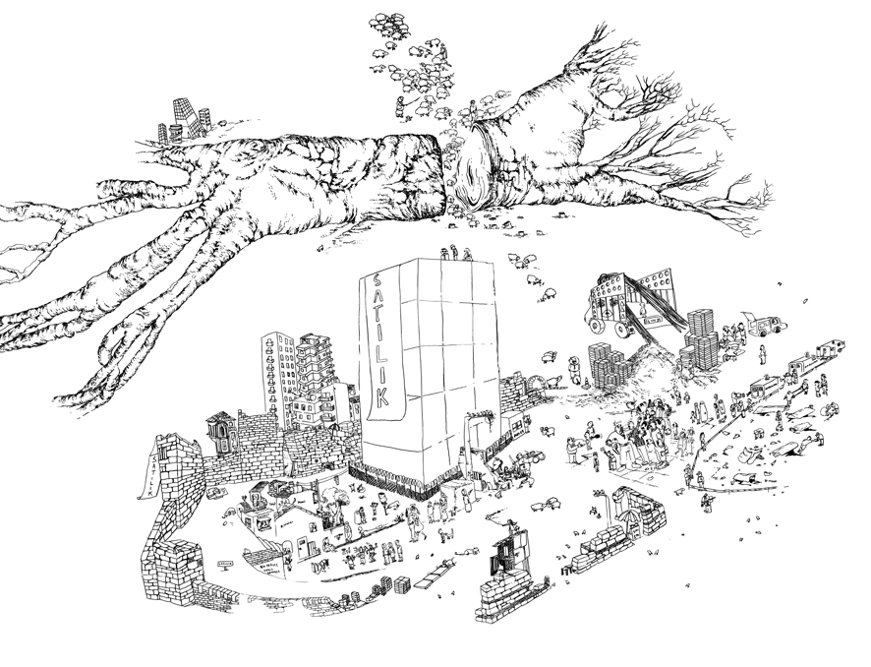

Ceren Oykut, “Half and Alone”, Ink on paper, 83 x 111 cm, 2008

Cem Dinlenmiş, who shapes the given surface in accordance with his story or idea, enables perceptions that vary with the position of the audience. In Basel, Dinlenmiş exhibits the second piece of his double faceted paintings that reveal two different images when viewed from different angles. These images overlap and reappear as the viewer moves.

Ali Elmacı exhibits his brand new works “The Fare V” and “Save Me With Your Fire III” at the fair. “The Fare V” criticizes the fake, glorious lives presented by the media that disguise the real problems of a society. In “Save Me With Your Fire III” Elmacı portrays two bureaucrats who cannot hide their own anxiety, yet hope to inspire confidence in the audience. The artist gives referance to the spurious promises that politicians make today about extending human rights and freedom.

Seda Hepsev takes an alternative approach and displays her realist drawings which depict ornaments and objects that remind us of a grandmother’s home, accompanied by one woman figüre, who’s assumed to be in the same location. Hepsev points out the relation between the lacework and her realist drawing style.

Ceren Oykut brings together painting and cartoon in her work where she combines her personal memories with everyday scenes from Turkey. Her drawings, “Beautiful and Alone” and “Lego” reflect her subconscious while reconstructing social events.

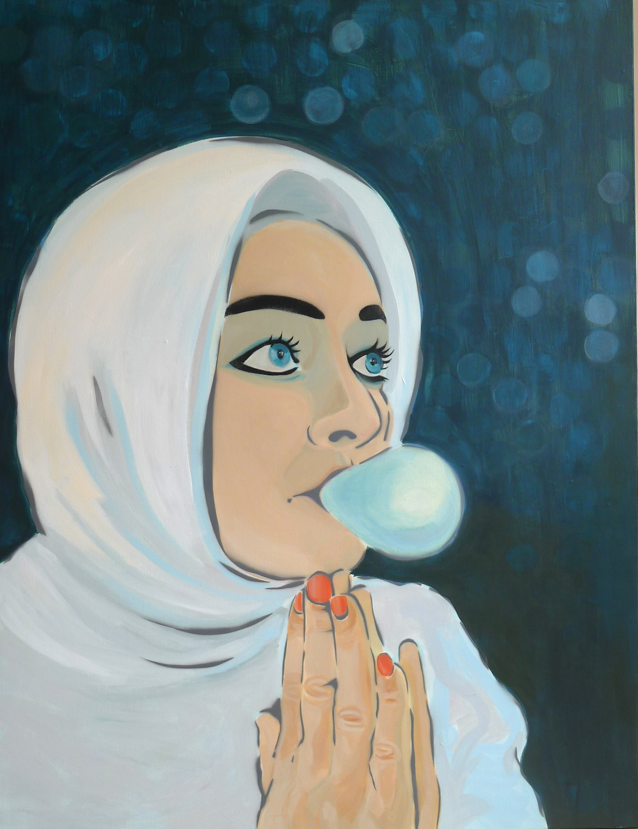
In her works “Shaman”and “Shadow” Sena paints the dark and the pure sides of the human soul, through the use of symbols and experimental material use. According to the artist, the spirit cannot exist without this dark side. Combining different religions and philosophies, Sena hints to the secrets of the human soul and body.

Lale Tara, who uses inanimate sexual surrogates to represent herself in her one-shot stories, takes place in Scope Basel with “Sentimental Toys”. This photograph gives clues about her upcoming show at x-ist in September, 2013, coinciding with the Istanbul Biennale.

Erkut Terliksiz takes place in Scope Basel with three paintings that belong to his recent series “Nothing Personal” which concurrently runs at x-ist. Terliksiz can be traced through the details of his work that combine his subconscious and memories.

Gözde Türkkan exhibits works from the Full Contact series - realised in Southeast Asia in 2011 - that focuses on the use of male and female bodies and their commercial re-appropriation. In these photographs, which according to the artist, can be classified as “subjective-documentary”, Türkkan captures intimate shots from an insider’s perspective, without claiming to be an “insider”.

Nalan Yırtmaç, “Over Coded”, Acrylic and stencil on canvas,
120 x 90 cm, 2012

In her brand new work titled “Flappergirl and Cat” Banu Birecikligil focuses on the character, instead of the story or the location.

Nuri Kuzucan presents the first piece of his new series, “Plan II” after his latest show Interior & Exterior.

Finally, Nalan Yırtmaç explains her new work “Over Coded”: “Since the day Eve ate the apple, every gaze at the human body attached desires and wishes to it. The young girl in the painting is a wish tree and the eyes that look at her gave her so much burden that no fashion style can free her now.”

x-ist looks forward to seeing everyone at Scope Basel, booth G14.

