 | Abdi İpekçi Caddesi Kaşıkçıoğlu Apt. No:42 D:2 34365 Nişantaşı İstanbul  www.artxist.com  info@artxist.com  T. +90 212 291 77 84 F. +90 212 343 69 35 | PRESS RELEASE

x-ist @ Unseen Amsterdam
x-ist participates in the inaugural edition of Unseen Amsterdam, the international photography fair
organized by Amsterdam’s FOAM Museum. Taking place at Westergasfabriek between September 19-23, 2012.
Unseen hosts more than 50 galleries from around the world. Unseen is a meeting place for young photographic
talent and known photographers exhibiting new work.

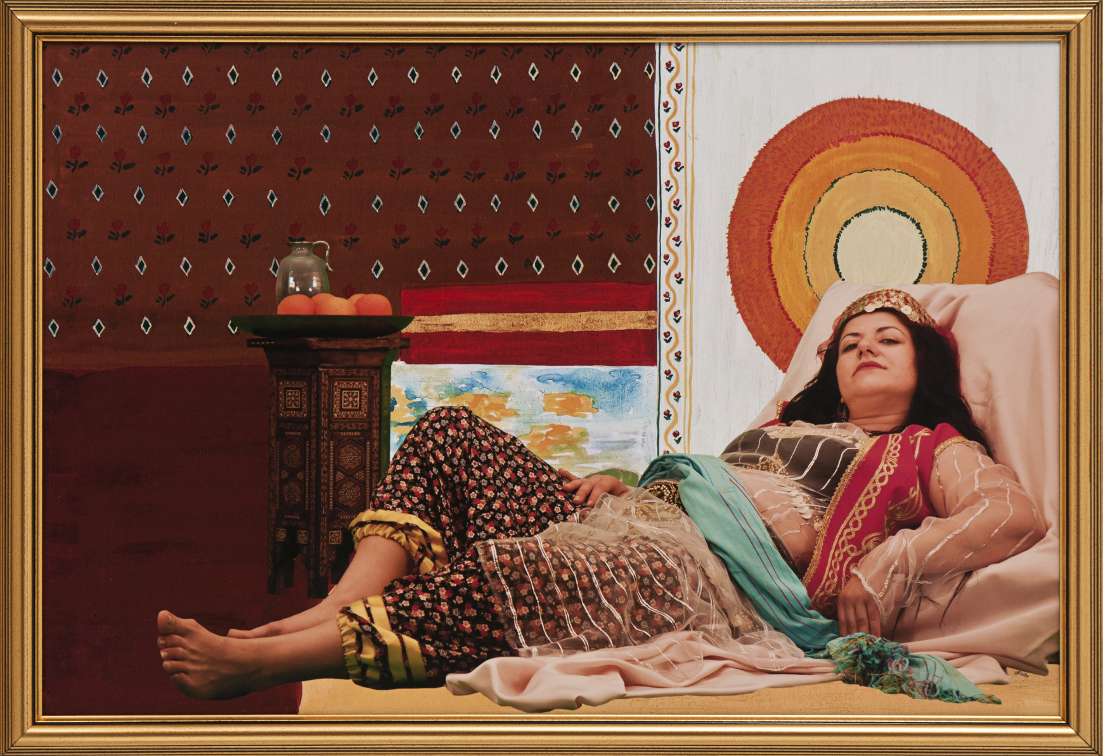

Canan, Turkish Delight Series IV, Photography, c-print, 70 x 100 cm (unframed), 2011

x-ist exhibits the works of Canan and Lale Tara in Unseen. Using inanimate sexual surrogates and objects as definitive characters which embody the artist herself, Lale Tara presents a selection from her Doppelganger and Innocent Surrogates series as well as her recent exclusive piece, Sentimental Toys. The artist strengthens the relationship between her experiences and imagination through her photographs constructed in a multitude of scenes and abandoned spaces.

Known for her biopolitical works, Canan exhibits her new series Turkish Delight, where she reinterprets well known ‘odalisque’ or ‘Harem Interiors’ produced by male Western Orientalist painters. Canan uses herself as the subject matter in her photographs. The artist investigates the remains of orientalism today, where the West’s dominance over the East was consolidated through the female figure.

Many international galleries, including Yossi Milo, Danziger Gallery, Flatland and Aando Fine Art, working with well-known photographers are taking place at Unseen.

Artist Biographies

CANAN
İstanbul, 1970

After graduating from Marmara University, Fine Arts Faculty, CANAN won many awards and participated in residency programs in Germany and the USA. Among her exhibitions are “Bashfulness” (Performance, Platform Art Center, Istanbul, 2007 and Center Pompidou, Paris, 2010), “Bahname” (Masa Project, Istanbul, 2007), “Behind the Curtains” (Festival De Rode, Amsterdam, 2006), “Finally in You’re in Me” (İstanbul, 2000) and “New Works, New Horizons”, (Istanbul Museum of Modern Arts,Istanbul, 2009). CANAN participated in Contemporary Istanbul 08, 09, 10 and 11, IFCA 13th International Festival of Computer Arts (Maribor), 9th International Istanbul Biennial Hospitality Zone, SCOPE Basel 2009, 11th International Istanbul Biennial, ART HK’10 (Hong Kong International International Art Fair), SCOPE New York 2010 and Art Dubai 2011. She took place in the Sotheby’s 2009 and 2010 “Contemporary Turkish Art Auction” in London. CANAN had two solo shows at x-ist; “Even a Cat Has a Mustache” (2010) and “Turkish Delight” (2012). CANAN was one of the 11 artists in the show titled “A Dream But Not Yours, Contemporary Art From Turkey” exhibited at the National Museum of Women in the Arts (Washington D.C., USA) in 2010. CANAN participated in the show titled “Istanbul Cool! What’s Happening in Contemporary Turkish Art Now” in Leila Taghinia-Milani Heller Gallery (New York, USA, 2010) and “Confessions of Dangerous Minds” in Saatchi Gallery (London, 2010). In 2011 and 2012, Canan exhibited her work in group exhibitions such as “Dream & Reality” (2011) at İstanbul Museum of Modern Art, "Collage Istanbul" at Gaîté lyrique, Paris, "Scenarios About Europe: Scenerio 3" at GfZK, Germany and "Contre L’Histoire" at Centre d’art de Fribourg, Switzerland.

LALE TARA
İstanbul

Tara graduated from The New School University (New York) and OCTET: School of Visual Arts (New York). Her visual diary “sevenmonthssevendays” was published by the Robinson Crusoe Publishing House in 2005. Following her exhibits “Live” (Bilsar, 2006) and “Hello Earth Goodbye” (Bilsar, 2007), x-ist hosted her show “doppelgänger (RUI)” in 2009. The artist participated in Contemporary İstanbul’ 09 & 10, Start-2009 (14th European Contemporary Art Fair, Strasbourg, France), ART HK’10 & 11(Hong Kong International Art Fair), VIP Art Fair (2012), SCOPE Basel 2011 & 12 fairs and the exhibit “A Subjective Panorama on TurkishContemporary Photography” in Maison des Métallos (Paris). In 2010, Tara took place in “Neither Here nor There: Reflections on Cultural Hybridity and the Third Space” organized by the art initiative in London, JAMM (Art & Beyond), the multi-national exhibit “Tradition of the New” in Sakshi Gallery, Mumbai (India) and “Between History and Tale: Contemporary Photography” in Sakshi Gallery, Taipei(Taiwan). In 2011, Tara exhibited her solo show “Innocent Surrogates” at Istanbul Museum of Modern Art and also participated in the group exhibit, “Idols and Icons” at Yavuz Fine Art, Singapore.

