 | Abdi İpekçi Caddesi Kaşıkçıoğlu Apt. No:42 D:2 34365 Nişantaşı İstanbul www.artxist.com  info@artxist.com  T. +90 212 291 77 84 F. +90 212 343 69 35 | PRESS RELEASE

x-ist takes part in the Photo London fair to be held on May 19-22 with Ahmet Polat’s solo exhibiton.

x-ist @ Photo London’16
Stand // Booth No: D7

Continuing his works in Turkey and mainly in the Netherlands, Ahmet Polat participates in Photo London’16 with a special selection from his last solo exhibition “A Bridge Too Far” (2016) at x-ist and his series “Kemal’s Dream” (2014). To be held for the second time this year, Photo London brings together prominent photography artists, galleries, curators and collectors from different countries of the world in the center of London.

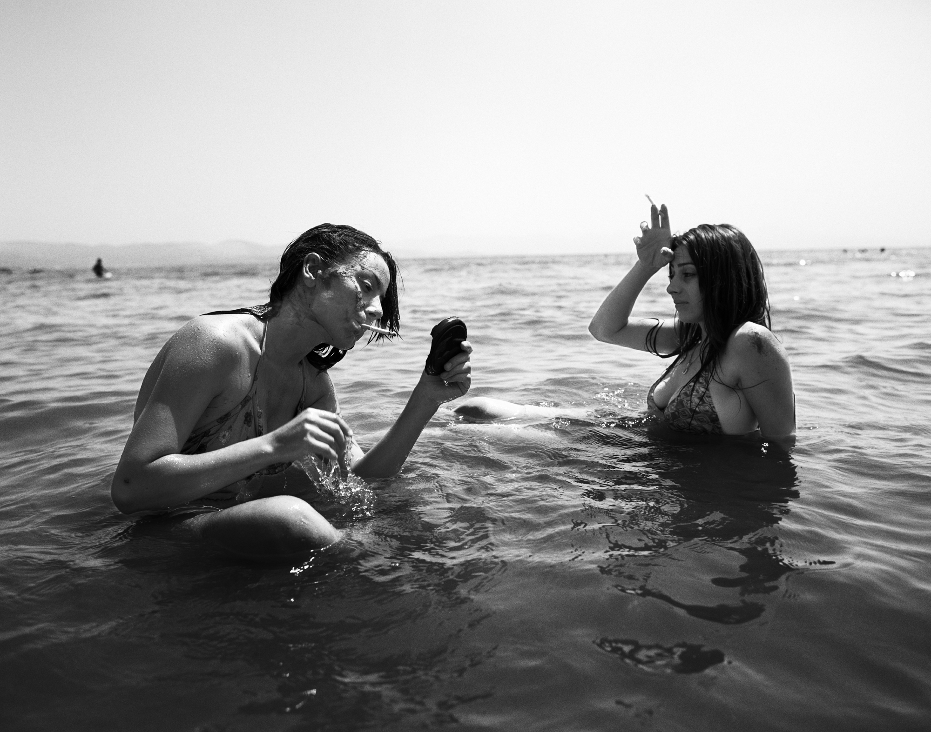
Ahmet Polat, “Smoking in the Sea, İzmir”, Fotoğraf | Photography,
5 ed. + 1 AP, 55 x 70 cm
For Photo London’16, Ahmet Polat brings together under the curatorship of Paul McMillen a selection from “A Bridge Too Far”, which has been exhibited in the Europalia Art Festival BOZAR and analyzes the present-day Istanbul and social dynamics, and from the series “Kemal’s Dream” - nominated previously for the Dutch Doc Award and launched as a book at the Unseen Amsterdam Fair - in which he photographed youngsters from different regions of Turkey between 2006-2012.

Photographs from the series “A Bridge Too Far” and “Kemal’s Dream” created within an interval of almost 10 years by Ahmet Polat, who has the opportunity to address the representative power of photography in different cultures, can be seen at x-ist’s booth D7 at the Photo London’16 fair on May 19-22.

AHMET POLAT I Holland, 1978
Ahmet Polat is a Turkish-Dutch photographer living in Istanbul & Holland. After graduating from St. Joost Academy in Breda, 2000 he started exhibiting his work in Turkey and the Netherlands. Among his solo exhibitions are, “Silence in Kayapinar” (Dorts Museum, Netherlands, 2001), “Home Is Where I Left My Dreams” (Karşı Sanat Gallery, Istanbul, 2003; Resim Heykel Museum, Ankara, Turkey), “Old Country, New Country” (Photo Museum The Hague, Netherlands, 2004), “Neither Here nor There” (Breda Photo Biennial, 2008), “Kemal's Dream” (FOAM, Amsterdam, 2010, DEPO, Istanbul, 2012).
At x-ist he had three solo shows titled “Submitted to Change” (2005), “Invitation Only” (2006), “The Other Kemal” (2014) in addition to a public space installation “Where Are You?” in 2007. Polat has received the “Young Photographer” award in the 22nd Infinity Awards given by one of the most important photography institutions of the world, ICP (International Center of Photography in New York). The artist also participated in several international group shows like “Old Country, New Country” (Stroom, The Netherlands, 2005), “Genç Açılım” (Pera Museum, Istanbul, 2005), “Fluorescent Adolescent” (7th International Biennial of Photography, Netherlands, 2010), “In what language shall I tell you my story?” (Stedelijk Schiedam, Netherlands, 2012), “Modern Turkey” (Rijksmuseum, Amsterdam, 2012), “Istanbul Modern – Bahrain” (Bahrain National Museum, Bahrain, 2013), “On the Move” (Stedelijk Amsterdam, 2014) and x-Tension (Office 4200, Bursa, 2015).
Polat also takes commercial and fashion photographs for several international magazines such as French and Turkish Vogue, Harper’s Bazaar, New York Times, Paris Match, Marie Claire, Quest and Vice. Among the art fairs Polat participated are Art-Rotterdam, Contemporary Istanbul 07, 12, 13, 14 & 15, UNSEEN Amsterdam 2012 and ArtInternational 2013 & 2014.
The book of his latest work “Kemal’s Dream” has been launched in the Unseen Photography Fair, Amsterdam in 2012. In 2013, Polat was nominated for the long list of Dutch Doc Award, the largest Dutch photography prize, with his two different projects, “Kemal’s Dream” and “Dark Moon”. In 2015, Polat has received "Ambassador of Dutch Photography" title by FOTOWEEK Festival. The photo series Polat took for the festival is presented during FOTOWEEK (FOTODOK, Netherlands, 2015). He had an exhibition entitled "Imagine Istanbul", in Palais des Baux Art in Brussels curated by R. Paul McMillen.

For detailed information please consult Gözde Ulusoy from x-ist.

gozde@artxist.com
M. 545 357 60 70
T. 212 291 77 84

