 | Abdi İpekçi Caddesi Kaşıkçıoğlu Apt. No:42 D:2 34365 Nişantaşı İstanbul www.artxist.com  info@artxist.com  T. +90 212 291 77 84 F. +90 212 343 69 35 | Press Release

One of x-ist’s youngest artists Murat Palta, best known for his works that recreate scenes from cult movies with traditional miniature art is opening his new solo show; “Incarnated by Words” in St. Petersburg Savina Gallery between
September 28 – October 15.

Murat Palta explains his creative process for his third solo show which reinvents both classic and contemporary literature works such as; “Crime and Punishment”, “The Little Prince”, “Lord of the Rings”, “Lolita” and “1984” as;

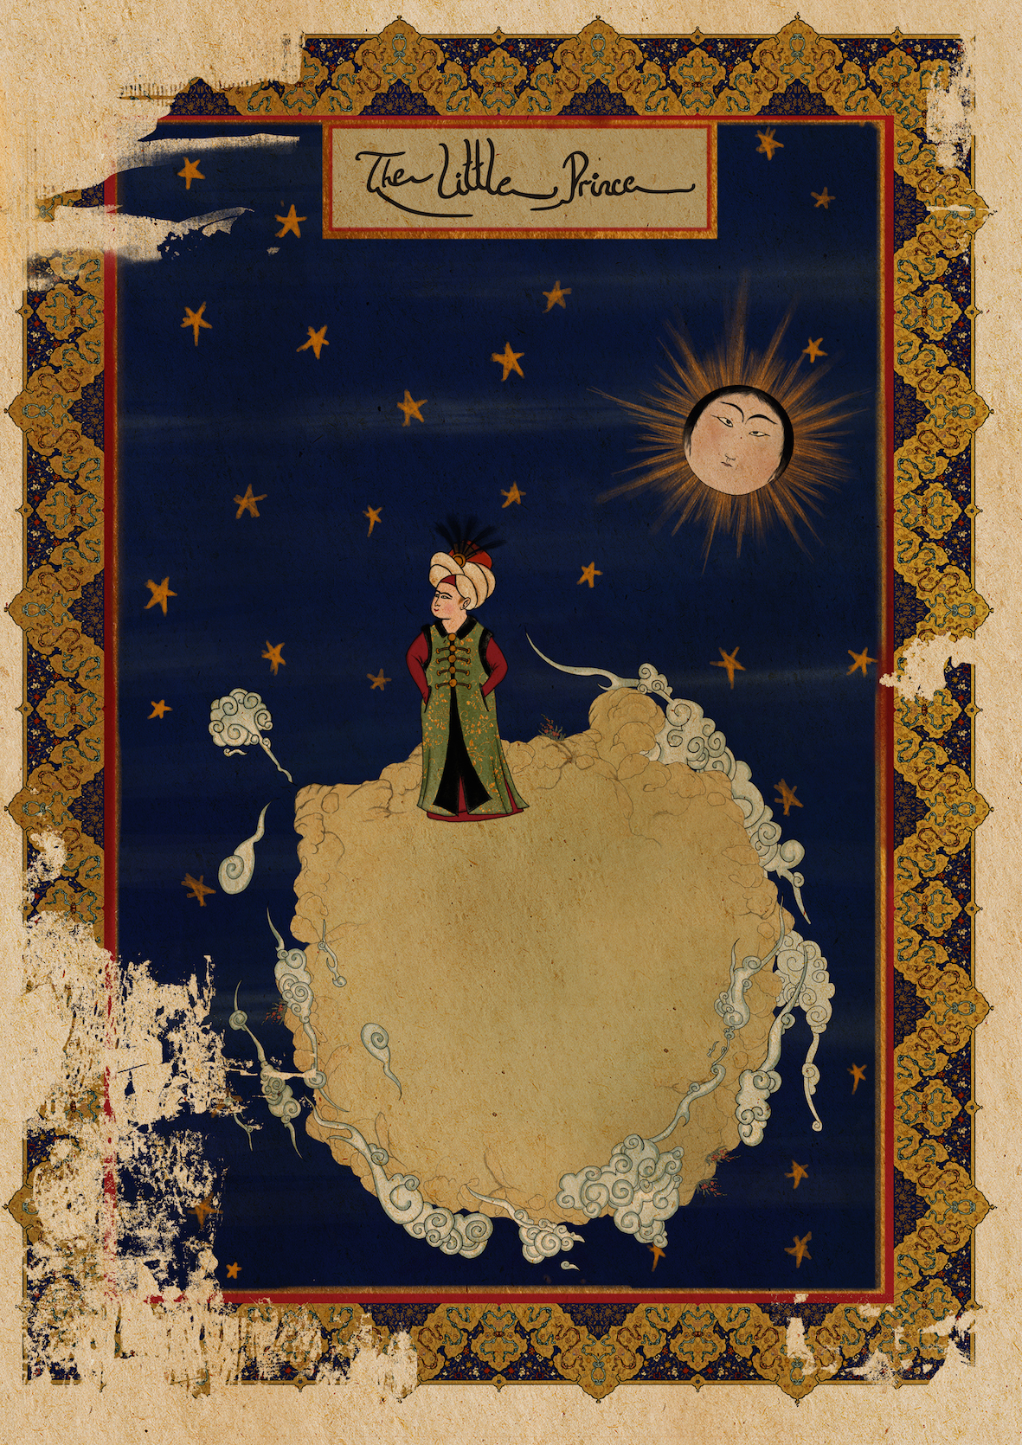
“In my previous works I underlined the fact that contemporary illustration and traditional miniature art had overlapping purposes. But I still had to go beyond the fields of use of both. This time I turn to the basis and reenter the miniatures’ fields of use. While doing it I don’t give up on the earlier conflicts: The Contemporary vs the traditional East and West.

The Ottoman Empire encompassing a wide range of cultures hosts a great variety of literary works. Particularly Şahname is one of the sultans’ favorites. The miniatures in it apparently shaped the Ottoman art. Although it contains works ranging from the Greek and Persian to the Indian, the first translation from the Western literature begins around 1860 with works such as La Fontaine. Again in the same period the traditional miniature art begins to lose its power with the passing of time.

Even though the classics of that period differ from the modern classic literary and illustration styles, I create this body of work by maintaining this viewpoint and describing the world classics through miniatures.”

Murat Palta, “Little Prince”, Monoprint on fine art paper, 85 x 60 cm, 2015

About Murat Palta:

His series consisting of 16th century versions of the most famous movie scenes toured the world as a record breaking social media phenomenon with hundreds of thousands of shares. Palta’s appearances in CNN, BBC and Huffington Post have gained him an international reputation. Then, Palta's work was exhibited for the first time in 2014 at the Museo Civico delle Cappuccine in Italy. The works in this solo exhibition were presented under the title “Murat Palta: Cult Hollywood Movies as Ottoman Miniatures”.

Murat Palta’s first gallery exhibition hosted by x-ist; “Depictions of White Screen”, meticulously created with the precision of a miniature artist, describes cult movie scenes from the standpoint of a completely different time frame, one that goes back five centuries.

For further information please contact x-ist.
info@artxist.com
M. 545 357 60 70
T. 212 291 77 84

