 | Abdi İpekçi Caddesi Kaşıkçıoğlu Apt. No:42 D:2 34365 Nişantaşı İstanbul www.artxist.com  info@artxist.com  T. +90 212 291 77 84 F. +90 212 343 69 35 | PRESS RELEASE

Didem Erk's first solo exhibition "Home is a Place Called Never" will be on view at x-ist from September 7 to October 14, 2017.

DİDEM ERK
HOME IS A PLACE CALLED NEVER
CURATOR IŞIN ÖNOL

In her first solo exhibition "Home is a Place Called Never", on view at x-ist from September 7 to October 14, 2017, Didem Erk presents recent works encompassing performance, video, installation and text. In a seven-piece cycle of performance videos and photographs, realized in isolated bays around Datça and on Cyprus, the artist addresses the concepts of language, memory, migration and border.
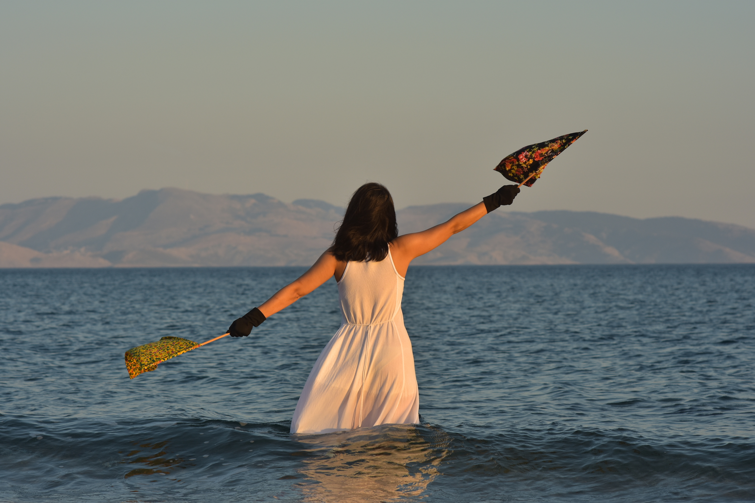
Didem Erk, "Home is a Place Called Never" Dual-channel video installation

In the double-channel performance video "Home is a Place Called Never", eponymous to the exhibition title, the artist can be seen standing still in the breakwater, holding two flags made of printed fabric. This gesture may at first glance look like a call for help or a gesture of resistance. The two flags however, held at a 45-degree angle signify "cancel / disregard signal" in the maritime semaphore language. The two video channels show views into opposite directions: One from Datça towards the Aegean Sea; the other from Datça towards the Mediterranean and the Island of Symi, which has been the destination of myriad migrant passages.

Curated by Işın Önol, the exhibition "Home is a Place Called Never" assembles works that aim to understand how memory gets erased or enforced, perhaps depending on the intensity of pain, on the various shores that migration departs from, or seeks to reach.
In what follows, an excerpt is given from a conversation between Işın Önol and the artist that can be found in the exhibition catalogue:
"Real life, however, is too wild to be real. When we look at the recent and ancient history of humanity, we see that the human being is too "inhumane" to be real. And yet everything is so real, given all the witness accounts, that the human being is too human to be real. And what Cyprus experienced in 1974 and before, and even after, is so human that it cannot be real. This is the human being's testimony to and amazement at humanity; it is the testimony to evil which surprises each time, and each time the victim has to prove this inhuman humanity that is too real to be true: as bad as evil. In all these testimonies, what maybe puts us in a tight spot is to prove to the perpetrator his cruelty. Rather than learning not to be cruel, humans - who are at the same time their official historiographers - have learned to hide and deny their cruelty. Considering the phenomenon of official history, Cyprus is a very special place. And so is Lefkoşa/Nicosia which is still the only divided capital today. Datça between two seas and Lefkoşa/Nicosia between two cities. What have you witnessed in these places?
Twin images, construction of invisible walls. A state of monologue on its own, traumas, paranoias and mourning. Mourning is a way of transformation, but it seems that the people of Cyprus could not experience it in a healthy way. Even if the walls and the barrels get removed, the invisible walls have taken root in the individuals. Like a lover that one cannot break up with, or a fatality one cannot cope with. But they did not want to get intimate and in one night they burned the blankets made of clothes that the Greeks had abandoned. Numbers were placed on the houses, which prevented them from becoming home. It made the residence uncomfortable and kept feelings of guilt alive. As for Datça, there is no form of political existence other than being between two seas. And this is normal for everyone: to jump in a boat, make people immigrate and get paid for it. Although it is not legal of course, nobody is surprised by the people who do it. I found pieces of boats in the Gereme bay in Datça, I gathered them. I went home later; the news I read told that the bodies of refugees had washed up on the shore and it seems that the boat pieces that I had gathered were part of an escape. They cried out loud, demanding not to be kept secret. I had to hear it. It has drowned that night, I had to remember it."

The exhibition "Home is a Place Called Never" can be visited between September 7 and October 14, 2017 at x-ist.

For more detailed information, please consult Gözde Ulusoy from x-ist.

gozde@artxist.com
M. 545 357 60 70
T. 212 291 77 84

