 | Abdi İpekçi Caddesi Kaşıkçıoğlu Apt. No:42 D:2 34365 Nişantaşı İstanbul www.artxist.com  info@artxist.com  T. +90 212 291 77 84 F. +90 212 343 69 35 | PRESS RELEASE

Emin Mete Erdoğan’s second solo exhibition “The Flood” meets the audience between March 7 – April 7, 2018 at x-ist.

EMİN METE ERDOĞAN
THE FLOOD

In his first solo exhibition at x-ist, Emin Mete Erdoğan had brought together organic and inorganic forms on surfaces such as aluminium and canvas in a depiction of a dystopian world. Now in his second solo exhibition at x-ist, he meets the audience with alternative answers to the question “What kind of a scene would we have to deal with if the Great Flood happened today?”

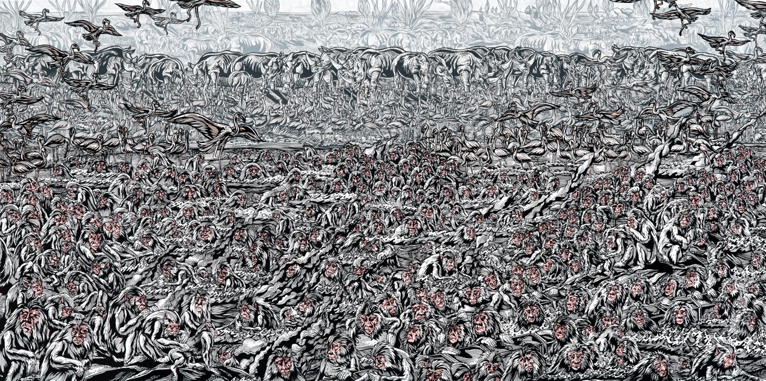
Emin Mete Erdoğan, “Follow the Water I”, Acrylic ink on canvas, 81 x 151.5 cm, 2018

The artist is impressed by how the Great Flood contains both an annihilation and a new beginning, and interprets the fact that throughout the history of mankind one encounters written narration in two thousand different geographies and time periods from the Sumerians to the Egyptians, from Babylon to the Divine Religions as a story of a common history of mankind. The artist thinks that as all the living beings on the world we are just in the middle of a pre-apocalyptic scenario similar to the Great Flood due to the global warming and the rising ocean level and we share this, and while he interprets the Great Flood as a past narrative, he actually also depicts today’s world. Including different materials into his production process, the artist will be sharing for the first time his sculptures and reliefs made of polyester casting besides his works created with the use of canvas, aluminium, acrylic on paper and ink in his exhibition entitled “The Flood”.

“In this series we generally see herds moving towards the human figures in the center or the structure in the form of a globe consisting of equilateral triangles that I used as the representation of human mind. This selection of composition indicates to man’s positioning oneself just in the middle of the cosmos and having the illusion of holding the destiny of all the living beings in the World.”

-Emin Mete Erdoğan

Emin Mete Erdoğan’s second solo exhibition entitled “The Flood” to be held at x-ist can be visited between March 7 – April 7, 2018.

A selection of the artist’s works from the same series can be seen at x-ist’s booth no: E7 at Art Dubai’18 fair between March 21-24 simultaneously with the exhibition.

For more information, please consult Gözde Ulusoy from x-ist.

gozde@artxist.com
M. 545 357 60 70
T. 212 291 77 84

