 | Abdi İpekçi Caddesi Kaşıkçıoğlu Apt. No:42 D:2 34365 Nişantaşı İstanbul www.artxist.com  info@artxist.com  T. +90 212 291 77 84 F. +90 212 343 69 35 | PRESS RELEASE

x-ist will host the fourth solo exhibition by Cem Dinlenmiş entitled “"Attn: Block Residents"” between May 18 – June 16, 2018.

CEM DİNLENMİŞ
"ATTN: BLOCK RESIDENTS"
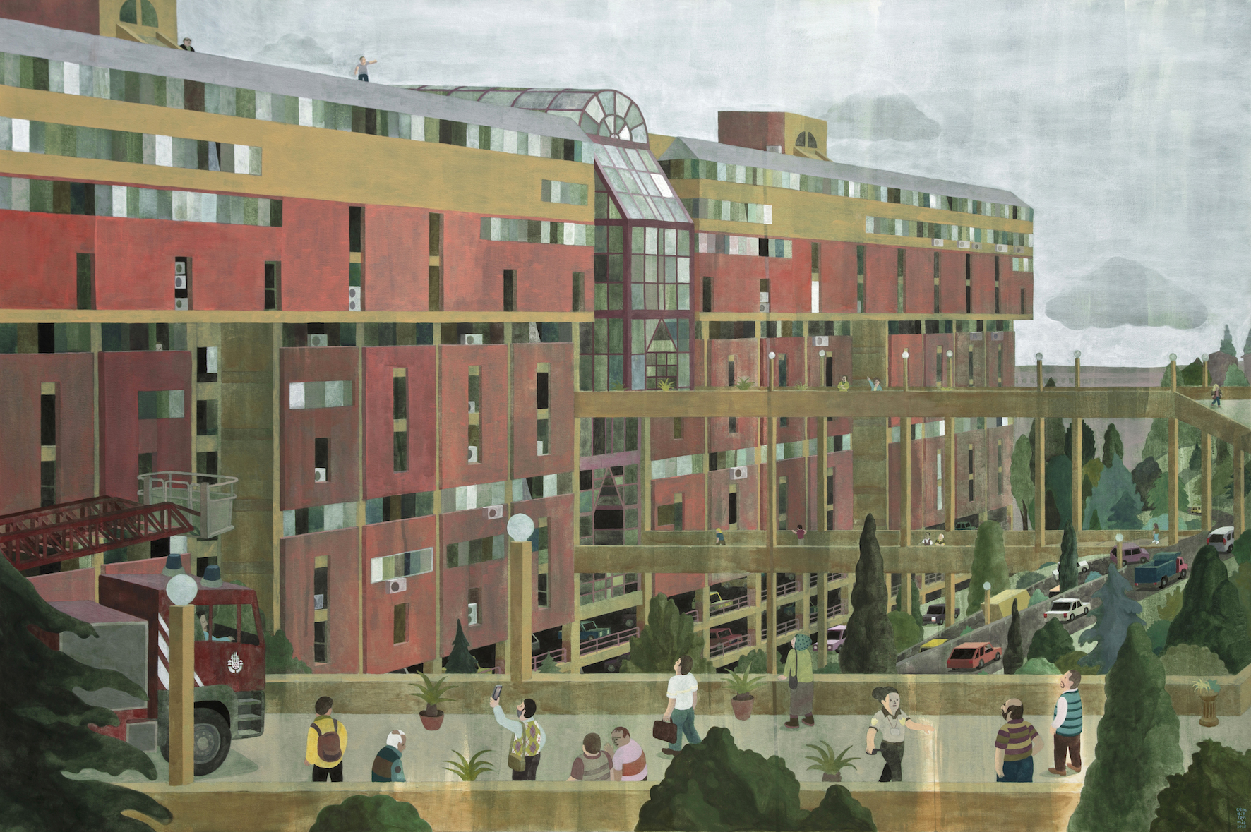

Cem Dinlenmiş, “Won’t jump, just making a scene”, Acrylic and marker on canvas, 100 x 150 cm, 2018

In his solo exhibition “Attn: Block Residents”, Cem Dinlenmiş focuses on public spaces. Continuing the narrative structure of his previous solo exhibitions, the artist follows traces of sociocultural change in the urban environment of 1980s and 1990s Turkey. While depicting the familiar faces of venues such as Perpa, Milli Reasürans Building, Tekstilkent, and Galleria Shopping Centre in Ataköy, he investigates the aesthetic codes of the period in which he grew up.
The exhibition also includes paintings of suburban prison complexes' entrance structures. By visiting the past, Cem Dinlenmiş paints with his simplified visual language expressed through geometric forms, repeating structural elements and topography that he links together.

The fourth solo exhibition by Cem Dinlenmiş titled “Attn: Block Residents” can be visited between May 18 – June 16, 2018 at x-ist.

CEM DİNLENMİŞ l İSTANBUL, 1985

Born in 1985 in Istanbul, Cem Dinlenmiş has graduated from the Graphic Department of the Fine Arts Faculty at Marmara University. In 2005 he started to draw comics for the weekly Penguen Magazine. His column entitled ‘Her Şey Olur’ (Anything Goes) in Penguen was published into books in 2010, 2012, 2013 and 2014. After the group exhibition “Intersection III” at x-ist in 2008, he opened the solo exhibitions entitled “Internal Affairs” in 2010, “Not Now” in 2012 and “You’ll Know When You See It” in 2016. His paintings were exhibited in the group exhibition “Variations on ‘An Andalusian Dog’” (x-ist, 2015) and in international fairs such as Contemporary Istanbul 09, 10, 11, 12, 13, 14, 15, 16 & 17, Art Dubai 2011, SCOPE Basel 2012. Other works by him were exhibited at galleries and institutions such as Salt Beyoğlu in Istanbul, MAXXI Museum in Rome (National Museum of 21st Century Arts), nGbK (New Society for Visual Arts) in Berlin and ISCP (International Studio and Curatorial Program) in New York. After the closure of Penguen in 2017, he continues to draw his column “Her Şey Olur” (Anything Goes) in Uykusuz Magazine.

For more detailed information, you can consult Gözde Ulusoy from x-ist.

gozde@artxist.com
M. 545 357 60 70
T. 212 291 77 84

